Social Worker
Service: |  | People | Grade: | Level 1 (3B), Level 2 (3C), Level 3 (4A) |  |  |  | Salary: |  |  | Dependent on level
Reporting to: |  | Practice Manager | Location: | Various |  |  |  | Hours: |  |  | 36 hours per week
About the role |  |  |  |  |  |  |  |  |  | Our priorities
- You will work directly with children and their carers using a range of knowledge, skills and interventions as required, in accordance with statutory responsibilities to secure positive outcomes for children.  - You will build effective relationships with children, young people and their families enabling full participation in assessment, planning, review and decision making.  - You will effectively manage a caseload, with varying degrees of complexity dependent upon skills and length of experience, with appropriate supervision, guidance and support.  - You will work in accordance with national and local policies and procedures, and use the law, regulatory and statutory guidance to inform practice decisions.  - You will prepare and producing a variety of high quality professional written documentation to required quality standards on behalf of the City Council.  - You will work with partner agencies and represent the Council at a range of meetings, proceedings and reviews as required. You will secure access to services, negotiating and challenging other professionals and organisations to provide the help required.  - You will provide support based on best evidence, which is tailored to meet individual child and family needs and which addresses relevant and significant risks. |  |  |  |  |  |  |  |  |  | 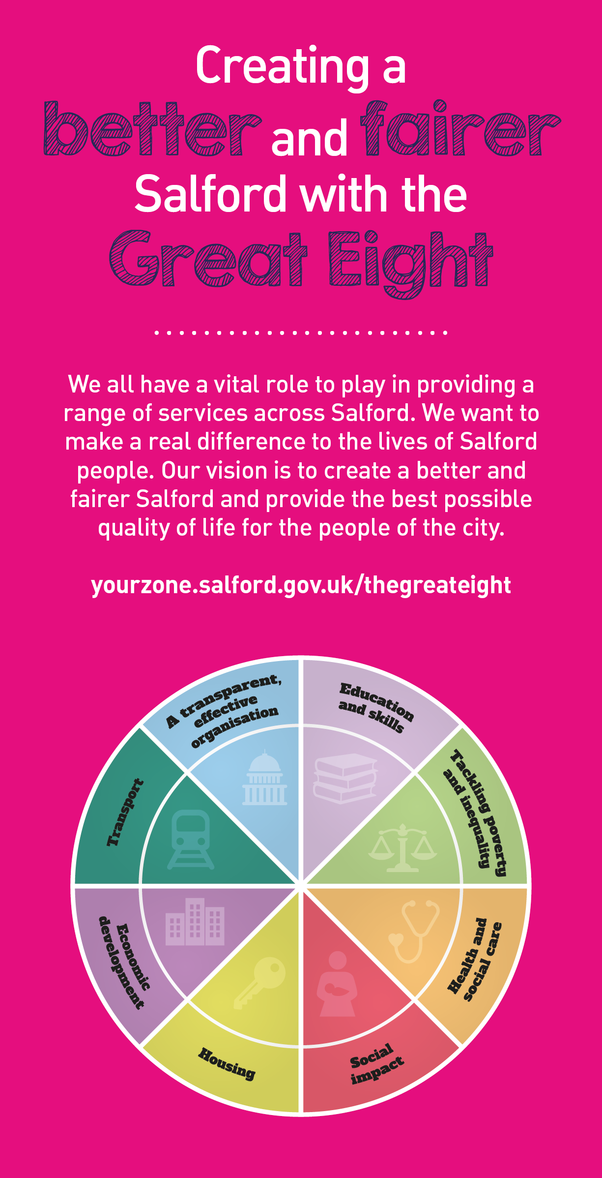
 | Key outcomes
 | - You will undertake your role demonstrating the knowledge and skills statement for child and family practitioners.  - You will work to the highest standard in line with the Council’s Employee Code of Conduct, and other relevant policies.  - You will maintain timely and accurate recording of work undertaken in client information systems, having regard to the GDPR and associated policies.  - You will ensure that PIMs data is up to date, interpreted and actioned appropriately  - You will be responsible for and committed to safeguarding and promoting the welfare of children and young people and for ensuring that they are protected from harm. |  |  |  |  |  | - You will be aware of and apply Salford’s values at all times.  - You will take responsibility for your own continuing professional development and support the development of others.  - You will demonstrate a personal commitment to reflective practice, self-development and team improvement.  - Through personal example, open commitment and clear action, you will ensure diversity is positively valued, resulting in equal access and treatment in employment, service delivery and communications.
 | What we need from you
 | - Possession of a recognised Social Work qualification and current registration with the professional regulatory body.  - Experience of working with children and/ or complex safeguarding. Personal and professional commitment to ensure positive outcomes for children in Salford  - Ability to communicate equally, appropriately and effectively with a wide range of individuals and groups across all sectors and levels of society. Ability to maintain accurate records and to communicate complex information clearly and concisely both verbally and in written form.  - You must clearly evidence your ability to develop effective relationships with partner agencies and effective engagement skills to work with their carer’s, families and partner agencies  - Ability to organise own time effectively, prioritising, preparing in advance and setting realistic timescales. Ability to maintain focus and objectivity under pressure and skill in managing and maintaining a complex workload  - Be able to demonstrate evidence of good assessment practice using analytical skills |  |  |  |  |  | - Evidence that you have a clear understanding of the Social Worker role and relevant legalisation, and understand the concept of integrated working, supporting colleagues to achieve a shared purpose.  - Ability to respond to immediate problems of a complex nature with associated risk factors and deliver immediate solutions sometimes under pressure  - Ability to think creatively and take and active role in team and service development. Personal commitment to supervision, reflective practice and self development.  - Willingness to flexibly work outside of office hours as required by the needs of the service. You will also contribute to the team duty service on a rota basis with team members  - Ability to use IT systems to retrieve, record and update information and willingness to learn to use new systems  - Ability to travel across Salford and Greater Manchester area either through use of a vehicle insured for business use or using public transport
What we can offer you
Your ongoing professional development and success in your role is important to us, and that is why we provide a variety of learning and development opportunities. Within the sections below you will find development options tailored to you which will enable you to further develop your existing skills and learn new ones at a pace that suits you best. If you are joining us now, your development will form part of ongoing discussions with your manager. If you are an existing employee, you should use your Personal Development Reviews to discuss your development with your manager and create your development journey. It’s important you also take full advantage of any informal learning available to you during the course of your work, including coaching, mentoring and shadowing. Please discuss these options with your line manager.

- Online Learning - Develop your knowledge across a wide range of areas through our Me-Learning platform, with over 200 free courses to choose from. To have the best possible start and comply with current legislation, you must complete the following modules: Welcome to Salford, Health and Safety in the Office, GDPR, Equality Essentials, Safeguarding Children and Adults, and Safer Recruitment. You may also benefit from a variety of courses in categories such as Business Skills, IT and Project Management which are available to learn at your own convenience and pace.  - Developing your digital skills – Our ambition is to provide our workforce with the right level of digital capabilities needed to be successful. Whatever your current digital abilities are, we can provide development ranging from essential workplace skills to specialist workplace skills’. These will be delivered through our Digital Skills Academy using both self-directed and guided learning opportunities to enable you to develop. Additionally, you can access free online courses through the iDea website. |  |  |  |  |  | - Professional Development – Gain role specific skills and time to learn through a wide range of development opportunities. Learn whilst working and get support towards your qualification through an apprenticeships standard. Access professional development ranging from entry level to master’s type qualifications, including achieving a role appropriate qualification. Details can be found on the Institute of apprenticeships website.  - Sharing your digital skills – Our goal is to support you to share your digital knowledge with other people. Our Digital Eagles programme has been designed to cover basic digital skills and build your confidence to assist others. By the end of this programme you will join hundreds of staff members who already are digital eagles, and be able to help colleagues, customers, residents, or people in your personal life with all things digital.

Application guidance |  | Our values
We are a values based organisation so reflecting our values or a values based approach in your evidence will support your application.

The different sections of this role profile are there to give you an understanding of the purpose of the role. The ‘what we need from you’ section outlines the minimum criteria you will need to meet within your application.

Please submit a CV and a cover letter (no more than 2 sides of A4) outlining how you meet the requirements and what you bring to the role.

