MOSSFIELD PRIMARY SCHOOL
Mossfield Road
Pendlebury

Manchester
M27 6EH

Headteacher :- Mr D Magee Deputy Head - Mrs M.Reaper
Website :- http://www.mossfieldps.salford.sch.uk Telephone No.: 0161 921 2160
School Blog- http://www.mossfieldps.co.uk Fax: 0161 921 2165

Mossfield Primary School

Mossfield is a modern and bright two form entry Primary School for children between the ages of 3 and 11. Fully renovated in recent years, at a cost of over 3 million pounds, our buildings provide an excellent environment for learning, with modern facilities and a welcoming, yet secure environment.

We are situated approximately half a mile from the centre of Swinton & the M60. The School consists of three main teaching areas (Foundation, KS1 & KS2) within two buildings. There is a hall in the main building which is used for assemblies, P.E. and also as a dining area. We are lucky to have superb ICT facilities, with a school wide wireless network and lots of computers and devices for the children to use on a regular basis.

The school has large hard core playgrounds, secured by fencing, and is surrounded by extensive playing fields. Classrooms are larger than average, proving a spacious working environment.

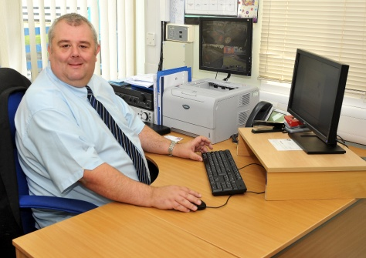
Dear applicant,

A warm welcome to Mossfield Primary School!

We hope that you will find this information useful in deciding whether to apply for a post at Mossfield Primary School.

We are extremely proud of our school and its well-ordered and harmonious community. We believe strongly that school should be fun (for staff as well as children! ) and that each child has the right to be encouraged and nurtured to reach their full potential. We provide a broad and stimulating curriculum within a friendly, happy and secure environment.

We recognise that appointing a person for a job vacancy is in fact a two way process – We must be sure that the successful candidate meets our criteria and will fit in well. Equally, you must be sure that the post you take on is right for you and that you will be happy in your future career. Nobody wants to work with somebody who is not happy in their work!

To assist you in deciding if Mossfield would be the right place for you, please could I suggest you take a look at our website. It has a wealth of recent information about the school and give a flavour of what it is like to work or study here.

Website - http://www.mossfieldps.salford.sch.uk/

We look forward to meeting you soon!

Yours sincerely,

Mr D Magee
Headteacher
Mossfield Primary School
Safeguarding Statement

Mossfield Primary School is committed to the safeguarding of all its pupils, staff and visitors.

Safeguarding is a priority with arrangements in place to ensure pupils feel, and are safe on school premises and during off site activities.

The pupil experience and individual achievement are paramount and safeguarding initiatives are developed to impact positively upon this.

The school ensures safeguarding legislation and guidance are adhered to and taken into account when developing and revisiting policies, procedures and associated arrangements.

The school provides a safe physical environment for its pupils and staff, ensuring that premises are of a good standard.

Health and Safety arrangements are in place to ensure adherence to current legislation and guidance.

Applicants will be subject to recruitment and selection procedures designed to emphasise the school’s commitment to the safeguarding of its pupils and staff.

The procedures include questioning at interview stage, verification of appropriate qualification, acquiring references and necessary safety checks.

The school has a ‘Designated Safeguarding Lead’ responsible for child protection, supporting staff in carrying out their safeguarding duties and working closely with other services.

The school has policies and procedures in place to deal effectively with child protection and safeguarding issues together with recording and monitoring processes.

It is a condition of employment that all staff are trained to a level appropriate to their safeguarding responsibilities.

The school’s commitment to safeguarding is paramount to the success of the learners.

School governors, senior management team and the ‘safeguarding working group’ will continue to keep abreast of developments in this area and implement arrangements to continually improve the safety and awareness of its pupils, staff and volunteers.

