Deputy Manager
Service: |  | People | Grade: | 3C |  |  | Salary: |  |  | £29,636 - £32,029
Reporting to: |  | No Wrong Door Team Manager | Location: | South Locality |  |  | Hours: |  |  | 36 hours per week
About the role |  |  |  |  |  |  |  |  | Our priorities
- You will contribute to the development of the service, embedding the vision and culture that generates commitment to the No Wrong Door way of working, helping to ensure that services are responsive to the needs of service users and their families / carers.  - You will deputise for the Unit Manager in their absence, undertaking all the day to day responsibilities of the Unit Manager  - You will be directly involved in the care and development of young people, making sure that they have appropriate plans in place, they know their options and their views are listened to.  - You will know what services and resources are available to support young people and their families /carers sharing this with the team.  - You will contribute to the recruitment, training and development of staff, including induction, ongoing training, appraisals / PDR’s, training audits, and learning and development plans.  - You will develop and maintain positive working relationships with staff and other professionals, young people and their families / carers, communicating well at all levels, showing consideration, concern and respect for other people’s feelings, opinions and differing needs and viewpoints.  - Working alongside the manager, you will provide a safe nurturing environment, ensuring that risk assessments are carried out and requirements are adhered to.  - You will keep up to date with policies and procedures, legislation and new initiatives, ensuring that all staff are aware of their responsibilities.  - You will have good analytical skills, making effective and timely decisions when required by seeking all possible relevant information, consulting appropriately, probing the facts and analysing information from different perspectives.  - You will build effective relationships with children, young people, adults and families by regularly reviewing client / carer needs and provide appropriate interventions to ensure that all services contribute effectively to the overall care plan.  - As required, you will have the ability to react to immediate problems of a highly complex nature, managing conflict and able to deliver immediate solutions sometimes under extreme pressure.  - You will establish and maintain personal and professional boundaries. |  |  |  |  |  |  |  |  | 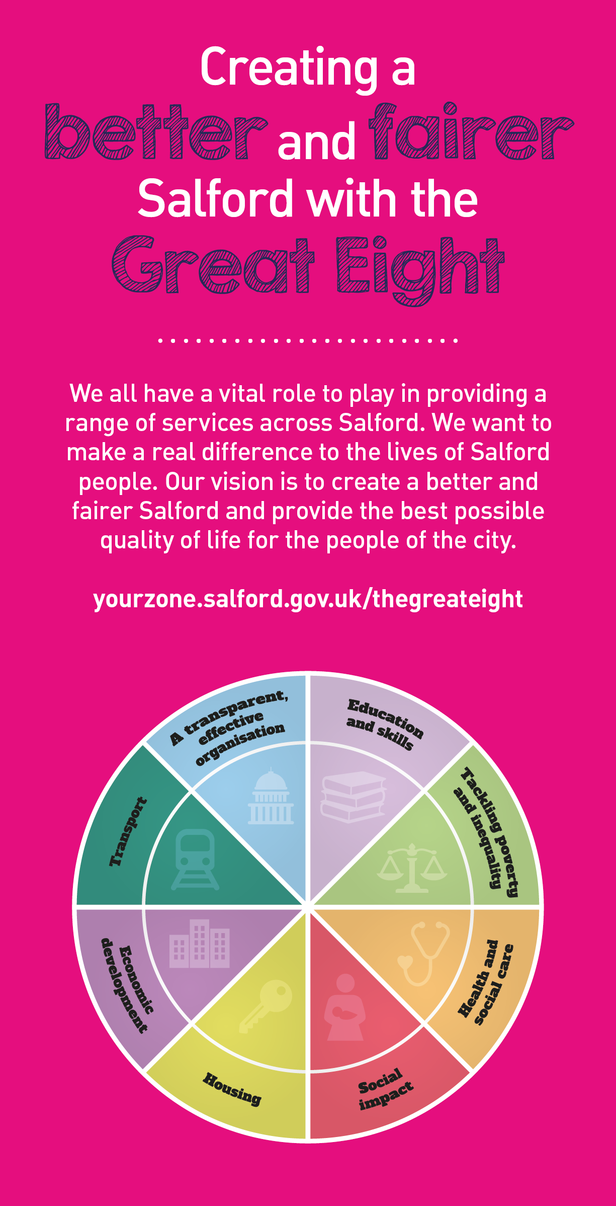
 | Key outcomes
 | - Alongside the Manager, you will offer advice, support and guidance to adults, carers, families and children in need. Working as part of a multi agency team you will display a genuine commitment to the needs and welfare of vulnerable children and adults to ensure the best outcomes for them.  - You will work co-operatively with others by readily sharing ideas, information and knowledge, enabling full participation in assessment, planning, review and decision making. You will co-operate and work well with other professionals in pursuit of goals by sharing information, acknowledging contribution and supporting others.  - You will ensure that the safety and welfare of children, young people and vulnerable adults that you come into contact with during the course of your professional duties is paramount at all times, responding appropriately to signs of harm, abuse and neglect and managing risk appropriately. |  |  |  |  | - You will support, encourage and motivate young people ensuring that every young person becomes a confident, resilient adult by focusing on building strong relationships, developing resilience, learning life skills and exploring opportunities to help them achieve their goals.  - You will ensure that young people are involved in discussions and decision making, ensuring that co-design and young people’s voice is core to all aspects of delivery.  - Alongside the Manager, you will ensure that the service operates at the highest standard, providing highly responsive care, built on trusting relationships.  - As part of the management team you will manage a 24 hour service, providing leadership and guidance to the multi-agency team as required, supervising and deploying staff effectively to provide the necessary support and interventions, and making key decisions to contribute to the overall goals to reduce the number of young people coming into care, and presenting at A&E.
 | What we need from you
- You must hold a Level 4 Diploma in Care and a Level 4 in Leadership and Management or equivalent (or willingness to undertake).
- Previous relevant experience of working with children/adolescents and families with complex needs who present high risk.
- Previous supervisory / management experience
- Enhanced DBS clearance
- Models and demonstrates our values and leadership behaviours.
- Commitment to the No Wrong Door Multi- agency approach, proactively supporting young people and their families / carers to ensure the best outcomes for them.
- You will undertake formal supervision of staff as directed by the Manager and contribute to the induction and ongoing training and development of new staff.
- To take responsibility as agreed with the Unit Manager for specified significant areas of work in the Unit.
- Ability to confidently and accurately assist with all duties relating to the financial management and administration of the Hub.
- Demonstrate excellent knowledge of Trauma Informed Approach and Restorative Practice.
- You will be able to demonstrate awareness of relevant legislation and implement / adhere to it as appropriate.
- Detailed knowledge of National Minimum Standards, Children’s Home Regulations and Safeguarding Frameworks.
- To keep informed of changes to legislation, practice and policies and disseminate as appropriate to the staff team.
- Contribute to the delivery and review of the Hub’s Statement of Purpose.
- To ensure that there are robust effective systems in place which provide suitable evidence to Ofsted and HMI inspectors and wider Council inspections.
- You will ensure quality assurance across the service and deliver against key performance targets, providing reports as necessary.
- To be responsible for the preparation and implementation of the rota which provides as necessary appropriate staffing cover for the service at all times. To work on that rota as necessary, taking an appropriate share of evening and weekend shifts to ensure that leadership in the unit contributes to high standards and continuity of care at all times.
- Willingness to flexibly work outside of standard office hours as required by the needs of the service
- To sleep in as and when required.
- You will need to demonstrate problem solving skills and the ability to find innovative solutions
- Ability to communicate equally, appropriately and effectively with the widest range of individuals and groups across all sectors and levels of society.
- You will have a good level of competency in basic computer skills including the use of Word, databases, the internet and email having regard to the GDPR and associated policies.
- You will ensure that all information received and disseminated, whether verbal or written, concerning all employees, prospective employees or clients, is treated in the strictest confidence, and that all such information held is regulated and controlled in a similar manner.
- You will carry out your duties to the highest standard, with full regard to the City Council's and service’s Policies, procedures, protocols and Code of Conduct.
- You will actively promote equality by identifying potential for discrimination and challenging inequality in all circumstances. Through personal example, open commitment and clear action, you will ensure diversity is positively valued.

Our leadership behaviours |  |  |  |  | Our values
As a values-based leader you will:  - Model the values and embed them in the way your team delivers services  - Hold people accountable for delivering the values  - Respect and care for others, treating everyone fairly, recognising the importance of ensuring equality of opportunity for all, and listening and acting on the things people say  - Be honest, taking responsibility for your actions and decisions  - Use resources that you are trusted with wisely. |  | To lead and develop people you will:  - Listen to understand, not to defend  - Give people the freedom to use their initiative  - Provide opportunities for people to discuss and solve problems and issues  - Regularly provide coaching and support to others to help them achieve their objectives and potential  - Appreciate and build on people’s strengths  - Motivate, engage, encourage and inspire others in order to be the best they can be.
To create a performance and development culture you will:  - Be visible, inject pace, vigour and purpose  - Expect high standards; mediocrity is not acceptable  - Take an evidence and whole system approach in making decisions  - Maximise technology and models to deliver quicker, easier, better services  - Have a digital mindset, fully utilising digital systems and solutions to deliver services differently  - Set context and challenging goals that will motivate people to take ownership, maximise performance, and develop. |  | To build and communicate a vision for the future you will:  Be optimistic and ambitious for the city and its people, helping others to understand the need to transform public services  Build strong collaborative relationships to find creative ways to make services more sustainable and flexible  Recognise and values the strengths of people and places, taking a strengths-based approach to make the most of opportunities  Support people through change, in undertaking new things, and taking risks  Take a place and whole system approach in designing, delivering and leading services  Ensure an inclusive approach with the aim of reflecting the increasing diversity of Salford.

Application guidance

We are a values based organisation so reflecting our values or a values based approach in your evidence will support your application.

The ‘Key outcomes’, ‘What we need from you’ and ‘our leadership behaviours’ sections of the Role Profile are there to give you an understanding of what we would like to see reflected in your application. Don’t give up if you are not able to reflect all of these in your application.

