Job specification
Job title: | Caretaker (Primary Sector)
Service: | MetroFresh
Grade:  Salary Range: | G3  £15,613 to £17,167
Reporting to: | Client Manager

Your job
MetroFresh provide a range of services to our schools across the borough, including the effective delivery of caretaking services.

You will undertake caretaking duties including basic repairs, daily and emergency cleaning and deep cleans during school holidays.

You will be responsible for opening and closing the school building as required ensuring security and correct use of the alarm systems.

You will take regular inspection of the grounds and buildings and take the appropriate actions to maintain health and safety and report any unsafe hazards and practices to the Headteacher or Business Manager.

You will liaise with outside contractors working within the school site under the direction of the Headteacher.

In this job you will
On an on-going basis you will:

- Ensure that all work is completed within specific timescales.
- Promote a welcoming and friendly environment to children, staff and visitors to the school.
- Comply with relevant quality assurance standards and adhere to the policies and procedures of the school and the service.
- Report any matters arising in relation to repairs & maintenance to the Headteacher and deal with any problems encountered with external contractors.
- Maintain adequate supplies of all chemicals and consumables to maintain correct stock levels.
- Adhere to health and safety working practices ensuring your own personal safety and that of others.
- Work with other team members and colleagues to develop and maintain effective working relationships.
- Be available to attend meetings for example Listening into Action, Staff Engagements and take part in staff surveys and My Time.

In this job you will need
You must be able to demonstrate the following essential requirements:

- Understanding of the principles of good customer care.
- Knowledge of caretaking and cleaning principles.
- A willingness to undertake training relevant to the job.
- Basic numeracy and literacy skills and good level of oral and written skills.
- Good communication skills.
- To have a passion to do your best.
- To be able to lift heavy equipment.
- Ability to use your initiative and without supervision, at times on your own and as part of a team.
- Willingness to work flexibly around the school day to meet the needs of the school including evenings and weekends if required.

Our culture
For us, it’s not just about all we achieve as an organisation, but how we do it. Therefore, all employees are expected to display our Be Wigan behaviours.
Be Positive… take pride in all that you do

Be Accountable… be responsible for making things better

Be Courageous… be open to doing things differently

Individuals with line management responsibilities are also expected to …
Inspire…lead by example and help others to see the big picture

Care… show genuine concern for people as individuals and value their contributions

Engage… I connect with others both within and beyond the organisation

Staff Deal
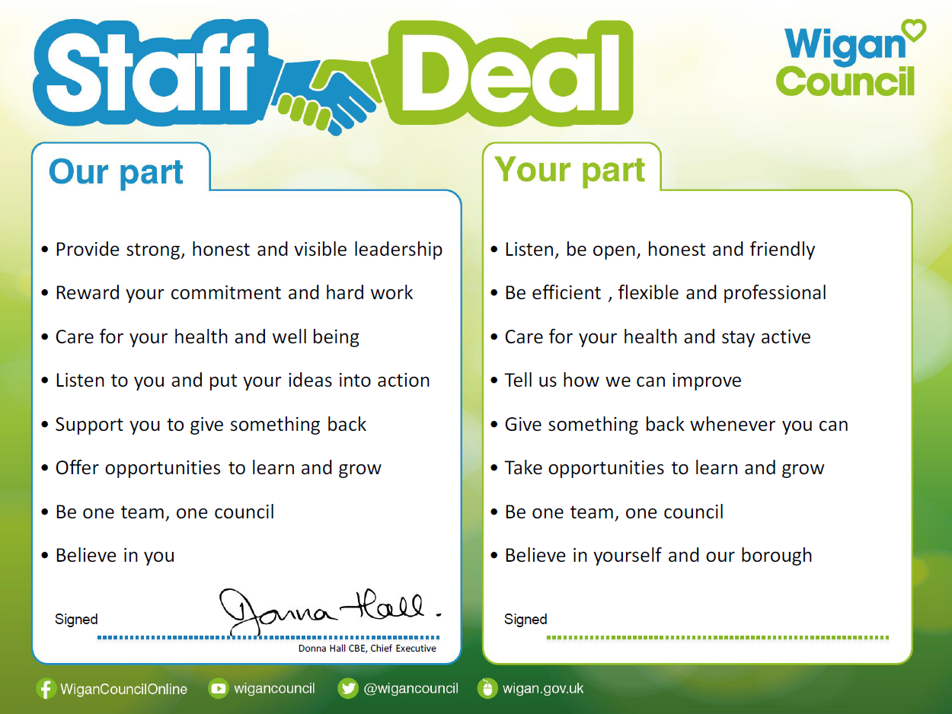
Our Staff Deal is an informal agreement with all staff. It outlines what you can expect from us, and in return what we expect from you

