Regulatory Services Officer
Service: |  | Public Health (COVID) | Grade: | 4B |  |  |  | Salary: |  |  | £35,934 to £38,813 full-time
Reporting to: |  | Director of Public Health | Location: | Flexible |  |  |  | Hours: |  |  | Part-time of Full-time up to 36 hours
About the role |  |  |  |  |  |  |  |  |  | Our priorities
- To assist in the procurement, monitoring and delivery of assigned tasks both individually and as part of formal and informal teams.  - To undertake all duties in full accordance with the relevant procedures and standing orders, ensuring that all relevant financial and statutory matters are dealt with promptly.  - To lead on specific elements within a focused area of work and work across other areas as required. The post holder will provide coaching, guidance and constructive challenge to colleagues as needed.  - To provide in-depth advice to Lead Practitioner, colleagues and customers on technical and regulatory issues relating to the area of work.  - To be alert for and highlight to the Lead Practitioner any emerging trends or patterns which may impact on the operational work of the Service and/or need to be addressed at a policy or strategic level.  - To collate and seize all types of relevant evidence, conduct interviews, issue warnings and notices to facilitate the fair and proportionate use of enforcement powers and, where necessary, to secure positive outcomes from any subsequent legal proceedings.  - Prepare and collate detailed case and prosecution files for submission to the legal team and where appropriate attend Court, Civil hearings, Tribunals and Public Inquiries and present necessary evidence, where appropriate give support to witnesses/victims.  - To give detailed technical support and advice and assistance to internal and external colleagues to secure the completion of agreed work programmes.  - To attend relevant meetings with other Directorates, or outside bodies as required, to promote the objectives of the Service and the City Council.  - To communicate effectively and appropriately with all stakeholders to ensure their understanding, engagement and involvement with relevant work programmes and projects including providing technical information relating to the officer’s area of work that is accessible and understandable.  - Appropriately apply technical knowledge and experience to real world situations with a view to ensuring compliance with relevant minimum standards and the promotion of established best practice; by supporting stakeholders in problem solving and encouraging excellence. |  |  |  |  |  |  |  |  |  | 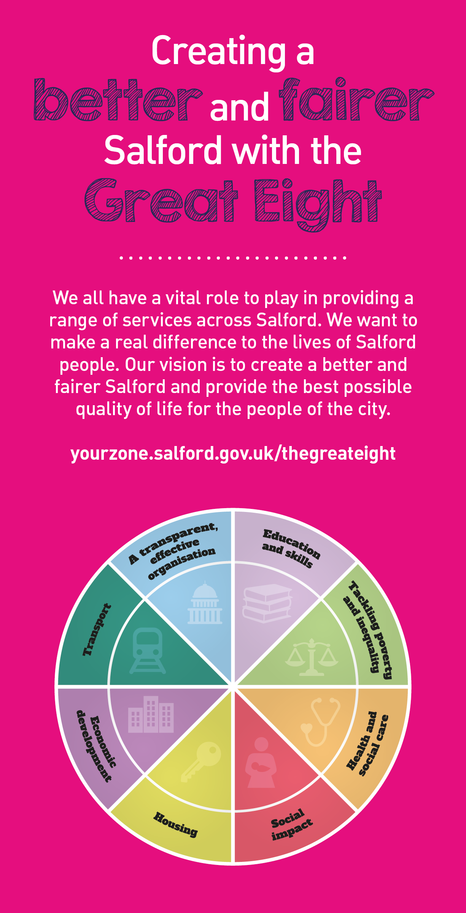
 | Key outcomes
 | - Contribute to the delivery of the service’s functions to protect and promote the health, safety and wellbeing of residents and visitors to Salford, and to support the maintenance and growth of Salford’s economy by working with businesses, consumers, service providers and other stakeholders to ensure that they can engage in trade, access services and accommodation in safety and with confidence.  - Assist Lead Practitioners and Service Managers in developing operational solutions to area based and thematic challenges across Regulatory Services in order to meet the aims and objectives set out in the City Councils Values, Strategies and Directorate Business Plan. |  |  |  |  |  | - You will ensure compliance with relevant minimum standards and promote improvement and the adoption of best practice by stakeholders.  - You will identify new opportunities for income generation and maximise take up on existing income generation schemes.
 | What we need from you
 | - Proven technical skills and ability in the role with a record of accomplishment for delivering outcomes.  - Professional credibility through proven relevant experience.  - To model and demonstrate our values and behaviours.  - Extensive and in-depth level of knowledge of relevant legislation and technical matters including practical application at a level commensurate with the skill area the post is within.  - Excellent interpersonal and communication skills to effectively carry out the role.  - To demonstrate the required competency requirements necessary to effectively carry out this role within the specific service area.  - The ability to research, gather and analyse information and evidence from a wide range of sources. Draw reasoned conclusion, identify options for action and where asked, to make appropriate recommendations. Updating and maximising computer systems and keeping accurate records. |  |  |  |  |  | - Excellent literacy, numeracy and digital skills to a standard acceptable for the institution of legal proceedings where necessary.  - Ability to deliver projects, solving problems in innovative ways and operating on own initiative with minimal direct supervision within established policy frameworks.  - Ability to use critical thinking and coaching, guiding and providing constructive challenge to support the thinking and development of colleagues.  - Ability to access and inspect all areas of the city in a timely manner. This will include a range of buildings and properties including accessing uneven ground, including calibration and maintenance of equipment.  - A demonstrable track record of working with a comprehensive range of stakeholders such as customers, agencies, elected members, community groups and third sector organisations. Including an understanding of various services and referral pathways available to customers.  - The ability to be assertive in a way that is appropriate, fair and proportionate.
What we can offer you
Your ongoing professional development and success in your role is important to us, and that is why we provide a variety of learning and development opportunities. Within the sections below you will find development options tailored to you which will enable you to further develop your existing skills and learn new ones at a pace that suits you best. If you are joining us now, your development will form part of ongoing discussions with your manager. If you are an existing employee, you should use your Personal Development Reviews to discuss your development with your manager and create your development journey. It’s important you also take full advantage of any informal learning available to you during the course of your work, including coaching, mentoring and shadowing. Please discuss these options with your line manager.

- Online Learning - Develop your knowledge across a wide range of areas through our Me-Learning platform, with over 200 free courses to choose from. To have the best possible start and comply with current legislation, you must complete the following modules: Welcome to Salford, Health and Safety in the Office, GDPR, Equality Essentials, Safeguarding Children and Adults, and Safer Recruitment. You may also benefit from a variety of courses in categories such as Business Skills, IT and Project Management which are available to learn at your own convenience and pace.  - Developing your digital skills – Our ambition is to provide our workforce with the right level of digital capabilities needed to be successful. Whatever your current digital abilities are, we can provide development ranging from essential workplace skills to specialist workplace skills’. These will be delivered through our Digital Skills Academy using both self-directed and guided learning opportunities to enable you to develop. Additionally, you can access free online courses through the iDea website. |  |  |  |  |  | - Professional Development – Gain role specific skills and time to learn through a wide range of development opportunities. Learn whilst working and get support towards your qualification through an apprenticeships standard. Access professional development ranging from entry level to master’s type qualifications, including achieving a role appropriate qualification. Details can be found on the Institute of apprenticeships website.  - Sharing your digital skills – Our goal is to support you to share your digital knowledge with other people. Our Digital Eagles programme has been designed to cover basic digital skills and build your confidence to assist others. By the end of this programme you will join hundreds of staff members who already are digital eagles, and be able to help colleagues, customers, residents, or people in your personal life with all things digital.

Application guidance |  | Our values
We are a values based organisation so reflecting our values or a values based approach in your evidence will support your application.

The ‘Key outcomes’, ‘What we need from you’ and ‘our leadership behaviours’ sections of the Role Profile are there to give you an understanding of what we would like to see reflected in your application. Don’t give up if you are not able to reflect all of these in your application.

Click here to enter text.

