Head of Planning
Service: |  | Place | Grade: | Band G |  |  | Salary: |  |  | £58,349 - £62,976
Reporting to: |  | Assistant Director Regeneration | Location: | Civic Centre |  |  | Hours: |  |  | 36 hours per week
About the role |  |  |  |  |  |  |  |  | Our priorities
- To represent the City Council as its Chief Planning Officer.  - Head of Service responsible for the Spatial Planning and Environment and Climate Change teams  - Provide strong leadership and clear direction as client lead to the Development Management and Building Control teams (returning to the City Council from Urban Vision February 2020); acting as the GM client for the Minerals and Waste Planning and Archaeology teams currently with Urban Vision and Salford University respectively.  - Play an active part in the development of planning work at a GM level, including the development and review of the Greater Manchester Spatial Framework and other plans/strategies  - Instil an entrepreneurial spirit to deliver on the City Mayor’s priorities for our City  - Lead, inspire and provide senior management support to employees within the division, motivating and supporting them to attain the highest professional standards, skills, knowledge, attributes and competencies required to fulfil their duties  - Work with the Heads of Development and Investment and encourage close liaison between the Infrastructure and other Regeneration teams to maximise the opportunities to deliver growth within our City.  - Provides senior management support to employees within the division, motivating and supporting them to attain the highest professional standards, skills, knowledge, attributes and competencies required to fulfil their duties.  - Provides strong leadership and clear direction to the division to achieve transformational change and co-ordinate the effective delivery of services  - Works closely with elected members and senior leadership to ensure the effective delivery of services in line with the City Mayor’s and City Council priorities  - Provides visible, strategic leadership for the division as part of the Regeneration Senior Management Team and Leadership team within Place, and embodies the City Council’s Leadership Framework  - Contributes to the overall leadership and management of the service through proactive engagement with the Senior Leadership Team  - Ensures effective people management across the division, encouraging a positive employee relations climate and active employee engagement and trade union consultation  - Ensures appropriate arrangements are in place for preparing and monitoring budgets and associated income for the division and adheres to the standing orders and financial arrangements of the Council  - Through personal example, commitment and action develop an inclusive, supportive and constructive environment where everyone is treated with dignity and respect and diversity is valued in the workplace, in service delivery and communications  - Ensure the Council meets its legal and statutory obligations for the service’s areas of responsibility. |  |  |  |  |  |  |  |  | 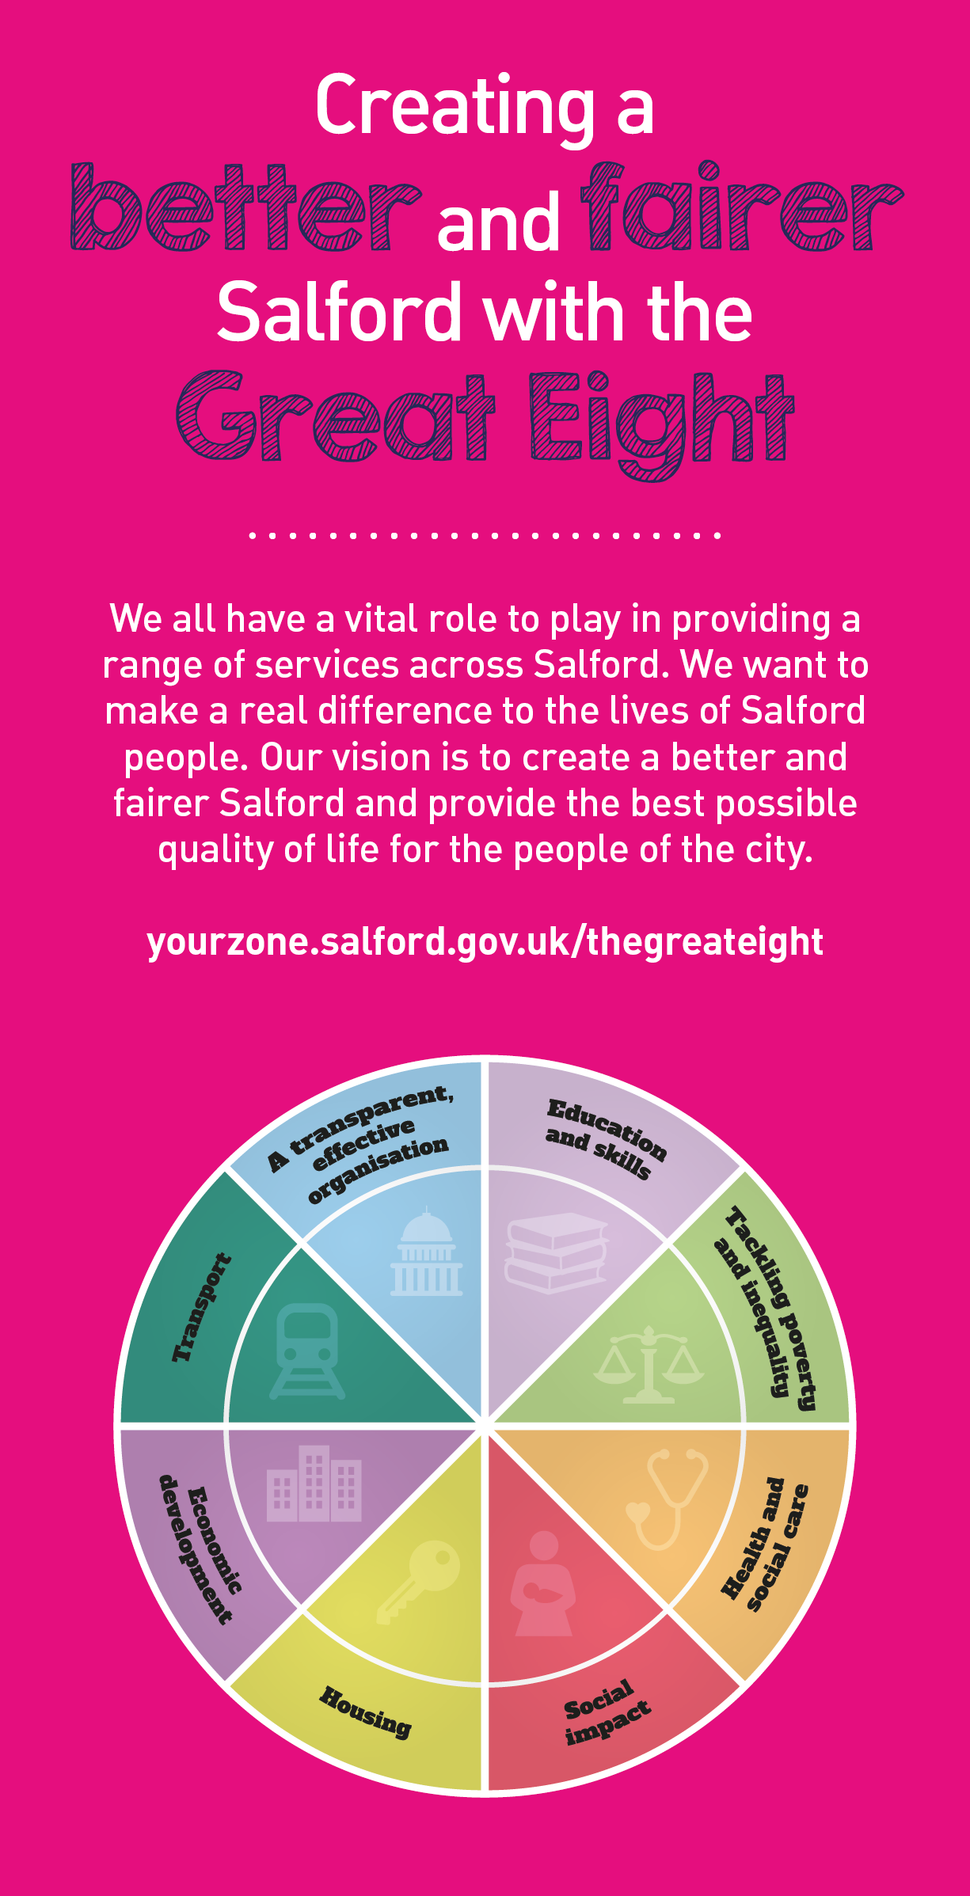
 | Key outcomes
 | - To secure the preparation, adoption, monitoring and review of the Council’s Local Plan and Supplementary Planning Documents, guidance and advice, and to contributing to joint work on statutory and non statutory spatial plans and strategies at Greater Manchester level.  - Contribute positively to the continued growth of the City whilst preserving the City’s natural, cultural and historical assets including the delivery of the Council’s statutory heritage functions in relation to conservation and listed buildings.  - Implement the Council’s commitment to reduce carbon and climate change mitigation.  - Drive forward the development of environmental policies and initiatives which support the Council’s climate change and green infrastructure agenda, including our commitments at Greater Manchester level and through the implementation of policies set out in the GMSF and our Local Plan.  - To oversee the administering of Section 106 contributions, and ensuring that those contributions are directed at projects in a timely manner, and in accordance with adopted policies.  - To display a high level of professional competency, maintaining a thorough and up to date knowledge of legislation and guidance and apply this to ensure legally sound, quality and robust recommendations and decisions to the Council in the capacity of Chief Planning Officer in accordance with legislation and the Council’s constitution.  - To provide accurate and balanced advice to the Council on planning issues including attendance at Council Committees, Member working groups, resident and business forums, partnerships and internal project groups.  - To advise the public, developers, other professional groups, organisations and individuals and other Council Services, Members of the Council and Members of Parliament on planning issues and procedures offering advice and guidance, including the initiation of correspondence, on such matters in accordance with Service and Council policies and objectives. |  |  |  |  | - Develops and maintains a team with the capacity and technical capability to deliver projects and develops a culture that promotes innovation and creativity in delivering the planning service.  - Provide support to our partners across the City in achieving our inclusive growth priorities, including both public sector partners and private sector business and development partners.  - Puts effective performance management processes in place and routinely monitors them to secure continuous improvement in the services provided, and to address any issues that may affect service delivery.  - Co-ordinating the City Council’s responsibilities as lead local flood authority under the Flood and Water Management Act 2010.  - Along with the Assistant Director of Regeneration and Place Senior Leadership Team, produces an annual business plan so that all Place work programmes are aligned with the Council’s political priorities and that resources are made available to deliver them within established budget. To be responsible for staff recruitment and development in accordance existing people policies and procedures.  - To ensure the Council’s Code of Conduct for Members and Officers dealing with planning matters is fully complied with and response to any complaints in accordance with established protocols.  - Support the Assistant Director of Regeneration and Place Senior Leadership Team in the transition of planning services from Urban Vision back into the Place Directorate.

What we need from you
- Achiever – Proven technical skills and ability to lead programmes to deliver working collaboratively with others.  - Assured – Professional credibility, able to engage with authority and express what is needed; demonstrate initiative, confidence and personal responsibility for action.  - Flexibility – Demonstrate the skills needed to work collaboratively across a range of partners in a contractual/partnership and collaborative setting.  - Leader – Plan, monitor, and review the budgets, programme and pipeline, ensuring appropriate governance to ensure that projects are provided within budget and show value for money, and that all applicable grant funded budgets and other Local Authority budget areas are effectively managed. Ensuring that project variance and risk is reported and managed appropriately  - Solution Seeker – Understand the local context and able to identify outcome focussed solutions to meet needs.  - Values Based – Model and demonstrate our values and leadership behaviours.  - Diplomat – Open to views of others - able to constructively challenge and be challenged.  - Resource Weaver – Able to build collaborative partnerships, bring together multi-faceted activities to improve performance and/or resolve business critical issues.  - Healthy Approach to risk – Able to confront problems, take calculated risks, have difficult conversations and consider a range of options. |  | - Motivator – Experience of developing teams to achieve their maximum potential. Develop and maintain a workforce with the capacity and capability to deliver Place priorities and develop a culture that promotes innovation and creativity in service transformation and delivery.  - Tenacious – Experience of driving forward multiple large projects in challenging circumstances.  - Conscientious – Balanced and comprehensive thinker, able to combine self-discipline, an organised approach to work, and innovative practice.  - Technically proficient (experience) – Evidence of significant expertise and knowledge in contributing to strategy development and reviewing operating models and developing and implementing improvements.  - Technically proficient (skills/knowledge) – Able to prepare and deliver reports translating complex data and information, understanding of technical and regulatory environment.  - Astute – Able to work in and understand the political environment and effectively manage political and reputational risks.  - Adjusted – Able to deal with pressure and healthy stretch without affecting others.  - Story Teller – Able to focus on priorities, present succinctly and translate complex ideas and information into meaningful and ‘user friendly’ information; ‘tells the story’ to bring people along and ensure all audiences understand the key messages.

Our leadership behaviours |  | Our values
As a values-based leader you will:  - Model the values and embed them in the way your team delivers services  - Hold people accountable for delivering the values  - Respect and care for others, treating everyone fairly, recognising the importance of ensuring equality of opportunity for all, and listening and acting on the things people say  - Be honest, taking responsibility for your actions and decisions  - Use resources that you are trusted with wisely |  | To lead and develop people you will:  - Listen to understand, not to defend  - Give people the freedom to use their initiative  - Provide opportunities for people to discuss and solve problems and issues  - Regularly provide coaching and support to others to help them achieve their objectives and potential  - Appreciate and build on people’s strengths  - Motivate, engage, encourage and inspire others in order to be the best they can be
To create a performance and development culture you will:  - Be visible, inject pace, vigour and purpose  - Expect high standards; mediocrity is not acceptable  - Take an evidence and whole system approach in making decisions  - Maximise technology and models to deliver quicker, easier, better services  - Have a digital mindset, fully utilising digital systems and solutions to deliver services differently  - Set context and challenging goals that will motivate people to take ownership, maximise performance, and develop |  | To build and communicate a vision for the future you will:  - Be optimistic and ambitious for the city and its people, helping others to understand the need to transform public services  - Build strong collaborative relationships to find creative ways to make services more sustainable and flexible  - Recognise and values the strengths of people and places, taking a strengths-based approach to make the most of opportunities  - Support people through change, in undertaking new things, and taking risks  - Take a place and whole system approach in designing, delivering and leading services  - Ensure an inclusive approach with the aim of reflecting the increasing diversity of Salford

Application guidance

We are a values based organisation so reflecting our values or a values based approach in your evidence will support your application.

The ‘Key outcomes’, ‘What we need from you’ and ‘our leadership behaviours’ sections of the Role Profile are there to give you an understanding of what we would like to see reflected in your application. Don’t give up if you are not able to reflect all of these in your application.

