Principal Planning Officer – Development Management
Service: |  | Development Management | Grade: | 4C |  |  |  | Salary: |  |  | £38,813 - £41,675
Reporting to: |  | Planning Group Leader | Location: | Salford Civic Centre, Swinton |  |  |  | Hours: |  |  | 36
About the role |  |  |  |  |  |  |  |  |  | Our priorities
- As a principal planning officer you will manage a caseload which will be almost exclusively made up of large scale major developments and complex planning and related applications (e.g. new build housing (above 50 dwellings), commercial development (above 2500sq.m floorspace), high rise tower developments, complex mixed use schemes, large scale regeneration projects) and produce concise, accurate, robust and timely reports and recommendations applying current legislation and policy changes as appropriate.  - Working as part of, and often leading, a multi-disciplinary team of officers to deliver on major project development.  - Undertake pre application discussions and provide advice on major and complex planning and related applications, being proactive and problem solving to achieve deliverable outcomes.  - Briefing the Chair of planning panel on casework to be presented to planning panel for a decision and presenting applications at panel meetings, including responding to questions from members of the panel.  - Preparing and presenting proofs of evidence, statements of common ground and other related appeal documents in preparation for Public Inquiries against the refusal of planning permission or use of planning conditions. Attendance at and presentation of case at Public Inquiry including being subject to cross examination of evidence.  - Ensure decisions are made within statutory timescales and records of discussions and negotiations with applicants or agents are kept up to date to prevent the return of the fee that accompanies a planning application.  - Negotiate, review and advise on details of complex legal agreements (s.106 agreements) including financial and benefit in kind contributions which can often be for up to and occasionally over £1million in value. As part of this have an excellent understanding of complex viability statements and be able to challenge developers on their case to deliver significant public benefits.  - Leading on service improvements to achieve cost efficiency and effectiveness whilst project managing your work to ensure KPI’s are met/exceeded in terms of timeliness and quality of output, adding value wherever possible.  - Leading on aspects of delivery and improvement of business management systems, procedures and processes.  - Providing supervision, guidance and support for junior colleagues to distribute knowledge, manage performance, and ensure contemporary planning issues and legislation are cascaded and understood.  - Review recommendations of planning graduates and make decisions on their applications under delegated authority on behalf of the council. |  |  |  |  |  |  |  |  |  | 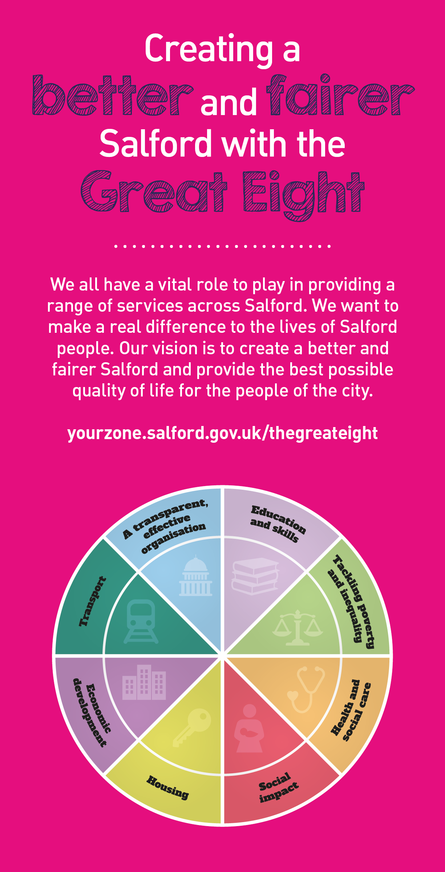
 | Key outcomes
 | - Contribute positively to the continued growth of the City whilst preserving the City’s natural, cultural and historical assets including the delivery of the Council’s statutory heritage functions in relation to conservation and listed buildings.  - Secure the delivery of high quality, sustainable development by improving the quality of proposals where possible.  - Contribute to an innovative, digitally driven service that focuses on the needs of its customers. |  |  |  |  | - Timely determination of planning and related applications so as to support the growth agenda of the Council.  - Display a high level of technical competence, maintaining a thorough and up to date knowledge of relevant legislation and guidance and apply this to ensure legally sound, quality and robust recommendations and decisions on planning and related applications.  - To give accurate advice on planning matters to applicants and their agents, members of the public, councillors and others as necessary.
 | What we need from you
 | - Proven technical skills and ability in the role with a record of accomplishment for delivering outcomes  - Professional credibility through proven relevant experience  - To model and demonstrate our values and behaviours  - Provides high quality, customer focussed timely and outcome based development management services  - Excellent level of ability to prioritise and manage a challenging workload  - Excellent technical ability and appropriate level of knowledge and understanding and application of current and emerging planning legislation |  |  |  |  |  | - Be concise and possess the ability to communicate effectively at all levels, be well organised and efficient, have a positive attitude, be proactive and solve problems to produce well balanced outcomes  - Negotiate and work positively with applicants and agents in order to find solutions and obtain high quality outcomes within given time constraints  - Have a planning degree and be eligible for membership of the Royal Town Planning Institute.  - Have a proven track record of successfully managing a caseload of large-scale and complex planning applications

Application Guidance |  | Our values
We are a values based organisation so reflecting our values or a values based approach in your evidence will support your application.

The ‘Key outcomes’, ‘What we need from you’ and ‘our leadership behaviours’ sections of the Role Profile are there to give you an understanding of what we would like to see reflected in your application. Don’t give up if you are not able to reflect all of these in your application.

