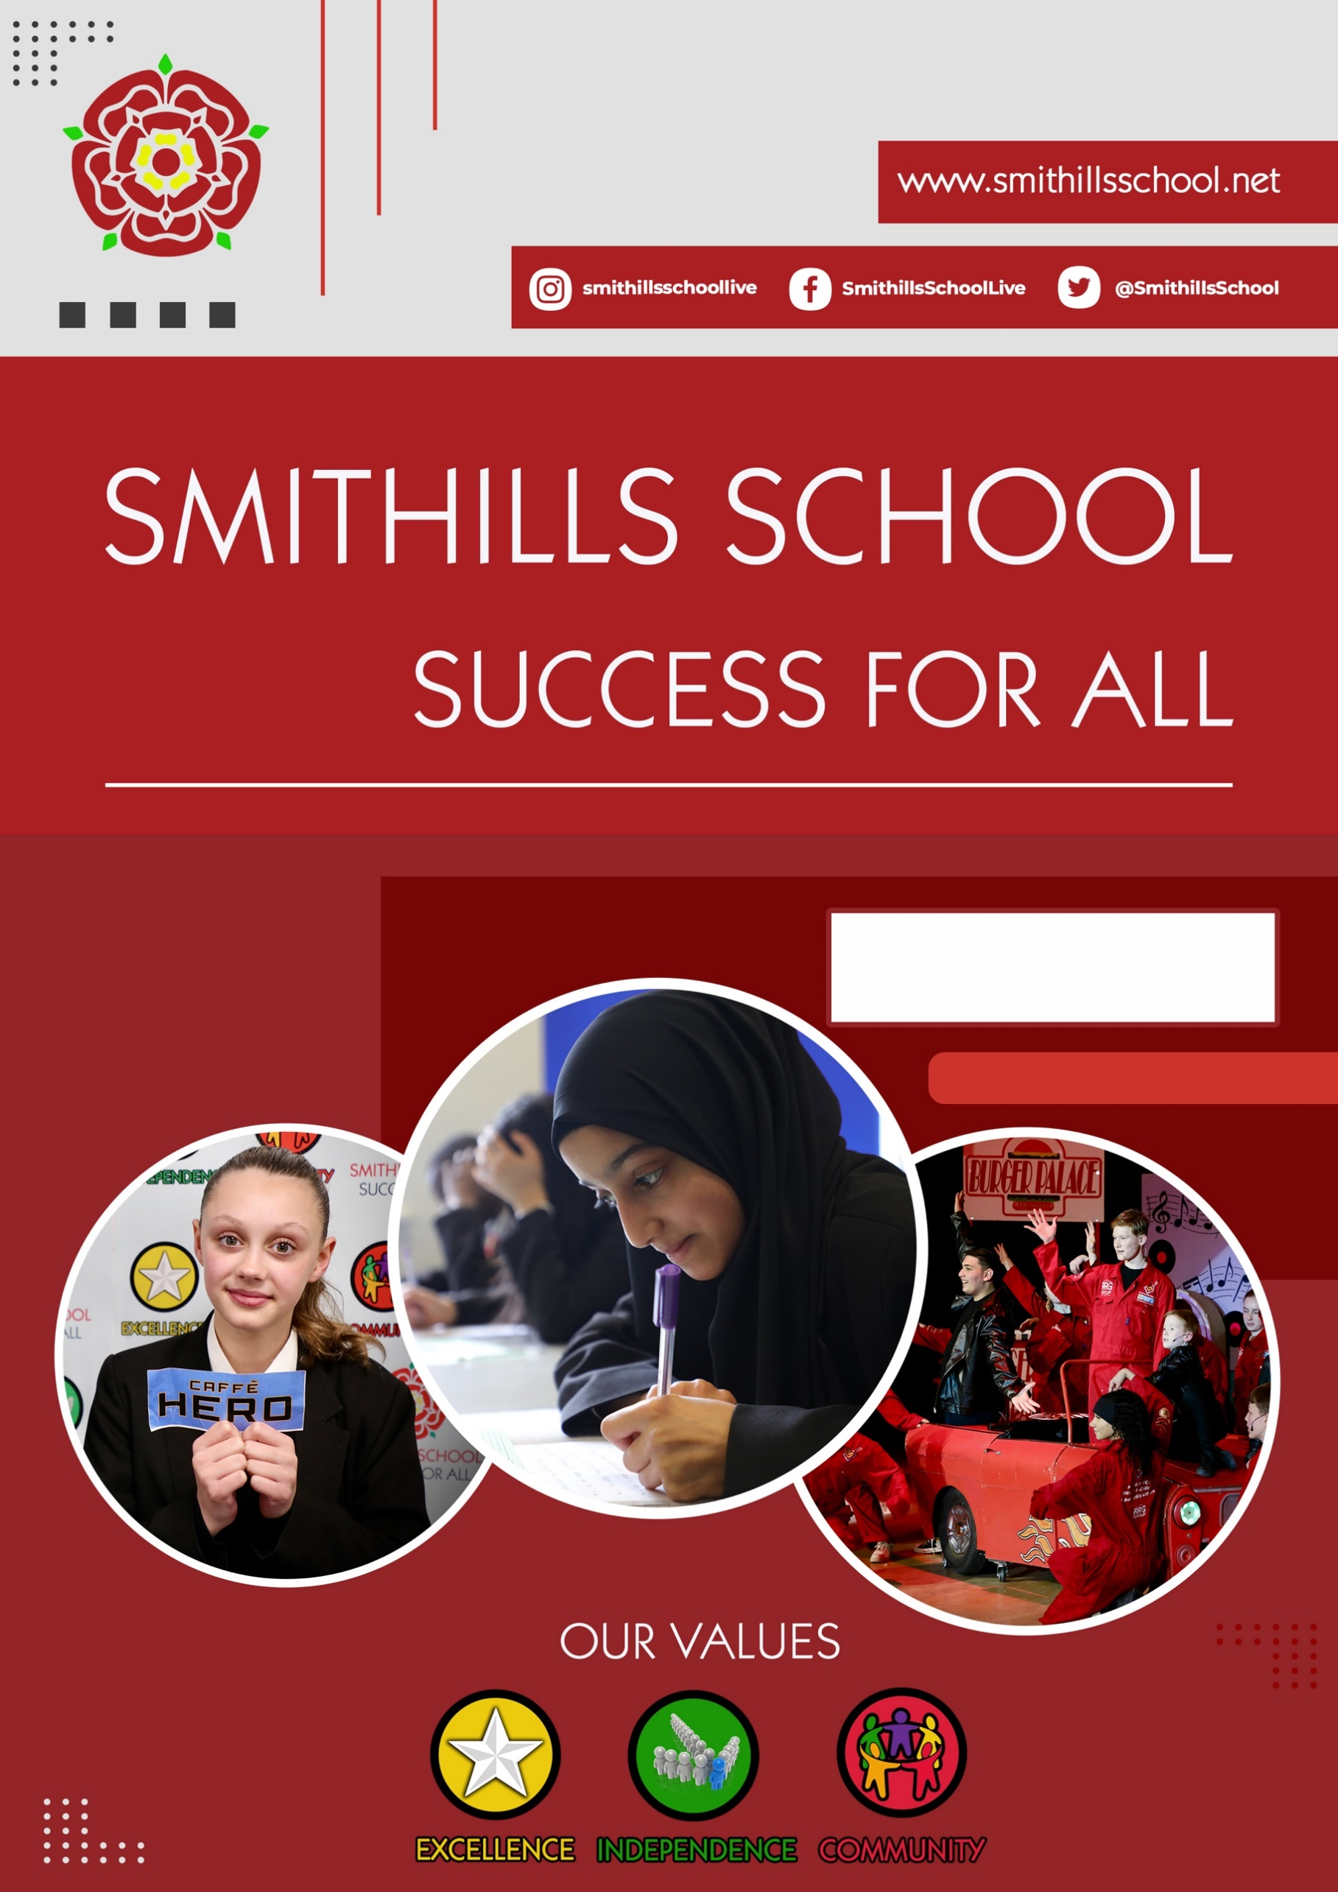

[Grab your reader’s attention with a great quote from the document or use this space to emphasize a key point. To place this text box anywhere on the page, just drag it.]

Leader of Pedagogy
In Mathematics
Candidate Information

Welcome to Smithills School
Thank you for expressing an interest in the position of Leader of Pedagogy in Mathematics. This is a wonderful opportunity to join our successful, over-subscribed 11-16 school at an exciting stage of our journey.
We are a large secondary school, a single Academy Trust, situated in the heart of Bolton. As Headteacher I am fortunate to work alongside our talented staff, pupils, families and community partners. Our school is a very special place where we respect individuality, diversity and difference. Every child who joins us is encouraged to achieve and every adult who joins our team is given the opportunity to contribute.
Our values of Excellence, Independence and Community are evident in all that we do. They combine to ensure our vision of ‘Success for All’ is achieved.
September 2023, two weeks into my headship, the school was judged as requires improvement for Quality of Education and Leadership and Management, but good for Personal Development and Behaviour and Attitudes. Ofsted commented ‘pupils are warmly welcomed and quickly settle into school life’, we have ‘high aspirations for pupils’ achievement’ and ‘staff feel happy and proud to work’ at the school. They remarked that we are on the right track with the changes we are making, we simply need more time to implement and embed them.

Our pupils are at the heart of everything we do. We are committed to developing and nurturing every child, providing the very best standards of education through a strong, knowledge rich curriculum, which is built around our expectations that all pupils will develop their depth of understanding across a wide range of subjects, securing an ambitious education for all. We also offer our pupils a wealth of cultural experiences, broadening horizons and developing self-esteem which provides them with the skills to make positive contributions to society, now and in the future.

We are committed to the continued professional development of all our colleagues and take our responsibility to develop leaders of the future seriously. We are equally committed to staff wellbeing: we provide a package of support to help all colleagues achieve a happy work life balance and we have a thriving wellbeing group that initiates real change in school.

If you are a dynamic, motivated, conscientious professional who has a passion for working with children and young people and you feel you have the skills and personal attributes to work as part of an innovative, energetic and ambitious team, we would love to hear from you.

Carolyn Dewse
Headteacher

Why work at Smithills?
As a team, we value every member of staff – from the site team to middle leaders, from teachers to SLT, from canteen staff to teaching assistants, from pastoral staff to IT support. We know that every person on our staff is crucial to the strategic development and the operational work of our school. As such, we promote well-being and prioritise manageable workloads in the following ways:
- SLT are supportive and highly visible around our site
- Teachers have their own classrooms
- We are committed to the Education Staff Wellbeing Charter
- Staff wellbeing is prioritised with free access to our swimming pool, gym, ‘Friday football’ and all sports centre activities during the week and at weekend
- The Staff Wellbeing Team includes broad representation from teaching and associate staff
- This team meets at least every half term, capturing staff voice and responding with concrete actions
- Teaching staff typically have above the national expectation of 10% of Planning, Preparation and Assessment (PPA) time
- Every teacher has a protected Professional Development hour every fortnight
- CPD is a regular feature of our calendar and includes teaching and support staff
- Opportunities for career development are embedded in our structures and systems
- Early Careers Teachers thrive in a supportive and caring environment. They have access to a broad and individualised programme of professional development
- As part of our commitment to continuous professional development all staff are encouraged and supported to undertake further study
- Internal applications for a range of roles are actively encouraged
- Data entry points are kept to a minimum for each year group
- Every department has high quality 5-year curriculum plans in place
- Departmental marking policies have been designed to actively reduce marking workload
- All teaching staff have an iPad/laptop
- The correction system is centralised
- Lunch duties are paid
- Reprographics is centralised
Most of all, though, we offer something which a bullet point list cannot capture: our staff and students are friendly and fiercely loyal to our school. Our school is a community and we are proud of that.
‘Leaders at all levels carefully consider the impact of any changes that they make to school systems which may affect the workload and well-being of staff’.

OFSTED
September 2023

We encourage you to come and see our school for yourselves. Please contact the Headteacher’s PA, Chris Shaw on 01204 842382 ext. 104 or c.shaw@smithillsschool.net to arrange an appointment. A member of SLT will be only too happy to show you around.
Closing date for applications: 9.00am on Monday 13th May 2024

Interview date: TBC

Job Description
Department | SMITHILLS SCHOOL
Job Title | Pedagogy Leader in Mathematics  Permanent
Salary Scale | Teachers Pay Scale plus TLR2A £7847 PA
Reporting to | Subject Leader and Nominated Senior Leader
Responsible for | Teaching and Associate staff within the department
Every member of staff at Smithills School is expected to maintain, support and promote the vision and values of the school in and through the exercise of all contractual duties and any voluntary activities.

MAIN RESPONSIBILITIES OF THE POST
The post holder is required to fulfil the professional responsibilities which are common to all classroom teachers in the school, as outlined in the current School Teachers’ Pay and Conditions Document. These detail the professional duties required of teachers, together with requirements for management time, working time, guaranteed planning, and preparation time. The school complies with these requirements in order to make reasonable demands of teachers.

The post holder’s key responsibilities will be to lead and manage pedagogy in the Mathematics Department, ensuring the highest quality curriculum, teaching and learning and, thus, the best possible outcomes for all learners

PROFESSIONAL RESPONSIBILITIES
The post holder will be expected to match the characteristics described in the Professional Standards for Teachers, as appropriate to his/her career stage, and will be required to exercise his/her professional skills and judgement to carry out, in a collaborative manner, the professional duties set out below. This post is covered by the School Teachers’ Pay and Conditions Document (STPCD) and the Burgundy Book Conditions of Service for School Teachers in England and Wales.

The main and professional responsibilities for this post assume those of a teaching post. In addition, the following apply:
Post-Specific Responsibilities In particular you will:
Assist the Headteacher in leading Smithills School in such a way that the highest standards are secured amongst staff and students in all areas of the school’s performance and practice
- Act as a role model for staff, providing support and advice to them whilst holding them accountable
- Lead on improvement strategies, coach and support staff, ensure quality, monitor and evaluate performance
- Contribute to all self-evaluation measures and lead on quality assurance processes within Mathematics
As Pedagogy Leader in Mathematics you will:
- Work alongside the Subject Leader to evaluate and review all aspects of the Department’s work as part of an annual cycle and action plan for all improvements needed
- Work alongside the Subject Leader to lead the Maths Department to meet all targets in the departmental action plan
- Lead on and evaluate the implementation of high-quality Schemes of Learning across the department
- Work alongside the Subject Leader and other TLR post-holders to lead on the quality of Teaching and Learning in the Maths Department, ensuring that all students are engaged and challenged in all lessons
- Scrutinise the progress of different groups of students in Maths, including the more able, disadvantaged children and students with SEND, and intervene to provide pedagogical strategies where necessary to ensure all learners can make at least expected progress and no child is left behind
- Ensure the teaching of reading, writing and communication is effectively incorporated into lessons across the Maths curriculum, actively equipping colleagues with a tool-kit to bring this about
- Actively identify and remove barriers to learning in the Maths Department including managing student behaviour within the department
- Hold Maths staff to account through Quality Assurance and Appraisal procedures
- Ensure all staff in the Maths Department access high quality professional development to support both individual and departmental needs
- Lead on professional development related to pedagogy within Maths
- Support the Subject Leader to monitor the impact of this and other professional development
- Support, manage and coach trainee and Early Career Teachers as required
- Create a happy, dynamic, innovative culture in the Department and ensure all staff are performing to at least a good standard and are happy and motivated in doing so

Other responsibilities
- Liaise and collaborate with peers in school and in other schools to share, disseminate and develop good practice, particularly linked to the dissemination of and training on powerful pedagogical strategies and approaches
- Comply with any reasonable request from a manager to undertake work of a similar level which is not specified in this job description
- Engage actively in the performance review process
- Be committed to continuous professional development
- Carry out any other reasonable duties as assigned by the Headteacher

The roles and responsibilities in this job description may change and/or evolve in a reasonable manner over time.

The post holder may reasonably be expected to undertake other duties commensurate with the level of responsibility that may be allocated from time to time.

Person Specification

The successful candidate must be able to demonstrate that he/she has the qualifications, experience, knowledge, abilities and personal qualities outlined below. References obtained about candidates will also be used in the assessment of their suitability for the post.

Essential | Desirable | Method of Assessment
Qualifications, Training, Experience
• A relevant degree and teaching qualification  • Qualified Teacher Status  • Post qualification professional development  • Experience as TLR holder / Assistant Subject Leader in Maths Department  • Evidence of outstanding classroom teaching  • Evidence of leading on department self-evaluation and assessment for learning  • Experience of effective use of data to challenge underperformance  • Proven record of raising standards  • Good prioritisation and time management skills | Experience of leading CPD and developing others, and of supporting colleagues at various professional stages | Application form, observed lesson and interview
Knowledge and Abilities
• To have detailed knowledge of the requirements of National Curriculum in Maths  • Knowledgeable with the planning and delivery of KS3 and KS4 Maths courses with a view to improving attainment and achievement  • Thorough knowledge of the most powerful pedagogical strategies and how to coach others to deploy these to significant effect  • The ability to use data, resources and initiatives to raise attainment for all students  • Evidence of using new initiatives successfully  • Proven interpersonal skills to form and promote positive relationships with staff, students, parents, external agencies  • Set high expectations for students and establish a clear framework for classroom discipline promoting good student relationships and independence whilst managing student behaviour constructively.  • Strong communication skills, particularly linked to sharing vision and taking colleagues with you  • The ability to manage the work of others and monitor and evaluate the quality of their work, including holding to account and coaching conversations to bring about improvement  • Work effectively as part of a team developing positive relationships with colleagues, students, parents and other agencies as appropriate.  • The ability to lead and use innovative ICT to facilitate learning |  | Application form, observed lesson and interview
Personal Qualities
• Ability to work under pressure, meet deadlines and remain calm  • Good time management and organisational skills  • Clear dedication to teaching as a career  • Energy and enthusiasm and a liking for work with young people  • Flexibility and an ability to respond creatively to changing circumstances  • Appropriate professional dress and appearance  • Sense of humour | Commitment to extra-curricular activities | Application form/ interview

Please note that this list of duties is illustrative of the general nature and level of responsibility of the role. It is not a comprehensive list of all tasks that the careers leader will carry out. The postholder may be required to do other duties appropriate to the level of the role.

Safeguarding
Smithills School is committed to safeguarding and promoting the welfare of children and young people and expects all staff and volunteers to share this commitment. Successful candidates are subject to an enhanced disclosure from the Disclosure & Barring Service.
Current or previous employers will be contacted as part of the verification process pre-appointment checks if the applicant is short-listed. Information requested will include:
- Disciplinary offences relating to children, including any which the penalty is “time expired”
- Whether the applicant has been the subject of any child protection concerns
- The outcome of any enquiry or disciplinary procedure

Any discrepancies or anomalies in the information provided or issues arising from references will be taken up at interview.
We may use internet searches using information held in the public domain to perform due diligence on candidates in the course of recruitment, in terms of suitability for the post applied for. Where we do this, we will act in accordance with our data protection and equal opportunities obligations.
C. Dewse
Headteacher
April 2024

