Senior Highway Engineer
Service: |  | Highways | Grade: | 4A |  |  | Salary: |  |  |  | £32,233 - £35,229
Reporting to: |  | Principal Engineer | Location: | Swinton Civic Centre |  |  | Hours: |  |  |  | 36
About the role |  |  |  |  |  |  |  |  |  | Our priorities
- Manage and undertake feasibility studies, conceptual, preliminary and detailed design, procurement and supervision of the construction of a range of civil engineering and highway projects.  - Manage the work of Engineers, Technicians, Clerks of Works, temporary and seconded staff within the team and working with external consultants.  - Liaise with Clients, Stakeholders, and the public on projects.  - You will have an extensive knowledge and understanding of the relevant legislation, standards and procedures. Possess an extensive working knowledge of standard highway and civil engineering specifications, conditions of contract and methods of measurement.  - Deal apprpriately and effectively with external organisations, statutory bodies and clients  - Undertaking feasibility studies including preparing reports, cost estimates, investigating problems, and identifying of options  - Extensive experience in the use of AutoCAD software in the preparation of designs and drawings, preferably in a 3D environment. |  |  |  |  |  |  |  |  |  | 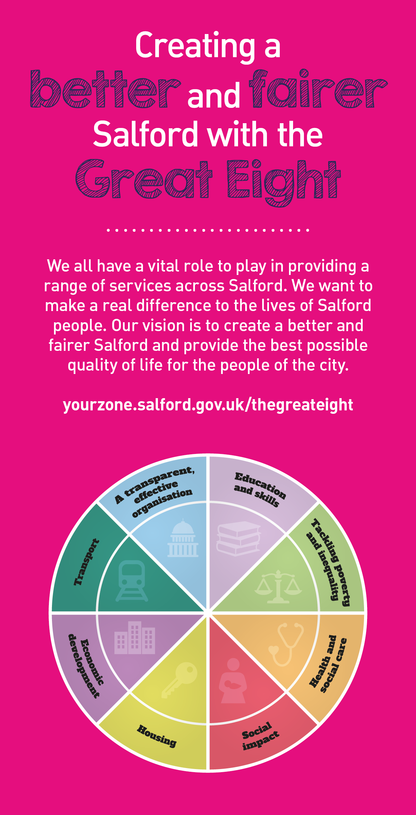
 | Key outcomes
 | - Arranging the procurement of highway improvement works through competitive tendering. Prepare, manage, report and maintain project cost plans.  - Implement projects to meet the requirements of quality, health and safety, environmental standards, and time to both national and corporate standards.  - Assimilate work that may be assigned to a team of engineers and technicians to deliver a variety of projects covering a range of complexities. |  |  |  |  | - Preparing schemes for tender using: the NEC3 ECC Forms of Contract; Manual of Contract Documents for Highway Works; Specification for Highway Works and the Standard Method of Measurement.  - Supervision and monitoring of works on site including: making valuations for payment assessments; chairing and managing progress meetings; identification and assessment of additional payments due to variation orders or compensation events; determination of project final accounts and satisfactory completion of the defects period.  - Ensure compliance of the team’s work with a high regard to Health and Safety and the application of the CDM Regulations and other legislation.
 | What we need from you
 | - Proven technical skills and ability in the role with a record of accomplishment for delivering outcomes  - Professional credibility through proven relevant experience  - Models and demonstrates our values and leadership behaviours  - You will possess a Bachelors or Masters degree in Civil Engineering or a related subject accredited by the Engineering Council OR possess a Higher National Diploma in Civil Engineering or a related subject.  - You will have a minimum of 5 years post qualification experience in the design, implementation and supervision of all aspects, in highway design.  - You will possess an extensive knowledge of standard highway and civil engineering specifications, conditions of contract and methods of measurement. |  |  |  |  | - You will demonstrate initiative, confidence and personal responsibility for action.  - You will be able to understand the bigger picture and broader context and will be able to translate to a local setting. You will understand the local context and will identify outcomes focused solutions.  - You will have analytical skills and will be able to use data insight to inform workforce strategies plans.  - You will be open to the views of others, able to constructively challenge and be challenged, and you will remain positive under challenging circumstances.  - You will be a skilled communicator who communicates with clarity, conviction and enthusiasm and is able to demonstrate integrity, create rapport and build trust and confidence.  - You will be committed to continous professional development and service improvement
Our leadership behaviours |  |  |  |  |  |  |  |  | Our values
As a values-based leader you will:  - Model the values and embed them in the way your team delivers services  - Hold people accountable for delivering the values  - Respect and care for others, treating everyone fairly, recognising the importance of ensuring equality of opportunity for all, and listening and acting on the things people say  - Be honest, taking responsibility for your actions and decisions  - Use resources that you are trusted with wisely |  | To lead and develop people you will:  - Listen to understand, not to defend  - Give people the freedom to use their initiative  - Provide opportunities for people to discuss and solve problems and issues  - Regularly provide coaching and support to others to help them achieve their objectives and potential  - Appreciate and build on people’s strengths  - Motivate, engage, encourage and inspire others in order to be the best they can be
To create a performance and development culture you will:  - Be visible, inject pace, vigour and purpose  - Expect high standards; mediocrity is not acceptable  - Take an evidence and whole system approach in making decisions  - Maximise technology and models to deliver quicker, easier, better services  - Have a digital mindset, fully utilising digital systems and solutions to deliver services differently  - Set context and challenging goals that will motivate people to take ownership, maximise performance, and develop |  | To build and communicate a vision for the future you will:  - Be optimistic and ambitious for the city and its people, helping others to understand the need to transform public services  - Build strong collaborative relationships to find creative ways to make services more sustainable and flexible  - Recognise and values the strengths of people and places, taking a strengths-based approach to make the most of opportunities  - Support people through change, in undertaking new things, and taking risks  - Take a place and whole system approach in designing, delivering and leading services  - Ensure an inclusive approach with the aim of reflecting the increasing diversity of Salford

Application guidance

We are a values based organisation so reflecting our values or a values based approach in your evidence will support your application.

The ‘Key outcomes’, ‘What we need from you’ and ‘our leadership behaviours’ sections of the Role Profile are there to give you an understanding of what we would like to see reflected in your application. Don’t give up if you are not able to reflect all of these in your application.

