Job Summary
Admin
Service: |  | Provider Services | Grade: |  |  | G4 |  | Salary: | £16,655 - £18,820 p.a. pro rata
Reporting to: |  | Shift Leader and Registered Manager | Location: |  |  | Heathside residential, leigh |  | Hours: | 25 hours per week
Your job
To provide support to the management team and develop and implement a range of monitoring, evaluation and review systems, to ensure efficient and effective services are delivered. You will be responsible for undertaking reception duties, including welcoming and escorting visitors as required. You will be required to maintain systems, equipment, records and files in good order including archive systems.
Heathside residential supports residents with Dementia; You will be responsible for producing monthly presentations and supporting the team with all aspects of administration and clerical support.

You will |  |  |  |  | Our culture
This is a rewarding role You will:-  √ Act as the first point of contact by receiving calls from professionals, carers and relatives.  √ maintain adequate stock levels keeping accurate records  √ Input and extract data from data bases including bed status, reports and support the management team.  √ Handle all issues of confidentially with the upmost discretion.  √ Ensure appropriate information is passed to colleagues, managers and other professionals in an appropriate manner.  √ Provide a wide range of administration and clerical support including typing, specifications, spreadsheets and presentations.  √ Maintain accurate records on a daily basis.  √ Contribute and participate to team meetings and my time / my time extra.  √ Communicate effectively with residents, colleagues and the management team.  √ |  |  |  |  | For us, it’s not just about all we achieve as an organisation, but how we do it. Therefore, all employees are expected to display our Be Wigan behaviours.  Be Positive… take pride in all that you do  Be Accountable… be responsible for making things better  Be Courageous… be open to doing things differently  In addition to these, our managers are expected to display the three manager Be Wigan behaviours.  Inspire…lead by example and help others to see the big picture  Care… show genuine concern for people as individuals and value their contributions  Engage… I connect with others both within and beyond the organisation

Our ideal candidate |  | Staff Deal
Our ideal candidate will have  - Excellent communication skills, both oral and written.  - Considerable office experience.  - Effective interpersonal skills with residents, families and other professional colleagues.  - self-motivated and able to use your own initiative  - Excellent computer skills and experience with databases.  - Meet deadlines and manage your own workload effectively.  - The ability to work on your own and as part of a team and deliver best practice.  - To be flexible and meet the needs of the residents and service. |  | 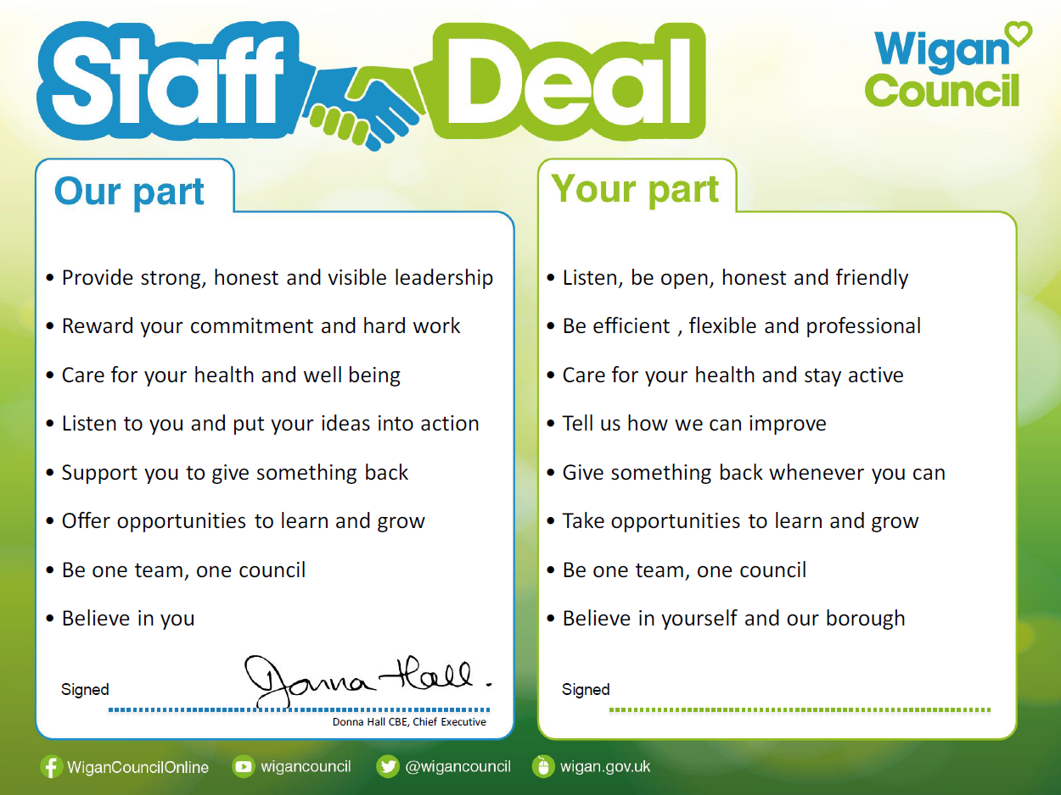  Our Staff Deal is an informal agreement with all staff. It outlines what you can expect from us, and in return what we expect from you

