Care Assistant (Nights)
Service: |  | Children’s Services | Grade: | 2A |  |  | Salary: |  |  | £17,729 + enhancement and allowance
Reporting to: |  | Click here to enter text. | Location: | Barton Moss Secure Care Centre |  |  | Hours: |  |  | 32
About the role |  |  |  |  |  |  |  |  | Our priorities
- To provide care in a secure environment, for young people who are subject to the criminal justice system and have a range of complex welfare needs. This is underpinned by: dignity and respect, compassion, inclusion, responsive care, support and wellbeing in accordance with the Children’s Home Regulations 2015.  - To demonstrate Barton Moss’s values, which include improving the outcomes for all young people at the centre, by enabling them to have an active say in their development, their environment and their future, which includes and values the contribution of families / carers and to actively contributes to the child centred ethos of the centre that is continually developing.  - Provide observational support of young people, whilst maintaining a wakeful watch at all times. Contributing to their health, safety and wellbeing in a manner that is relevant to their individual risk level.  - To ensure that all information received and disseminated, whether verbal, written or electronic concerning all employees, prospective employees or service users, is treated in the strictest confidence, and that all such information held is regulated and controlled in a similar manner.  - To respond positively in relation to potential risks and events (including unexpected events) in accordance with unit policy and procedure.  - Use identified recording systems to provide an appropriate record of young people’s progress and risks.  - To undertake a range of domestic tasks ensuring the homes are maintained to a high standard of comfort and cleanliness.  - In addition to the basic salary the following allowances are payable : +2 increments for weekend working; 30% enhancement for night working; secure unit allowance £1,114 per annum |  |  |  |  |  |  |  |  | 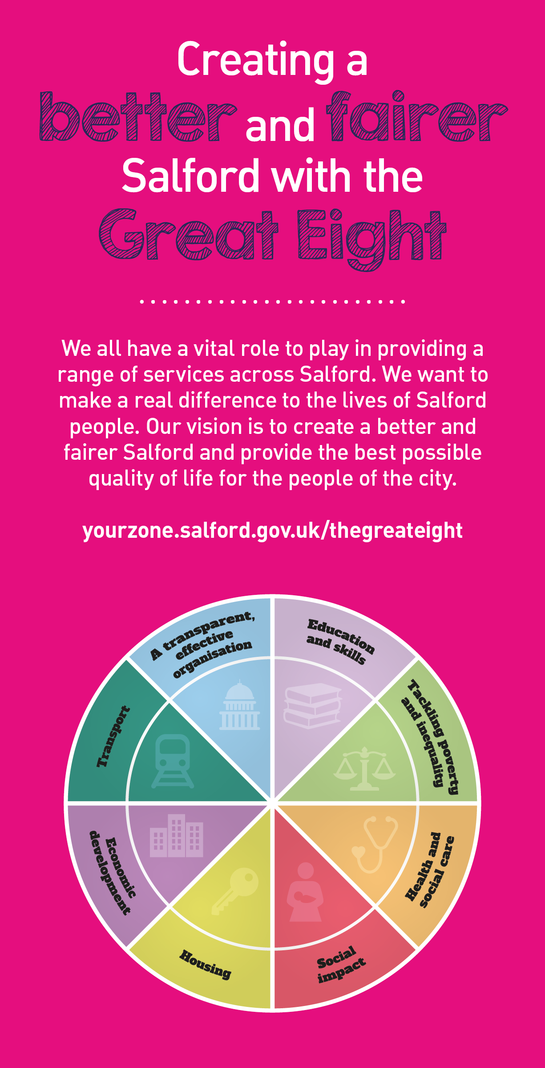
 | Key outcomes
 | - That young people are kept safe and harm is minimised during the night.  - To ensure all young people receive individual personal care.  - That unexpected events are managed appropriately and where necessary escalated to senior manager within agreed timescales. |  |  |  |  | - That the environment is cared for and well maintained.  - To enable the young people to develop resilience and self-identity.  - To safeguard and help improve the mental health and emotional wellbeing of all children within the secure setting.
 | What we need from you

- Proven technical skills and ability in the role with a record of accomplishment for delivering outcomes  - Professional credibility through proven relevant experience  - To model and demonstrate our values and behaviours  - The skills and ability to recognise harm and vulnerability in young people, responding appropriately in a variety of situations.  - The ability to communicate clearly, effectively and appropriately in verbal, written and electronic form, and be able to maintain effective recording systems.  - To be able to write clear and concise records, both manually and electronically, following appropriate departmental guidance and legislative requirements.  - To engage in formal supervision from a designated supervisor, including participating in the annual appraisal and personal development reviews, in line with the departmental policy. |  | - Awareness and understanding of additional risk factors that are a detriment to positive child development and the impacts such risk may have on others or the surrounding environment.  - Demonstrate an outstanding awareness and knowledge base of child protection and safeguarding procedures.  - The ability to work in a safety conscious manner within the scope of all health & safety practices and procedures. In addition to working in accordance with the appropriate and safe standard of dress.  - To be an integral part of the night staff team working on a rota system, including weekends, as required to meet the needs of the young people living at the home.  - The skills to prepare simple refreshments, light meals, cleaning and washing up of crockery for service users along with other general cleaning duties as allocated.

Application Guidance |  | Our values
We are a values based organisation so reflecting our values or a values based approach in your evidence will support your application.

The ‘Key outcomes’, ‘What we need from you’ and ‘our leadership behaviours’ sections of the Role Profile are there to give you an understanding of what we would like to see reflected in your application. Don’t give up if you are not able to reflect all of these in your application.

Click here to enter text.

