Job specification
Job title: | Reablement Support Worker
Service: | Early Intervention
Grade:  Salary Range: | G5  £12,387 - £14,547 p.a.
Reporting to: | Reablement Manager

Your job
The Reablement team is part of the Early Intervention Service which is a multidisciplinary team consisting of Occupational Therapists, Reablement staff and Assistive Technology assessors. As a Reablement Support Worker you will be part of the team providing integrated, multidisciplinary programmes of Reablement across the borough. You will need to use an approach which considers what a person can do, rather than what they can’t and to promote independence and help restore/maintain the service user’s ability to remain within their own home. You will be allocated a number of service users to support for up to a six week period where you will visit them to try to find out as much information as you can about their health, lifestyle, abilities and what they would like to achieve.

In this job you will
On an ongoing basis you will:

- Take an active role in encouraging and supporting individuals to develop and maintain links with families, friends and local communities.
- Assist individuals to take prescribed medication as directed.
- Make minor adjustments to equipment, including assistive technology and record changes on an ongoing basis.
- Contribute to the evaluation and modification of activity plans on a regular basis.
- Use moving and handling techniques.
- Maintain accurate records.
- Be able to work flexibly working weekends/bank holidays and shifts on a rota basis to meet the needs of the service.
- Contribute to assessments through the use of IT systems.
- Liaise with other agencies and professionals such as social workers and therapists on a daily basis.
- Carry out therapeutic activity in line with the agreed care plan to encourage independence and self-management.
- Support service users and their carers to cope with the psychological effects of any loss of independence.

Within the first 12 - 18 months you will:

- Attend and complete the Care Certificate as part of induction and complete all mandatory training.
- Complete Trusted Assessor Award.
- Obtain NVQ Level 3 in Health and Social Care/QCF credit value.

In this job you will need
You must be able to demonstrate the following essential requirements:

- NVQ Level 3 in Health and Social Care/QCF credit value or a commitment to complete within a 18 month period.
- Be able to work flexibly in approach to hours including working weekends/bank holidays and shifts on a rota basis.
- Excellent communication skills, both oral and written.
- Excellent decision making skills and the ability to ask the right questions, break down problems and come up with innovative solutions.
- Effective interpersonal skills with service users, carers and professional colleagues.
- The ability to monitor and review service user’s needs.
- The ability to work on your own and as part of a team and be confident as a lone worker.
- The ability to undertake moving and handling tasks.
- An understanding and awareness of Reablement processes which allow service users to return home and live as independently as possible.
- A current valid driving licence or the ability to travel across the borough to meet the needs of the service.

Our culture
For us, it’s not just about all we achieve as an organisation, but how we do it. Therefore, all employees are expected to display our Be Wigan behaviours.

Be Positive… take pride in all that you do

Be Accountable… be responsible for making things better

Be Courageous… be open to doing things differently

Individuals with line management responsibilities are also expected to …
Inspire…lead by example and help others to see the big picture

Care… show genuine concern for people as individuals and value their contributions

Engage… I connect with others both within and beyond the organisation

Staff Deal
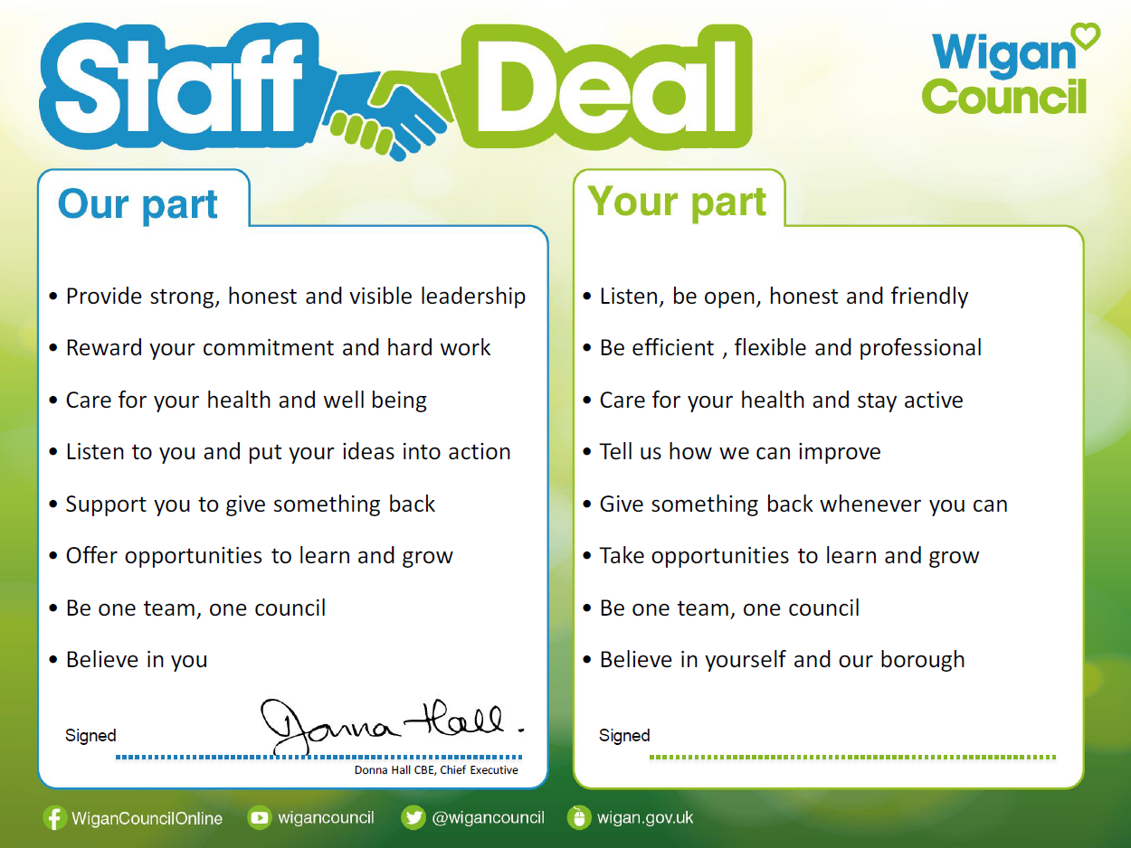
Our Staff Deal is an informal agreement with all staff. It outlines what you can expect from us, and in
return what we expect from you

