Job Summary
Support Worker
Service: |  | Day Opportunities | Grade: | G4 |  | Salary: | £11,253 - £12,716
Reporting to: |  | Establishment Manager | Location: | Etherstone Day Centre |  | Hours: | 25

Your job
Etherstone Street Day Centre is a specialist service providing support for people with age related illness and Dementia. You will join a highly motivated and experienced team of support workers. You will support individual’s on a day to day basis to maintain health and wellbeing in a safe and caring environment.
You would be involved in the ongoing development of the service to ensure continued delivery of the Deal for Adult Social Care and Health.

You will |  | Our culture
√ Support individuals with daily activities to maintain health and wellbeing.  √ Use an asset based approach to support customers with their aspirations, past life history, achievements and memories. Including support in all decision making related to the support they receive.  √ Make connections with the local and wider community offering opportunities for our customers.  √ Liaise with other agencies and professionals such as social workers, Doctors, District nurses on a daily basis.  √ Provide a network of support and build positive relationships with carers.  √ Working with customers in a person centred way that respects people’s individuality and promotes choice and control.  √ Be an active member of the team, participating in personal development including training, My Time and My Time extra. |  | For us, it’s not just about all we achieve as an organisation, but how we do it. Therefore, all employees are expected to display our Be Wigan behaviours.  Be Positive… take pride in all that you do  Be Accountable… be responsible for making things better  Be Courageous… be open to doing things differently  Inspire…lead by example and help others to see the big picture  Care… show genuine concern for people as individuals and value their contributions  Engage… I connect with others both within and beyond the organisation

Our ideal candidate |  | Staff Deal
Our ideal candidate will have:  - Experience of working within a social care setting.  - Effective interpersonal skills with customers, carers and other professional colleagues.  - Excellent ability to understand the customers needs and wishes and be able to support them in a person centred manner.  - Excellent communication skills both oral and written.  - Understanding of The Deal for Adult Care and Health and how to implement this within provider services.  - The ability to work on own or as part of a team.  - Be flexible to meet the needs and demands of the service. |  | 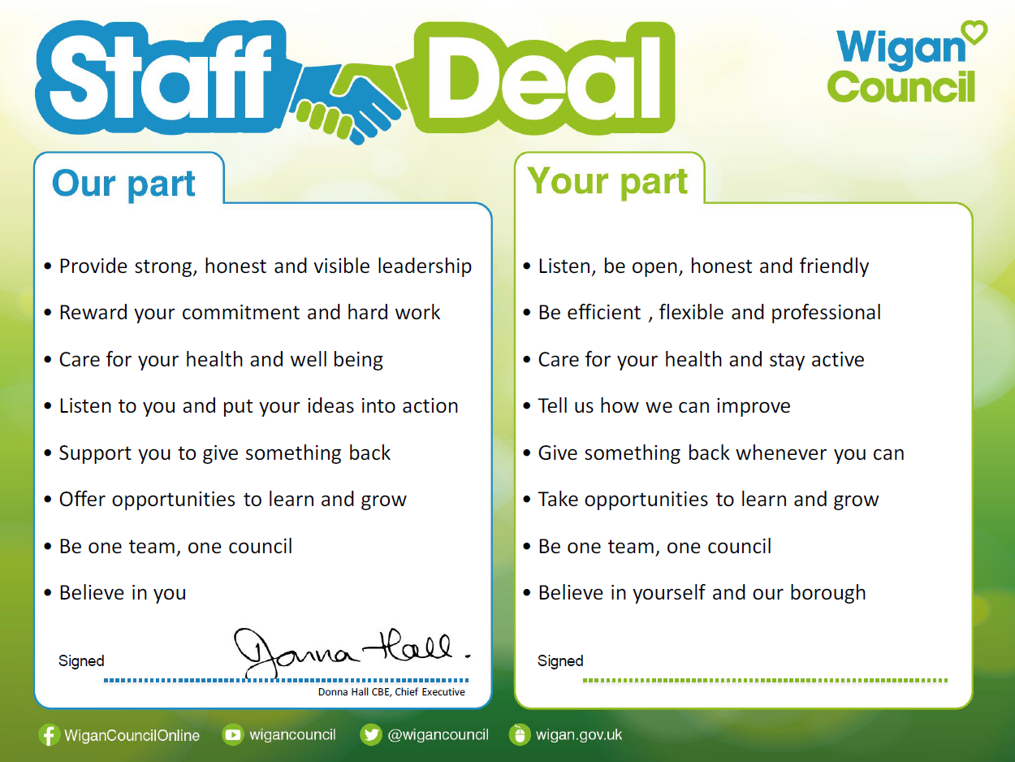  Our Staff Deal is an informal agreement with all staff. It outlines what you can expect from us, and in return what we expect from you

