St Teresa of Calcutta
Catholic Academy
Trust

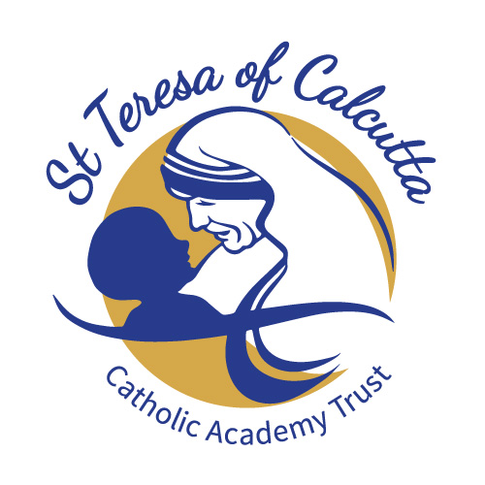

Privacy Notice for Prospective Employees

How The St Teresa of Calcutta Catholic Academy Trust (The Trust) uses prospective employees’ information

What categories of information are processed?
We process data relating to those applying to work at our trust. Personal data that we may collect, use, store and share (when appropriate) about you includes, but is not restricted to:
- Personal information – e.g. name, contact details, National Insurance number
- Qualifications and, where relevant, the subjects taught
- Recruitment information – e.g. documentation relating to employment checks, references
We may also collect, store and use information about you that falls into “special categories” of more sensitive personal data. This includes information about (where applicable):
- Race, ethnicity, religious beliefs, sexual orientation and political opinions
- Disability and access requirements

Why do we collect and use your information?
We collect and use your information for the following reasons:
- To inform the development of recruitment and retention policies
- To facilitate safer recruitment
- To comply with the Equalities Act
- To ensure appropriate access arrangements are in place
Under the GDPR, the legal basis/bases we rely on for processing personal information for general purposes are:
- For the purpose of facilitating safer recruitment, in accordance with the legal basis of public task, paragraph 2 (d) of Article 9 and the School Staffing (England) Regulations 2009.
- For the purpose of complying with the equalities Act, the legal basis we use is public task
- For the purpose of ensuring appropriate access arrangements the legal basis we use is public task to facilitate compliance with the Disability Discrimination Act.

How do we collect your information?
We collect your personal information via the following methods:
- Application forms
- Questionnaires
- Interview tasks and responses
Whilst most of the information you provide us is mandatory, some of it is requested on a voluntary basis. We will inform you at the point of collection whether you are required to provide certain information to us or if you have a choice.
How do we store your information?
We create and maintain a file for each vacancy. The information contained in this file is kept secure and only used for purposes directly relevant to the recruitment of the post.
Your personal information is retained and disposed of in line with the trust’s Records Management Policy, which can be found on the trust website.
For more information about how we securely store your information, please see the trust’s Data and E-security Breach Prevention and Management Plan.
Who do we share your information with and why?
We do not share information about you with anyone without your consent, unless the law and our policies allow us to do so.
Where it is legally required or necessary, we may share your information with the following:
- Ofsted – to evidence the school’s recruitment process and equality of opportunity, in accordance with the School Staffing (England) Regulations 2009 and the Equality Act 2010.
- Disclosure and Barring Service (DBS)
- Courts and tribunals
- Employers – when requests are received for references etc.
- Partner agencies
- Service providers – to enable you to access services which the school subscribes to
Any information we share with other parties is transferred securely and held by the other organisation in line with their data security policies.

Automated Decisions about your personal information
The Trust does not employ the use of any automated decision making processes which uses your personal information.
What are your rights?
You have specific rights to the processing of your data, these are the right to:
- Request access to the information the s we hold about you.
- Restrict our processing of your personal data, i.e. permitting its storage but no further processing.
- Object to direct marketing (including profiling) and processing for the purposes of scientific/historical research and statistics.
- Have your personal data rectified if it is inaccurate or incomplete.
- Not be subject to decisions based purely on automated processing where it produces a legal or similarly significant effect on you.
- Request the deletion or removal of personal data where there is no compelling reason for the continued processing.
- Seek compensation, either through the ICO or the courts.
If you want to request access to the personal information we have about you, please contact John Kenmure Data Protection Office (DPO) jkenmure@stpatricksrc.rochdale.sch.uk.
If you are concerned about the way we are collecting or using your information, please raise your concern with the school’s DPO in the first instance. You can also contact the ICO at https://ico.org.uk/concerns/.
How to withdraw consent and lodge complaints
Where our trust processes your personal data with your consent, you have the right to withdraw your consent at any time.
If you change your mind or are unhappy with how our trust uses your personal data, you should let us know by contacting the DPO, John Kenmure on jkenmure@stpatricksrc.rochdale.sch.uk.

How can you find out more information?
If you would like to discuss anything in this privacy notice, please contact John Kenmure on jkenmure@stpatricksrc.rochdale.sch.uk.
If you require further information about how we and/or the DfE store and use your personal data, please visit our website, the Gov.UK website, or download our Data Protection Policy and Records Management Policy found On the Trust Website.

---------------------------------------------------------------------------------------------------------------------------

