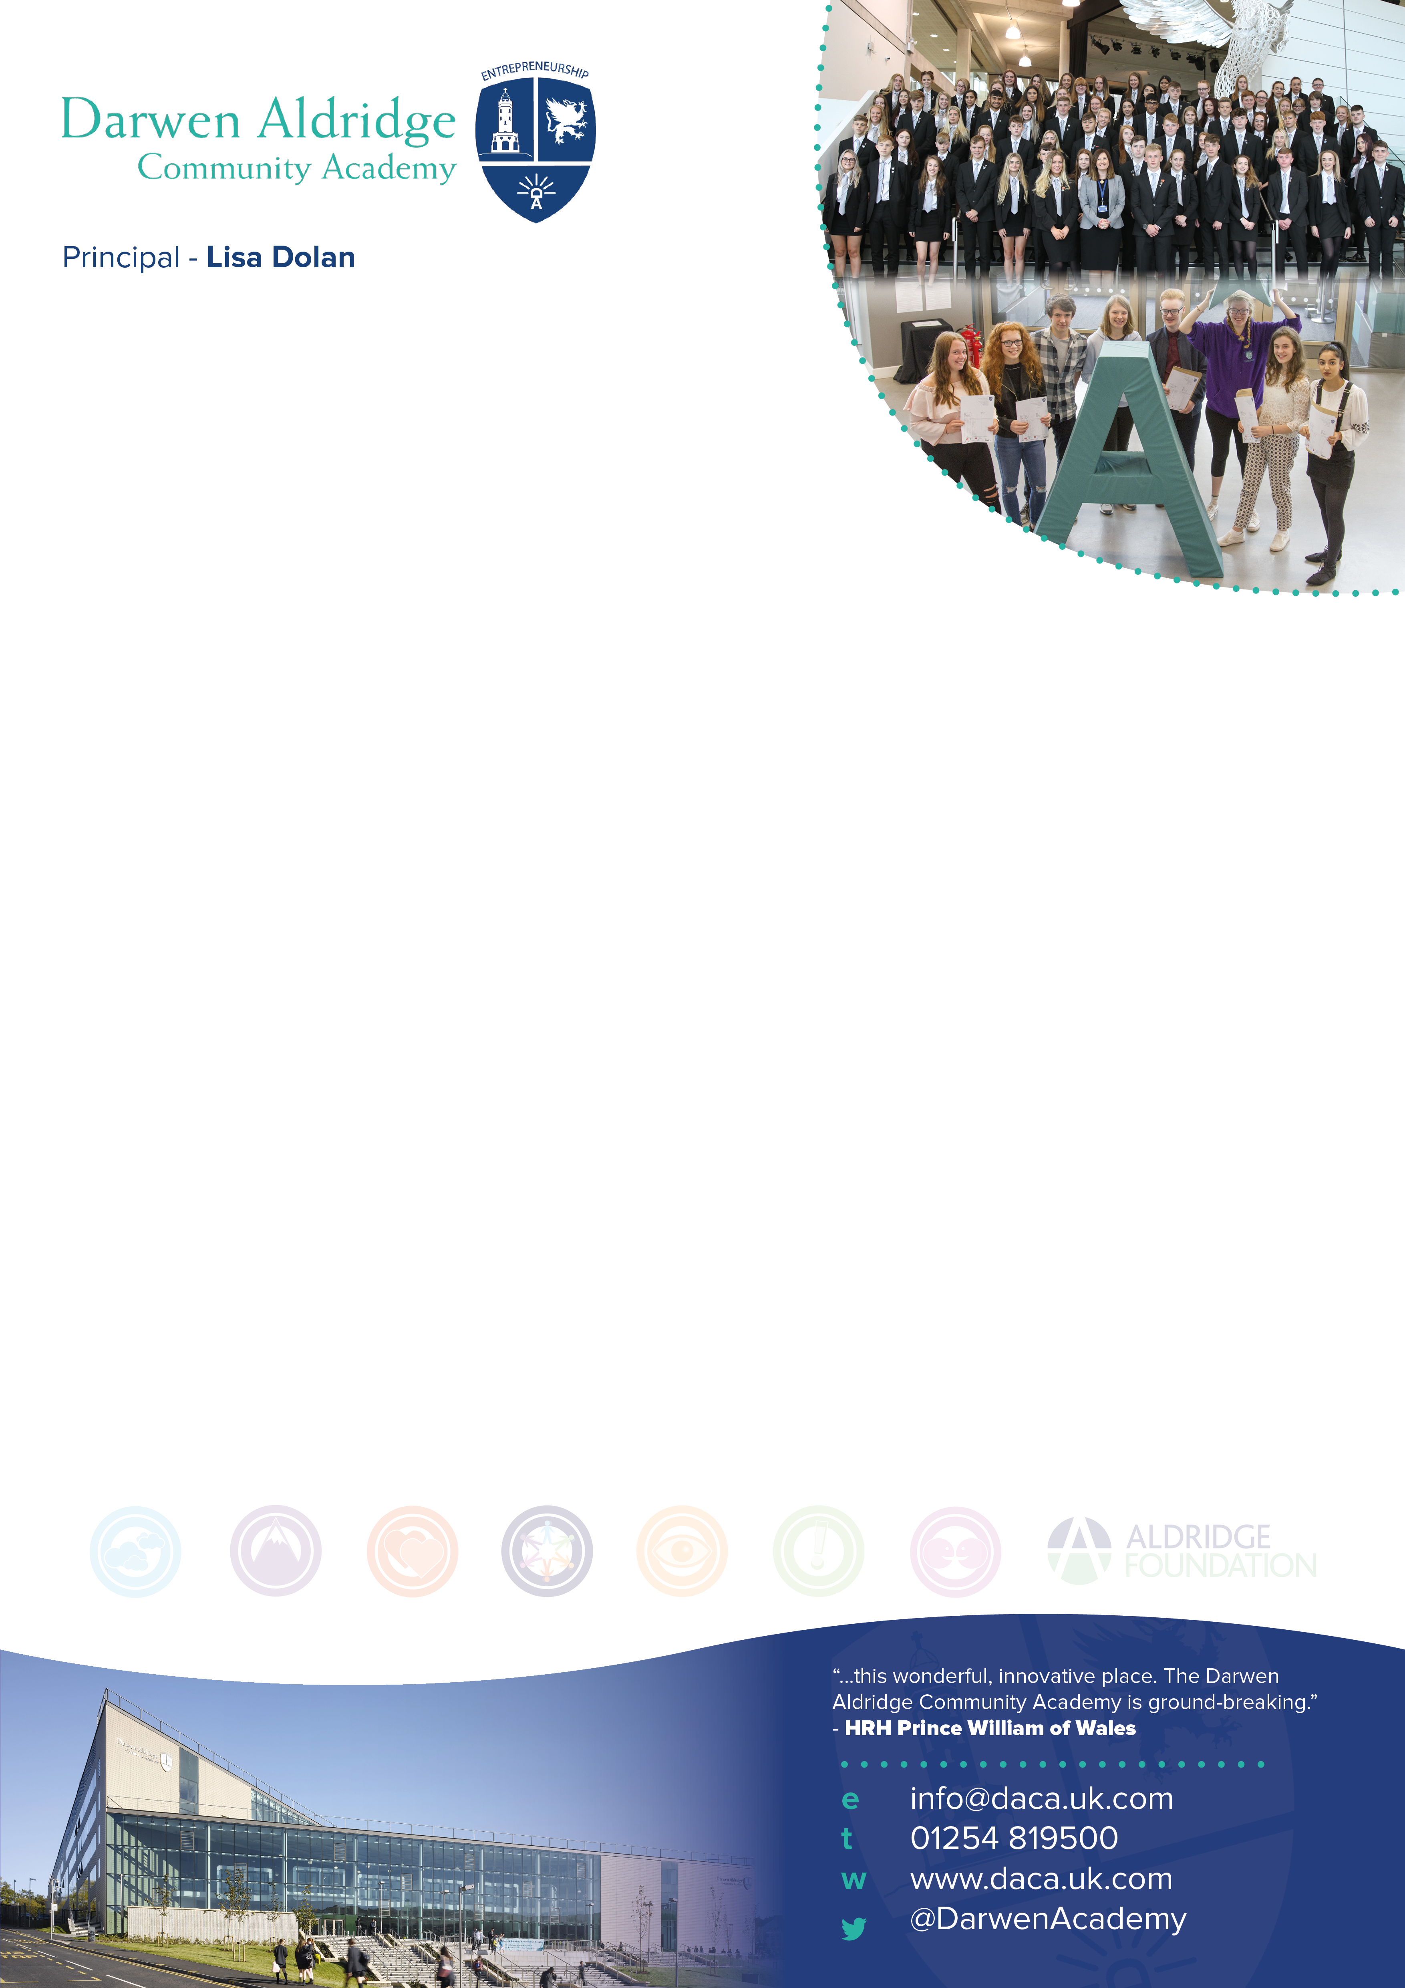
Director of Learning for Science required September 2021
Full-time, permanent – L8-L12 (£50,151 - £55,338)

We require a Director of Learning for Science to lead a committed group of
teachers.

Darwen Aldridge Community Academy is a larger than average 11-18 academy within
Blackburn with Darwen. We are part of Aldridge Education and have 1300 students on
roll. Our sixth form is in the top 10% of all sixth forms nationally. Our aim is to ‘get better
faster’ and secure an exceptional level of education, which all of our students deserve. Our passion
is about realising our students’ full potential regardless of background.

The competitive salary reflects the importance of this role and our commitment to developing leadership. This is an opportunity to lead the Science faculty to the next level and for the successful candidate to be fully prepared for future senior leadership, having made their mark on a key faculty. We are looking for a committed, enthusiastic leader who can develop a strategic vision for Science and who can ensure we are continually improving. Someone who:
- really loves their subject and is an excellent classroom practitioner
- is positive
- builds teams
- is collaborative
- shares good practice
- is committed to securing high standards of learning and teaching
- gets things done
- has a clear curriculum vision
- is very capable and is able to lead and inspire with confidence
- can develop staff so that our students are inspired and achieve great outcomes.
- will lead on the 'get better faster' approach to coaching for their faculty (full training will be available)
- is resilient
- is committed to wanting the very best for our students
- is committed to 'levelling the playing field' for students with disadvantage
If this is you, we look forward to hearing from you.

We offer:
- coaching, support and line management from an experienced senior leader
- the support of a trust lead for Science
- professional progression opportunities including NPQs
- dedicated coaching time as part of your timetable
- measures to reduce staff workload such as centralised detentions and a sensible feedback policy focused on whole class feedback
- collaborative and co-planning time within the school day
- an employee assistance programme.

Application documents are available to download in the vacancies section of the school website http://www.daca.uk.com/vacancies. Apply online by the closing date of midday on Thursday 13th May 2021 to sam.grimshaw@daca.uk.com. Interviews will take place the week commencing 17th May 2021.

Director of Learning for Science
Grade L8 – L12
(£50,151 - £55,338)

Information for Applicants
Required 1st September 2021

May 2021
Dear Candidate
I am delighted that you are interested in becoming our Director of Learning for Science. Darwen Aldridge Community Academy is a larger than average 11-18 academy, with nearly 1300 students on roll and we are part of Aldridge Education. Our academy’s passion is realising our students’ full potential regardless of background and our motto is that we all aim to be ‘Determined, Ambitious, Courteous and always Attending’ (DACA). The academy was founded by Sir Rod Aldridge as a way of promoting social mobility and supporting successful communities. We are an inclusive school, behaviour is good and we have high standards and expectations of our students and high standards of care for them.
Our academy and trust are committed to the power of coaching and how we can ‘get better faster’ using the methodology of Paul Bambrick-Santoyo. We believe that we are all learners and we realise that all staff need a coach regardless of level and experience. We believe that everyone is able and ready to inspire others with their subject scholarship and their love of teaching.
Whilst we are currently graded as a good provider by Ofsted, have achievement at KS5 in the top 10% of all schools nationally, we do not rest on our laurels and we are always striving to improve.
Science is a strongly performing subject in the academy with results increasing over the last 3 years. Science results at GCSE have taken off recently through improved pedagogy and curriculum design. Students follow the Combined Science course or choose Separate Science as an option in year 9. December moderated mock exam results this year recorded the Science department as being the strongest core subject at the academy and the most successful science department within the Aldridge trust schools. Students achieved 65% 4+ in 2 Science GCSEs in 2020 with predictions for 2021 in the range of 67%-71% 4+. The current cohort are due to record a record number of Grade 9s in separate Sciences this year, with 12 predicted in Biology, 9 in Physics and 6 in Chemistry. The success of the results in Separate Sciences has resulted in uptake onto A-level courses being very strong. At KS5 we currently offer Biology, Chemistry, Physics and Applied Science.

There are currently nine full time and one part time teaching staff who teach across the full age and ability range. The successful candidate will be supported by a KS3 coordinator within the faculty and a Trust Lead for Science who works across the Aldridge schools in the North west. The faculty has one full-time Science technician and two part time science technicians who support the faculty. The Science Faculty has a suite of ten labs with short throw projectors, a home-base and a prep room based on one floor.
The Director of Learning for Science is a key post in the academy and we are looking for the successful candidate to drive further improvement. It comes with a place on an Extended Leadership Team who meet regularly with SLT to develop practice, policy and curriculum, hence the competitive salary. This post is ideal for anyone who is looking to become a senior leader in the future and develop their wider leadership skills. You will report to and work alongside an experienced senior leader who will give support and coaching. You do not necessarily have to have experience of teaching in an 11-18 school. We want the right person and if your experience to date has been in an 11-16 context, then please do not be hesitant in applying.

We are looking for someone who really loves their subject, is positive, builds teams, is collaborative, shares good practice, is committed to securing high standards of learning and teaching, gets things done, has a clear curriculum vision, is very capable and is able to lead with confidence and develop staff so that our students are inspired and achieve great outcomes.
Should you have any queries about the role please contact sam.grimshaw@daca.uk.com who will arrange a call.
Please find enclosed with this letter;
- A job description for the post
- A person specification for the post
- Middle leader standards and Aldridge Education operating norms
- An application form

I hope that this information will encourage you to apply for this key post. Please return your completed application form, along with a supporting letter of no more than two sides of A4, before the closing date of midday on Thursday 13th May 2021. Applications should be submitted electronically to, Sam Grimshaw (sam.grimshaw@daca.uk.com).

Interviews will take place the week commencing 17th May 2021 and will include an observed lesson, a formal interview and a variety of tasks.

I look forward to receiving your application.

Lenny Lewis
Executive Principal

The Academy is committed to safeguarding and promoting the welfare of children and young people. References will be taken up for all shortlisted applicants, and successful candidates will be subject to satisfactory enhanced disclosure from the Disclosure and Barring Service. If you do apply for the above position and have not heard anything within one week of the closing date, you can assume that you have not been short-listed on this occasion.

JOB DESCRIPTION

Job Title: Director of Learning for Science

Responsible to: Senior Leader TBC
Responsible for: Science faculty staff
ETHOS
Promoting the ethos of the academy is a shared responsibility to which middle leaders make a significant contribution.

DUTIES AND RESPONSIBILITIES
Strategic direction
- Develop and implement policies and practices for the Science Faculty which reflect our academy’s commitment to high achievement, effective teaching and learning
- Create a climate which enables staff to develop and maintain positive attitudes towards their subject and confidence in teaching it
- Establish a clear, shared understanding of the importance and role of the faculty in contributing to students’ spiritual, moral, cultural, mental and physical development, and in preparing students for the opportunities, responsibilities and experiences of adult life
- Use data effectively to identify students who are underachieving in the faculty, and create and implement effective plans to support those students where necessary
- Analyse and interpret relevant national, local and school data, as well as research and inspection evidence, to inform policies, practices, expectations, targets and teaching methods
- With the involvement of relevant staff, establish short, medium and long term plans for the development and resourcing of the faculty
- Monitor the progress made in achieving faculty plans and targets, evaluate the effects on teaching and learning, and use this analysis to guide further improvement

Teaching and learning
- Ensure curriculum coverage, continuity and progression in the faculty for all students, including more able students, students with special educational needs and students with English as an additional language
- Make sure that teachers are clear about the teaching objectives in lessons, understand the sequence of teaching and learning in the faculty, and communicate such information to students
- Provide guidance on the choice of appropriate teaching and learning methods to meet the needs of the faculty and of different students
- Ensure effective development of students’ literacy, numeracy and IT skills through the faculty
- Establish and implement clear policies and practices for assessing, recording and reporting on student achievement, and for using this information to recognise achievement, set targets, and secure good progress
- Set expectations and targets for staff and students in relation to standards of student achievement and the quality of teaching
- Evaluate the teaching of the faculty in the school, use this analysis to identify effective practice and areas for improvement, and take action to improve further the quality of teaching
- Ensure effective development of students’ individual and collaborative study skills

- Work with staff to establish a partnership with parents to involve them in their child’s learning, as well as providing information about curriculum, attainment, progress and targets
- Develop effective links with the local community, including business and industry, in order to extend the curriculum, enhance teaching and to develop students’ wider understanding
Leading and managing staff
- Help staff to achieve constructive working relationships with students and parents
- Establish clear expectations and constructive working relationships among staff involved with the faculty, including through team working and mutual support; devolving responsibilities and delegating tasks, as appropriate
- Sustain your own motivation and, where possible, that of other staff involved in the faculty
- Appraise staff as required by the academy policy and use the process to develop the personal and professional effectiveness of the appraisee(s)
- Audit training needs of faculty staff
- Lead professional development of faculty staff through example and support, act as a lead coach and co-ordinate the provision of high-quality professional development by methods such as coaching, drawing on other sources of expertise as necessary, for example, higher education, Aldridge Education, faculty associations
- Make sure that trainee and newly qualified teachers are appropriately trained, monitored, supported and assessed
- Enable teachers to achieve expertise in their teaching
- Work with the SENCO and any other staff with special educational needs expertise, to make sure that education, health and care plans are used to set faculty-specific targets and match work well to students’ needs
- Make sure that the Principal, senior managers and governors are well informed about faculty policies, plans and priorities, the success in meeting objectives and targets, and faculty-related professional development plans
Efficient and effective deployment of staff and resources
- Establish staff and resource needs for the faculty and advise the Principal and senior leaders of likely priorities for expenditure, and allocate available faculty resources with maximum efficiency to meet the objectives of the academy and faculty plans and to achieve value for money
- Deploy, or advise the Principal on the deployment of staff involved in the faculty to make sure the best use of faculty, technical and other expertise
- Ensure the effective and efficient management and organisation of learning resources, including ICT
- Maintain existing resources and explore opportunities to develop or incorporate new resources from a wide range of sources inside and outside the academy
- Use space to create an effective and stimulating environment for the teaching and learning of the faculty
- Make sure that there is a safe working and learning environment in which risks are properly assessed

Please note that this list of duties is illustrative of the general nature and level of responsibility of the role. It is not a comprehensive list of all tasks that the faculty leader will carry out. The post holder may be required to do other duties appropriate to the level of the role.

GENERAL DUTIES
- To adhere to the policies and procedures of Darwen Aldridge Community Academy and Aldridge Education
- To carry out ‘the duties of a schoolteacher’ as set out in the Schoolteachers’ Pay and Conditions Document & Teacher Standards
- To lead the faculty, demonstrating the middle leaders’ standard
- To share in the responsibility for the development and well-being of all students
- To share in the responsibility for the development of E and online Learning, the innovative use of ICT and the innovation of classroom practice
- Make a positive contribution to the wider life and ethos of the school

- Demonstrate consistently the positive attitudes, values and behaviour which are expected within the academy community based on mutual respect between students and staff
- To take a pro-active part in the academy’s appraisal system, both as a reviewer and reviewee, with the ultimate aim of improving standards of teaching and learning in the academy
- To take reasonable care of one’s own health and safety and that of others and inform the Estates Manager of any concerns with regard to health and safety.
- To undertake any further reasonable duties as requested by the Principal

PERSON SPECIFICATION

ESSENTIAL | DESIRABLE
Qualifications and Experience  - To hold a degree in relevant subject area  - To be a qualified teacher  - A proven track record of examination success at GCSE level | - A proven track record of examination success at A level
Knowledge and Skills  - Excellent subject knowledge and classroom practice  - To understand the process of learning  - To understand the process and impact of coaching  - To have knowledge of special educational needs  - Expert knowledge of the National Curriculum, particularly science  - Understanding of high-quality teaching and learning strategies in the faculty, and the ability to model this for others and support others to improve  - Awareness of local and national organisations that can provide support with delivering faculty improvement  - Ability to build effective, collaborative working relationships with staff and other stakeholders  - Ability to adapt teaching to meet students’ needs  - Ability to build effective working relationships with students  - Knowledge of guidance and requirements around safeguarding children  - Good IT skills  - Effective communication and interpersonal skills  - A positive, energetic approach  - Ability to communicate a vision and inspire others | - To have knowledge and understanding of the latest educational developments  - A strong commitment to develop own skills and knowledge  - Continued professional development since qualification

