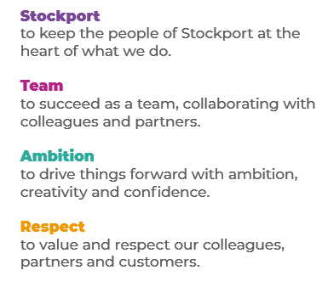
Job Profile and Working for Stockport Council
Our Council
Our employees are our greatest asset. We’re proud of the way we provide vital frontline services every day and work together, as one team.
Our 4 core values as shown above, run through everything that we do, and we aim to stay true to them regardless of the challenges that we may face.
To support our values, we have policies, guidance and procedures around health, safety and welfare, customer care, emergency planning and security that all our colleagues are adhering and working to.
We also pride ourselves on our commitment to wellbeing and inclusivity of our colleagues and residents.
You can find out more about working for Stockport Council and some of the benefits that we offer our employees at https://greater.jobs/locations/stockport/

Role: |  | Civil Enforcement Officer (Parking)
Service Area: |  | Public Protection
Directorate: |  | Services to Place
Salary Grade: |  | Scale 3 + 2 increments
About the Job

Main Purpose of the Job
Enforcement of parking restrictions on-street and in car parks.

Key Responsibilities

- Issuing good quality PCNs (Penalty Charge Notices) and other notices as required keeping clear and accurate records and providing supportive information.

- Acting upon dispensations and suspensions, placing cones, and posting notices as required.

- Recording and reporting on and off street defects and carrying out first line maintenance where trained.

- Assisting and informing the public on parking and a variety of non-parking issues

- Accurately recording and reporting incidents and complaints from the public, reporting crime and anti-social behaviour.

- Assisting the Notice Processing Team and Parking Facilities Team, other internal and external agencies including the emergency services where appropriate.

- Working flexibly in the interests of the service.

- To work positively and inclusively with colleagues and customers so that the Council provides a workplace to deliver a service that does not discriminate against people on the grounds of their age, disability, gender reassignment, marriage, civil partnership, pregnancy, maternity, race, religion, belief, sex, or sexual orientation.

- To fulfil personal requirements, where appropriate, with regards to Council policies and procedures, standards of attendance, health, safety and welfare, customer care, emergency, evacuation, security and promotion of the Council’s priorities.

Additional Information
The responsibilities set out in this document, in the advert and any additional information are intended to provide a flavour of the work you will carry out. It is not possible to include everything you will be asked to undertake, and we expect all colleagues to work flexibly according to business needs and to enhance your own development. Your skills, abilities and training needs will be taken into account and discussed with you when any significant changes to your role are needed. In line with our flexible approach, you may be required to work from home for a proportion of your time or from any of the Council's sites across the borough.
The Council is an inclusive employer and holds the Disability Confident and Armed Forces Covenant accreditations. If you have a disability, we will support you by implementing reasonable adjustments to enable you to perform your role.

About You
Please use your application to tell us how well you meet the criteria listed below as these are the key skills, experience, technical expertise, and qualifications needed to be successful in the role. We will then use all the information you provide in your application to help us decide whether you are shortlisted for interview. Any interview questions or additional assessments such as tests or presentations may also be broadly based on these criteria:
- Working to the Council’s values and behaviours by:
- Keeping the people of Stockport at the heart of what we do
- Succeeding as a team, collaborating with colleagues and partners
- Driving things forward with ambition, creativity and confidence
- Showing value and respect to our colleagues, partners, and customers.

- Full driving licence and willingness to drive a Council vehicle.

- Working knowledge of parking enforcement legislation and processes. (Desirable)

- Resilient – willing and able to appropriately and professionally handle confrontational situations involving members of the public who have been issued with PCNs

- Experience of working in team environment govened by clear protocols & procedures.

- Ability to assist in developing and amending working protocols and procedures.

- Ability to provide performance data

- Good advisory and guiding skills – to respond appropriately to queries from members of the public

- Commitment to the Health and Safety of all operations and the team’s welfare.

- Good motivational skills, to be able to issue and work effectively from instructions and guidance, always ensuring adherence to procedures and regulations.
- Willing and able to undertake uniformed patrols – covering >7-14 miles a day (excluding travel to and from sites) – carrying equipment relevant to role

- Demonstrate good numeracy, literacy, and ICT skills.

