SGO Co-ordinator
Service | Reporting to | Location | Grade
Special Guardianship Support Service | Team Manager | Unity House, Salford Civic Centre | 4A (SCP32-35) £40,221 to £43,421

About the role
An exciting opportunity has arisen for a full time Social Worker position in the Special Guardianship Service within the Salford Fostering Service as a fixed term 12 month post.
We are a friendly and stable team working with children and families who have special guardianship orders. We offer support and advice to families around contact, finance, behaviour and trauma. We have 2 social work posts in the team.
We cover the local authority area, currently through a combination of office based and home working arrangements are in place, in line with Salford City Council guidance. You will have access to the Co-wheels car club (permanent staff only). There is a requirement to be able to work outside the local authority area where carers reside elsewhere in England.
This qualified Social Worker role is a great opportunity for someone who wishes to contribute to the development of Special Guardianship services in Salford. You will receive a comprehensive induction and be supported through regular 1:1 supervision, personal development plan, regular team meetings and access to learning and development opportunities.
The role will require you to complete support needs assessments to identify areas of support for families. You will need to be flexible and able to undertake visits and attend multi-agency meetings. You will attend court and be skilled in completing statements and reports for court.
We are looking for applicants who will be confident in working with children and young people in sometimes difficult situations, their carers, birth parents, and other professionals. You will have an understanding of the Family Partnership Model and its application in practice.
You will have knowledge of therapeutic parenting or have a willingness to learn about this style of parenting, and be able to offer proactive support and reflection regarding children’s presentation and behaviours linking to attachment, secure base and trauma related theory.

Key outcomes
In Salford we’re passionate about successful long term outcomes for our care experienced children. We want them to have the same opportunities as other children and to achieve their hopes and aspirations for the future. But stable placements and positive outcomes for looked after children don’t just happen. They need a team of dedicated professionals committed to making sure children get the best possible care and permanency.
By providing support for our Special Guardians and the children and young people they care for, we can ensure our Care experienced children get an individualised package for the support they need.
You will be conducting Special Guardianship assessments and support plans in both public and private law, attending court, and supporting carers to achieve permanency for children and young people.
You will be skilled in needs assessments to identify eligibility and support children and young people to access the adoption support fund, and complete annual reviews of support plans including financial reviews and referrals and signposting to support services.
You will provide support and training to staff, foster carers, and special guardians, including to support the running of the support groups, and the design and delivery of preparation training groups for prospective special guardians.
You will have the opportunity to develop specialist services for Special Guardians in Salford.
You will have a good understanding of a range of ways of working with families and group-work experience and skills.
You’ll also be imaginative and effective in working in a multi-disciplinary team environment and in a range of settings. You will be able to understand the support needs and legislation that applies to SGO carers who live in England, the UK, and internationally.

What we need from you
- To model and demonstrate our values and behaviours;
- Qualified and professionally registered as a social worker;
- Have knowledge of current legislation and regulations relevant to Special Guardianship;
- Be able to demonstrate your experience and abilities in respect of working in partnership with children, young people, families and partner agencies using the Family Partnership Model;
- Respond to and undertaking a variety of contacts and referrals and assessments, including Fostering Duty;
- Knowledge of specialist advice and information to provide to colleagues and external professionals;
- Experience in supporting placements for children and young people;
- Experience in delivering workshops, training, and facilitating support groups;
- Experience completing special guardianship assessments and Adoption Support Fund applications;
- Ability to work as part of a multi-disciplinary, multi-agency team and co-work effectively with other professionals;
- Ability to work in isolation, at times, assess and manage risk, and seek support as necessary;
- Excellent communication skills, both written and oral;
- Excellent organisational and time management skills including the ability to manage own workload and work under pressure;
- I.T. skills (Recording, report writing, supporting young people & carers with internet usage);
- Driving Licence, use of a car, and ability to travel as required;
- Commitment to equal opportunities and anti-oppressive practice;
- Willingness to work flexible hours including some evening work, to meet the needs of the service.

.

What we can offer you
Your ongoing professional development and success in your role is important to us, and that is why we provide a variety of learning and development opportunities. Within the sections below you will find development options tailored to you which will enable you to further develop your existing skills and learn new ones at a pace that suits you best. If you are joining us now, your development will form part of ongoing discussions with your manager. If you are an existing employee, you should use your Personal Development Reviews to discuss your development with your manager and create your development journey. It’s important you also take full advantage of any informal learning available to you during the course of your work.

Online learning
Develop your knowledge across a wide range of areas through our Me-Learning platform, with over 200 free courses to choose from. To have the best possible start and comply with current legislation, you must complete the following modules: Welcome to Salford, Health and Safety in the Office, GDPR, Equality Essentials, and Safeguarding Children and Adults. You may also benefit from a variety of courses in categories such as Business Skills, IT and Project Management which are available to learn at your own convenience and pace.

Professional Development
Gain role specific skills and time to learn through a wide range of development opportunities. Learn whilst working and get support towards your qualification through an apprenticeship standard. Access professional development ranging from entry level to master’s type qualifications, including achieving a role appropriate qualification. Details can be found on the Institute of apprenticeships website.

Tailored Development
Develop your knowledge of Special Guardianship support services and the Adoption Support Fund.

Ofsted
We are an Ofsted rated ‘good’ authority (November 2023 Ofsted report – Children’s Services inspection overall “Good” with outstanding awarded in two areas: ‘leadership’ and the ‘experiences and progress of care leavers’).

A digital organisation
Developing your digital skills
Our ambition is to provide our workforce with the right level of digital capabilities needed to be successful. Whatever your current digital abilities are, we can provide development ranging from essential workplace skills to specialist workplace skills. These will be delivered through our Digital Skills Academy using both self-directed and guided learning opportunities to enable you to develop. Additionally, you can access free online courses through the iDea website.

Sharing your digital skills
Our goal is to support you to share your digital knowledge with other people. Our Digital Eagles programme has been designed to cover basic digital skills and build your confidence to assist others. By the end of this programme you will join hundreds of staff members who already are digital eagles, and be able to help colleagues, customers, residents, or people in your personal life with all things digital.

Our vision and priorities

Our vision
The council has a vision is to create 'A fairer, greener and healthier Salford'. To help us achieve this vision we have identified some key priorities to tackle the problems people in Salford are currently facing, the Great Eight.
Salford is beginning a journey of economic transformation, with the mapping out of the city’s economic future through key pieces of city council work. We’re calling this The Salford Way.
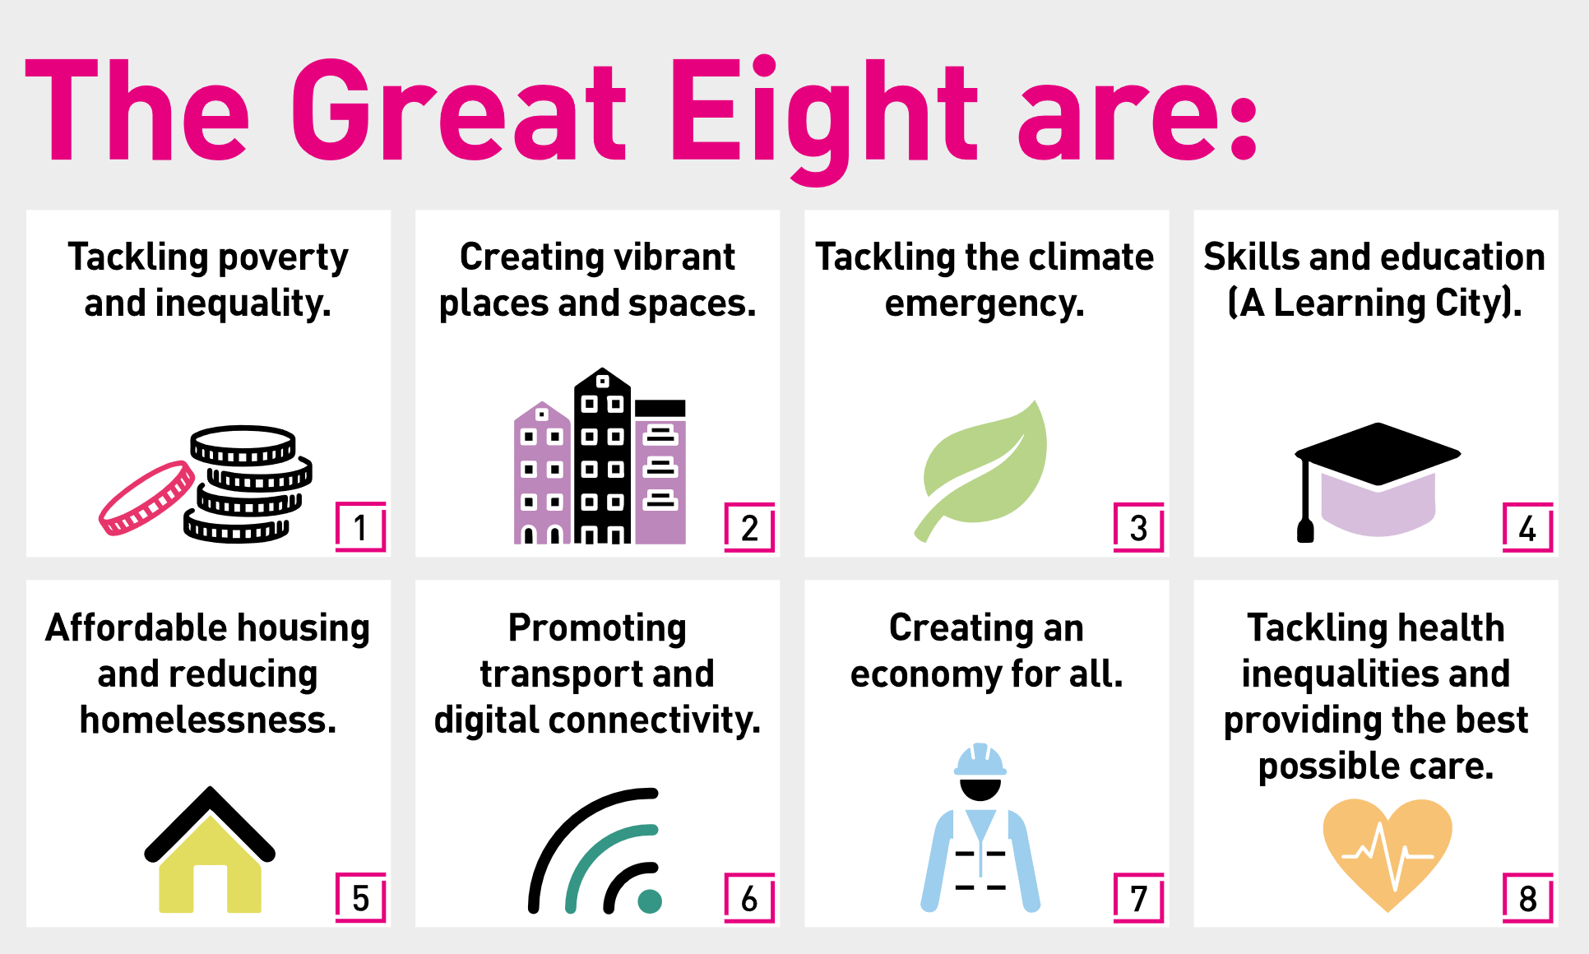

Our organisation’s values
We have four values: Pride, Passion, People, Personal responsibility.
Our four values are central to the way we communicate about the council and the way in which we behave with colleagues, customers, and partners - so that we live and breathe our values each day.

Application guidance
We are a values-based organisation so reflecting our values or a values-based approach in your evidence will support your application.
The different sections of this role profile are there to give you an understanding of the purpose of the role. The ‘what we need from you’ section outlines the minimum criteria you will need to meet within your application.

Role details
Completed by:
Date:
Job code:
Job score:
Date of evaluation:

