Communities & Engagement Strategic Lead
Service | Reporting to | Grade | Salary | Location | Hours
Place | Group Leader Investment | 4A | £33,782- £36,922 | Salford Civic Centre | 36

About the role
In this exciting and fast-paced role, you will lead and deliver proactive and coordinated communication, consultation, and engagement activity to support the delivery of high-profile major infrastructure projects alongside highways maintenance and traffic management updates.
You will lead, manage, and negotiate with a range of internal and external stakeholders working with design engineers to establish appropriate and timely project communications and project specific consultation and engagement approaches, at a City Mayor, Member, and stakeholder level. This will include but is not limited to:
- Acting as the lead point of contact for all stakeholder engagement and day to day enquiries on all major schemes.
- Preparing and delivering briefing sessions appropriate to target audiences
- Preparing and delivering public presentations at local meetings
- Organising and facilitating consultation events where appropriate
- Attending contractor meetings to share information on local issues raised and discuss potential solutions. Contract manage the delivery of social value.
- Relationship management with key external partners (e.g. TfGM, GMCA, Highways England, Department for Transport, Network Rail) will be essential.
Flexibility is key in being able to provide both strategic oversight and practical delivery of engagement activities to meet the needs of Technical Services, with the ability to respond to change in time-critical situations and equally comfortable representing the organisation externally with the ability to handle complex and sensitive project issues at a local level.
You will lead on public engagement including the development of networks to ensure consultation and engagement activity is inclusive and reaches Salford’s diverse communities.
You will act as the escalation point for all MP and Member inquiries for major infrastructure projects, liaising with the appropriate officers to facilitate a timely and appropriate response in line with council procedures.

Key outcomes
Lead and deliver proactive and coordinated communications, consultation and engagement activity to support the delivery of high-profile infrastructure projects, alongside highways maintenance and traffic management updates; ensuring the public and stakeholders are informed in a timely manner and are able to participate and engage.
Respond promptly to changing situations in complex project environments and prepare responses/narrative quickly and clearly using personal initiative. The ability to perform and multi-task under pressure is crucial.
Ability to make often complex language accessible and understandable to a broad range of people including innovative approaches to digital engagement.
Manage and assess information and data relating to engagement activities and ensure robust and auditable documentation and recording of engagement activities and outcomes.
Provide a responsive customer service function, monitoring and maintaining consultation email inbox(es) and directly responding to enquiries from the public and establish joint working protocols with appointed contractors.
Work closely with the Communications and Marketing team to ensure that all activities are delivered in line with the Council’s overall Communications Strategy, brand, visual identity, tone of voice and key messages.
Ensures compliance with regulations and requirements related to public consultation and engagement.

What we need from you
Graduate degree and/or post graduate qualification in a community development/ engagement/communications/marketing field or similar relevant degree or qualification with experience.
Knowledge, understanding and experience of using a variety of communication channels for engagement, including traditional, digital and social
An engaging, resilient, empathetic individual with excellent communication skills, to take ownership and lead an exciting and significant portfolio of work.
Detailed knowledge and understanding of community and stakeholder engagement best practice, and of the requirements and regulations related to public consultation and engagement
Highly developed organisational awareness and ability to understand any sensitivities within a complex multi-stakeholder structure; and think strategically to overcome obstacles to co-operation and progress
Experience of managing contractors/ consultants.
Proven experience of delivering and managing effective community relations in a high-profile and complex project environment.
Excellent attention to detail with an ability to work to tight deadline

Our vision and priorities

Our vision
The council has a vision is to create 'A fairer, greener and healthier Salford'.
To help us achieve this vision we have identified some key priorities to tackle the problems people in Salford are currently facing, the Great Eight.

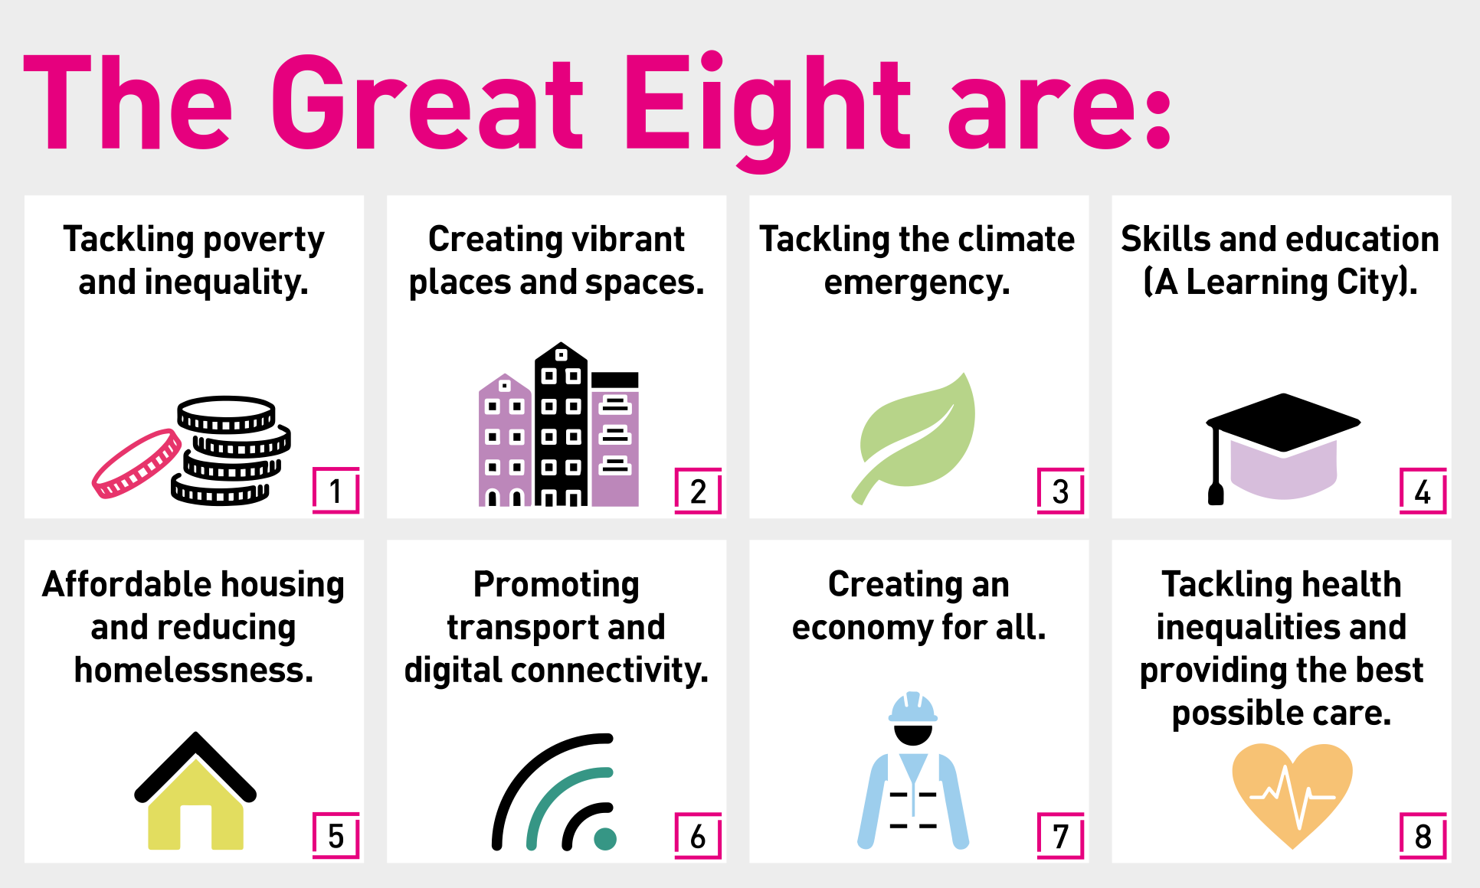

The Great Eight

Tackling poverty and inequality:
- Ensuring poverty prevention and reduction is at the heart of everything we do in the city
- Support people currently experiencing poverty through continuation of personalised care to the most vulnerable residents
- Work to reduce inequalities wherever they exist

Creating vibrant places and spaces:
- Deliver commitments within the city’s new Culture Strategy, including creation of a Salford Heritage Commission to support the city’s vibrant cultural assets
- Ensure local access to, and benefit from, the city’s world class cultural assets such as the Lowry and RHS Bridgewater
- Build on the city’s strong voluntary, community and social enterprise sector to build resilient community support and ensure Salford is a supportive and safe place
- Create and support vibrant neighbourhood centres at the heart of their local community

Tackling the climate emergency:
- Secure investment and development in green spaces and green infrastructure across the city, including electric vehicle charging points, affordable energy
- Encourage active travel and improvements in air quality
- Invest in green skills and green economic sectors to strengthen the city’s future economic resilience

Skills and education (A Learning City):
- Develop skills pipelines and a connected education system to link people to new job opportunities in productive growth sectors in the city
- Supporting young people to continue with their education in high quality and safe settings
- Support the transition of young people and recently unemployed into decent and sustainable jobs, focusing on growth sectors in the Salford and GM economy
- Support business development and innovation for the creation of new jobs and employment opportunities

Affordable housing and reducing homelessness:
- Continue efforts to reduce homelessness and rough sleeping
- Strengthen our commitment to provide decent and affordable social housing including through the council’s own ethical housing company Dérive

Promoting transport and digital connectivity:
- Support the development the cycling and walking network across the city
- Lobby for further investment in a connected public transport system, including extension of the GM Metro-link and GM bus franchising
- Invest in our digital infrastructure and skills to ensure no resident or business in the city is digitally excluded

Creating an economy for all:
- Maintain confidence to invest and develop in the city, focussed on our strategic opportunities and sectors and provide foundations for inclusive economic growth
- Maximise the social value and impact from our role as an anchor institution, including by prioritising local suppliers and local supply chains wherever possible, and committing to a strengthened Salford Social Value Alliance and 10% Better Campaign
- Supporting the development of alternative economic models and community wealth building to support residents to benefit from the local economy
- Lobby for a fair funding settlement for Salford to guarantee effective public services

Tackling health inequalities and providing the best possible care:
- Work to become a Marmot City
- Ensuring access to mental health care and support
- Ensuring children and young people are safe and have the best possible start in life
- Strengthening our unified model of health and care, including a valued care workforce

Our organisation’s values
We have four values: Pride, Passion, People, Personal responsibility.
Our four values are central to the way we communicate about the council and the way in which we behave with colleagues, customers and partners - so that we live and breathe our values each day.

Pride
“I’m proud of and committed to our city, its people, our work, and I demonstrate the ‘Spirit of Salford’ in everything I do.”

Passion
“I am optimistic and ambitious for the city and its people, being creative and positive about change and making the most of opportunities.”

People
“I respect and care for others, treating everyone fairly, listening and acting on the things people say.”

Personal responsibility
“I am honest, taking responsibility and ownership for my actions and decisions and using resources that I am trusted with wisely.”

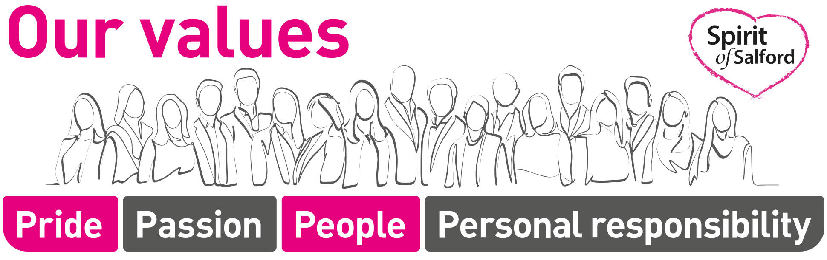

Application guidance
We are a values-based organisation so reflecting our values or a values-based approach in your evidence will support your application.
The different sections of this role profile are there to give you an understanding of the purpose of the role. The ‘what we need from you’ section outlines the minimum criteria you will need to meet within your application.

