Job specification
Job title: | Support Services Assistant
Service: | Integrated Community Equipment Store (ICES)
Grade:  Salary Range: | G4  £16,822 to £19,008
Reporting to: | ICES Manager

Your job
You will provide urgent support to provide equipment to facilitate hospital discharge and deliver and install equipment to allow people to live independently within their own homes.

You will be responsible for the correct input of data, upkeep and continued cleansing of database systems, correct creation of delivery notes. You will work on our reception and display excellent customer care skills.

You will liaise with both professionals and service users and will deal difficult situations on a daily basis.

In this job you will
On an on-going basis you will:

- Shadow early intervention staff to understand equipment provision in Wigan.
- Form part of the team to supply aids to daily living.
- Organise and attend supplier demo days for all prescribing officers.
- Treat all Customers of ICES with care and respect.
- Work hard to process as many deliveries as possible.
- To correctly Input and extract data from the various IT systems, - Mesals, excel and CES 360 including running reports and statistics as required.
- Identify operational improvements to increase deliveries.
- Deal with all incoming calls and be able to facilitate the customer’s request or signpost them to the correct service.
- Prioritise workload and work on your own initiative.

In this job you will need
You must be able to demonstrate the following essential requirements:

- Experience of working and dealing with the public.
- Considerable office experience.
- Experience of data entry on computer.
- Experience of using Excel.
- A willingness to train others in general office duties and use of the database.
- A willingness to undertake training when required in both related and non-related aspects of the Job.
- Ability to work as a team member.
- Flexible.
- Self-motivated.
- Good written and verbal communication.

Our culture
For us, it’s not just about all we achieve as an organisation, but how we do it. Therefore, all employees are expected to display our Be Wigan behaviours.
Be Positive… take pride in all that you do

Be Accountable… be responsible for making things better

Be Courageous… be open to doing things differently

Individuals with line management responsibilities are also expected to …
Inspire…lead by example and help others to see the big picture

Care… show genuine concern for people as individuals and value their contributions

Engage… I connect with others both within and beyond the organisation

Staff Deal
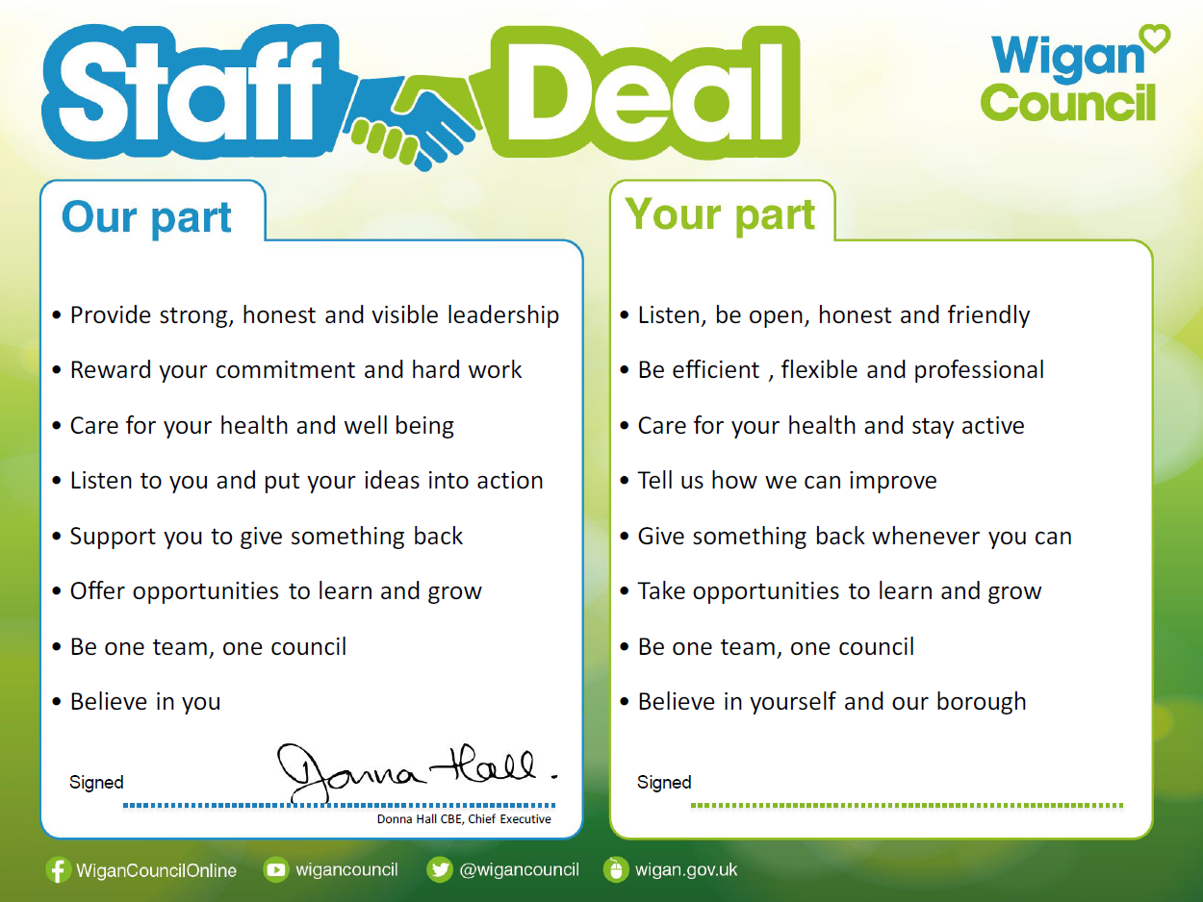
Our Staff Deal is an informal agreement with all staff. It outlines what you can expect from us, and in return what we expect from you

