Building Custodian - Apprentice
Service: |  | Facilities | Grade: | Apprenticeship |  |  |  |  | Salary: |  |  | £15,410 rising to £16,893 in your second year
Reporting to: |  | Assistant Facilities Managers | Location: | Various Salford Locations |  |  |  |  | Hours: |  |  | 36
About the role |  |  |  |  |  |  |  |  |  |  | Our priorities
- Movement and setting of furniture and other assets within and between buildings.  - Undertaking cleaning duties as required.  - Unlocking and security of buildings. Concierge service and including out of hours attendance as required.  - General portering duties to include delivery of parcels, delivery of print items, moving of furniture  and repair/handyperson, internal decoration work and replacement of faulty lamps and fluorescent  tubes as required.  - Collection of waste.  - Liaising with contractors ensuring a record is logged of their attendance.  - To be responsible for the appropriate checks, routine maintenance (e.g. fuel, oil, water, tyre  pressure, cleanliness) and completion of documentation of vehicles in an individual’s control from time to time.  - To identify and report to the Facilities Officers or Assistant Facilities Managers any potential issues that need resolution, particularly those relating to Health and Safety matters. |  |  |  |  |  |  |  |  |  |  | 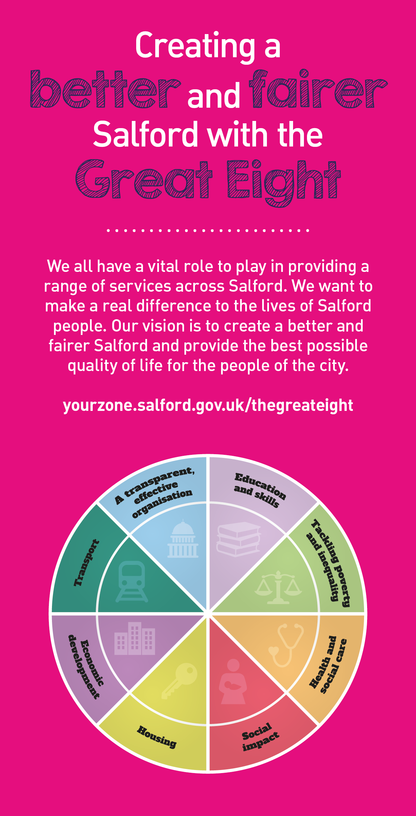
 | Key outcomes
 | - To provide efficient/effective custodian/handyman duties in line with specific requirements.  - To provide a professional, courteous service to all users  - To proactively improve personal performance and increase levels of job satisfaction. |  |  |  |  |  |  | - Keeping Council or School buildings as safe, efficient and clean working environments  - Ensure high standards of Health and Safety and reducing risks at work.
 | What we need from you
 | - Proven technical skills and ability in the role with a record of accomplishment for delivering outcomes  - Professional credibility through proven relevant experience  - To model and demonstrate our values and behaviours  - Interpersonal skills, demonstrating effective customer care  - Experience of working in an environment where the exercise of co-ordinated physical skills was required in an indoor and outdoor setting |  |  |  |  |  | - Knowledge of the operation of building security systems  - Written, ICT and numerical skills sufficient to record relevant information  - Knowledge of key health and safety requirements relating to the position  - Willingness to undertake training and development, this will include Facilities Service Operative Level 2 Apprenticeship Standard and Functional Skills (if applicable).  - You must be able to drive and will be required to provide a car for use in connection with the duties of this post and must be insured for business use.
What we can offer you
Your ongoing professional development and success in your role is important to us, and that is why we provide a variety of learning and development opportunities. Within the sections below you will find development options tailored to you which will enable you to further develop your existing skills and learn new ones at a pace that suits you best. If you are joining us now, your development will form part of ongoing discussions with your manager. If you are an existing employee, you should use your Personal Development Reviews to discuss your development with your manager and create your development journey. It’s important you also take full advantage of any informal learning available to you during the course of your work.

- Online Learning - Develop your knowledge across a wide range of areas through our Me-Learning platform, with over 200 free courses to choose from. To have the best possible start and comply with current legislation, you must complete the following modules: Welcome to Salford, Health and Safety in the Office, GDPR, Equality Essentials, Safeguarding Children and Adults, and Safer Recruitment. You may also benefit from a variety of courses in categories such as Business Skills, IT and Project Management which are available to learn at your own convenience and pace.  - Developing your digital skills – Our ambition is to provide our workforce with the right level of digital capabilities needed to be successful. Whatever your current digital abilities are, we can provide development ranging from essential workplace skills to specialist workplace skills’. These will be delivered through our Digital Skills Academy using both self-directed and guided learning opportunities to enable you to develop. Additionally, you can access free online courses through the iDea website. |  |  |  |  |  | - Professional Development – Gain role specific skills and time to learn through a wide range of development opportunities. Learn whilst working and get support towards your qualification through an apprenticeship standard. From day one you’ll have access to professional development to help you get on and succeed in your new role. This will include an immediate opportunity to gain a level 2 qualification in facilities services operative. Why not find out more about it here https://www.instituteforapprenticeships.org/apprenticeship-standards/facilities-services-operative/  - Sharing your digital skills – Our goal is to support you to share your digital knowledge with other people. Our Digital Eagles programme has been designed to cover basic digital skills and build your confidence to assist others. By the end of this programme you will join hundreds of staff members who already are digital eagles, and be able to help colleagues, customers, residents, or people in your personal life with all things digital.

Application guidance |  | Our values
We are a values based organisation so reflecting our values or a values based approach in your evidence will support your application.

The ‘Key outcomes’ and ‘What we need from you’ sections of the Role Profile are there to give you an understanding of what we would like to see reflected in your application. Don’t give up if you are not able to reflect all of these in your application.

Please apply with a CV and no more than one A4 sheet detailing why you feel you would be suitable for the role.

