 | Human Resources and Organisational Development Business Partner (Fixed Term 18 months)
 | Service: |  | Human Resources and Organisational Development | Grade: | 4A |  |  | Salary: |  |  |  | £32,878 - £35,934
 | Reporting to: |  | Strategic HR and OD Manager | Location: | Civic Centre |  |  | Hours: |  |  |  | Up to 36 hours per week
 | About the role |  |  |  |  |  |  |  |  |  | Our priorities
 | - Position the role of HR and OD Business Partner as an integral part of our delivery squad to lead the development and implementation of a new digital platform to support children and adult services.  - Work in partnership with Digital, Data & Technology and communications colleagues championing our #TeamSalford approach to empower our employees to work in new and different ways.  - Build effective relationships with other stakeholders including delivery partners to ensure the workforce are central to this programme of work.  - Work with senior managers to understand the future vision for the services and quickly build credibility to challenge existing practice and behaviours where required.  - Build effective relationships across the services, using a range of techniques to fully engage leaders and the workforce, challenging thinking and co-designing new ways of working.  - Utilise our established approach of co-design with practitioners, managers and senior leaders, ensuring needs are understood and then articulated into clear workforce development plans  - Work side by side with front-line practitioners and services to truly understand roles and service delivery processes/procedures and ensure the workforce are engaged, involved and motivated about the changes.  - Ensure a ‘people centred’ approach is taken throughout the programme of work using persuasion and influencing skills to bring about behavioural change in line with our vision and organisational values and further promote a positive culture.  - Be able to develop, change and adapt workforce development and learning solutions where needed and for different audiences to achieve the desired outcomes.  - Work closely with other members of the HR and OD team to ensure this programme of work is aligned to other HR and OD priorities across the services and wider organisation and ensure a close link to our overarching programme of change [My]Work. |  |  |  |  |  |  |  |  |  | 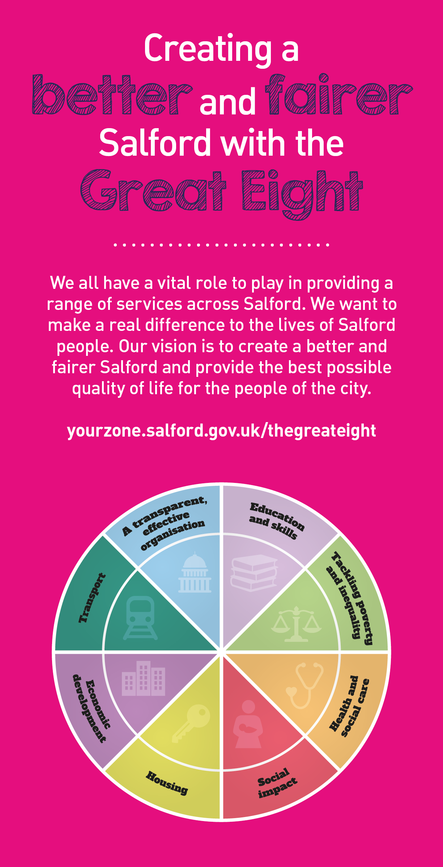
 |  | Key outcomes
 |  | Working with other squad members you will play a key role in the successful implementation of a new digital platform in children and adult services and introduce new ways of working to achieve desired outcomes and improved services for our citizens. Taking an intelligence led approach you will inform and develop workforce plans and approaches to deliver the key workforce priorities to enable and support smarter working practices which will deliver better outcomes to our citizens of Salford. Through immersion in children’s and adult services, you will take time to discover and fully understand the workforce and existing practice to inform the planning, co-design and implementation of a programme of outcome focussed organisational development activities to embed a new digital platform and empower people to work in new and different ways You will focus on building leadership capability through the implementation of the Salford leadership framework, the use of coaching, and designing and facilitating workshops and other development activities to support managers to own and lead this digital transformation programme. Utilise our approach of co-design to ensure the workforce are fully involved and engaged throughout the programme, using a range of different techniques. Identify good practice from across the services that reinforce and promote workforce ambitions and ensure learning and development is then shared across other services. Support the development of approaches to further embed our values. Play a key role in developing a values based positive permission culture organisation that can deliver a better and fairer Salford for everyone.
 |  | What we need from you
- Proven technical skills and ability in a similar role with a record of accomplishment for delivering outcomes across organisational development and behaviour change.  - The ability to empower and enable employees to be productive, efficient and effective to work, anywhere, anytime, creating a flexible workspace, whilst maintaining a healthy work life balance. ​  - A high level of understanding and practice in organisational and workforce development and delivering workforce plans to achieve desired outcomes.  - Curiosity coupled with excellent communication and influencing skills to understand and engage with services in a positive way to embed change.  - Able to work independently, and as part of a cross-disciplinary group, whilst connecting strategically with colleagues in Communications and OD.  - Able to build trust by role modelling ethical behaviour and applying consistent principles and values in decisions and choices.  - Able to see the bigger picture and identify strategic links.  - Able to creatively identify and deliver key workforce requirements and develop appropriate strategies and plans.  - Confidence to articulate and influence to gain buy-in whilst being open to the views of others - able to constructively challenge and be challenged. |  |  |  |  |  |  | - Able to influence, agree goals with colleagues and partners to develop effective collaborative approaches.  - A commercial mindset with behaviours that enable positive change.  - Strong organisational skills with ability to deliver key projects within agreed timescales.  - Able to bring together multi-faceted activities to improve performance.  - Able to take an intelligence-led approach and look for every opportunity to solve problems and improve the way we work whilst sharing learning with colleagues.  - A skilled communicator who acts with clarity, conviction and enthusiasm and is able to demonstrate build trust and confidence.  - Able to lead face-to-face engagement with forums, design workshops and information drop-ins.  - Systems knowledge: Microsoft Office package skills. Ability to use email campaign management tools, social media management tools, content management systems and image and video editing tools to create content across different channels.  - Able to use technology to collaborate, connect and share to make the most use of digital tools and model new behaviours.  - Modelling and demonstrating our values, leadership and required behaviours.  - Personal responsibility for self-development, identifying opportunities to learn new skills that will enhance capability and impact.
 | Our leadership behaviours |  |  |  |  |  |  |  |  | Our values
As a values-based leader you will:  - Model the values and embed them in the way your team delivers services  - Hold people accountable for delivering the values  - Respect and care for others, treating everyone fairly, recognising the importance of ensuring equality of opportunity for all, and listening and acting on the things people say  - Be honest, taking responsibility for your actions and decisions  - Use resources that you are trusted with wisely. |  | To lead and develop people you will:  - Listen to understand, not to defend  - Give people the freedom to use their initiative  - Provide opportunities for people to discuss and solve problems and issues  - Regularly provide coaching and support to others to help them achieve their objectives and potential  - Appreciate and build on people’s strengths  - Motivate, engage, encourage and inspire others in order to be the best they can be.
To create a performance and development culture you will:  - Be visible, inject pace, vigour and purpose  - Expect high standards; mediocrity is not acceptable  - Take an evidence and whole system approach in making decisions  - Maximise technology and models to deliver quicker, easier, better services  - Have a digital mindset, fully utilising digital systems and solutions to deliver services differently  - Set context and challenging goals that will motivate people to take ownership, maximise performance, and develop. |  | To build and communicate a vision for the future you will:  Be optimistic and ambitious for the city and its people, helping others to understand the need to transform public services  Build strong collaborative relationships to find creative ways to make services more sustainable and flexible  Recognise and values the strengths of people and places, taking a strengths-based approach to make the most of opportunities  Support people through change, in undertaking new things, and taking risks  Take a place and whole system approach in designing, delivering and leading services  Ensure an inclusive approach with the aim of reflecting the increasing diversity of Salford.

What we can offer you
Your ongoing professional development and success in your role is important to us, and that is why we provide a variety of learning and development opportunities. Within the sections below you will find development options tailored to you which will enable you to further develop your existing skills and learn new ones at a pace that suits you best. If you are joining us now, your development will form part of ongoing discussions with your manager. If you are an existing employee, you should use your Personal Development Reviews to discuss your development with your manager and create your development journey. It’s important you also take full advantage of any informal learning available to you during the course of your work.
- Online Learning - Develop your knowledge across a wide range of areas through our Me-Learning platform, with over 200 free courses to choose from. To have the best possible start and comply with current legislation, you must complete the following modules: Welcome to Salford, Health and Safety in Office, Equality Essentials, GDPR, Safeguarding Children and Adults, and Safer Recruitment. You may also benefit from a variety of courses in categories such as Business Skills, IT and Project Management, Leadership and Management which are available to learn at your own convenience and pace.

- Developing your digital skills – Our ambition is to provide our workforce with the right level of digital capabilities needed to be successful. Whatever your current digital abilities are, we can provide development ranging from essential workplace skills to specialist workplace skills’. These will be delivered through our Digital Skills Academy using both self-directed and guided learning opportunities to enable you to develop. Additionally, you can access free online courses through the iDea website.

- Sharing your digital skills – Our goal is to support you to share your digital knowledge with other people. Our Digital Eagles programme has been designed to cover basic digital skills and build your confidence to assist others. By the end of this programme you will join hundreds of staff members who already are digital eagles, and be able to help colleagues, customers, residents, or people in your personal life with all things digital.

Application guidance

We are a values based organisation so reflecting our values or a values based approach in your evidence will support your application.

The ‘Key outcomes’, ‘What we need from you’ and ‘our leadership behaviours’ sections of the Role Profile are there to give you an understanding of what we would like to see reflected in your application. Don’t give up if you are not able to reflect all of these in your application.

