MOSSFIELD PRIMARY SCHOOL
Mossfield Road
Pendlebury

Manchester
M27 6EH

Headteacher :- Mr D Magee Deputy Head - Mrs M.Reaper
Website :- http://www.mossfieldps.salford.sch.uk Telephone No.: 0161 921 2160
School Blog- http://www.mossfieldps.co.uk Fax: 0161 921 2165

Mossfield Primary School

Mossfield is a modern and bright two form entry Primary School for children between the ages of 3 and 11. Fully renovated in recent years, at a cost of over 3 million pounds, our buildings provide an excellent environment for learning, with modern facilities and a welcoming, yet secure environment.

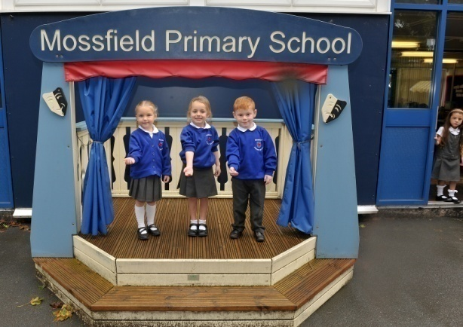
We are situated approximately half a mile from the centre of Swinton & the M60. The School consists of three main teaching areas (Foundation, KS1 & KS2) within two buildings. There is a hall in the main building which is used for assemblies, P.E. and also as a dining area. We are lucky to have superb ICT facilities, with a school wide wireless network and lots of computers and devices for the children to use on a regular basis.

The school has large hard core playgrounds, secured by fencing, and is surrounded by extensive playing fields. Classrooms are larger than average, proving a spacious working environment.

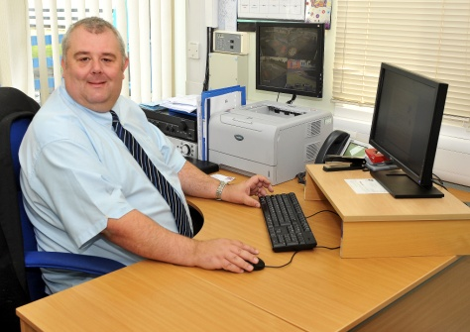
Dear applicant,

A warm welcome to Mossfield Primary School!

We hope that you will find this information useful in decided whether to apply for a post at Mossfield Primary School.

We are extremely proud of our school and its well-ordered and harmonious community. We believe strongly that school should be fun (for staff as well as children! ) and that each child has the right to be encouraged and nurtured to reach their full potential. We provide a broad and stimulating curriculum within a friendly, happy and secure environment.

We recognise that appointing a person for a job vacancy is in fact a two way process – We must be sure that the successful candidate meets our criteria and will fit in well. Equally, you must be sure that the post you take on is right for you and that you will be happy in your future career. Nobody wants to work with somebody who is not happy in their work!

To assist you in deciding if Mossfield would be the right place for you, please could I suggest you take a look at our website and school blog. Both have a wealth of recent information about the school and give a flavour of what it is like to work or study here.

Website - http://www.mossfieldps.salford.sch.uk/

School Blog - https://mossfieldprimaryschool.com/

We look forward to meeting you soon!

Yours sincerely,

Mr D Magee
Headteacher

