Beal Vale Primary School

Part of Crompton House Multi Academy Trust



Headteacher Candidate

Information Pack

### *****Learning is for Life, Enjoy the Journey!*****

**Table of Contents**

Message from the Chair of Governors ................................................................................................. 3

Overview of Beal Vale Primary School ..................................................................................................4

Headteacher Advert…………………...................................................................................................... 5

Job Description .........................................................................................................................................7

Person Specification ............................................................................................................................... 11

Application Details .................................................................................................................................. 14

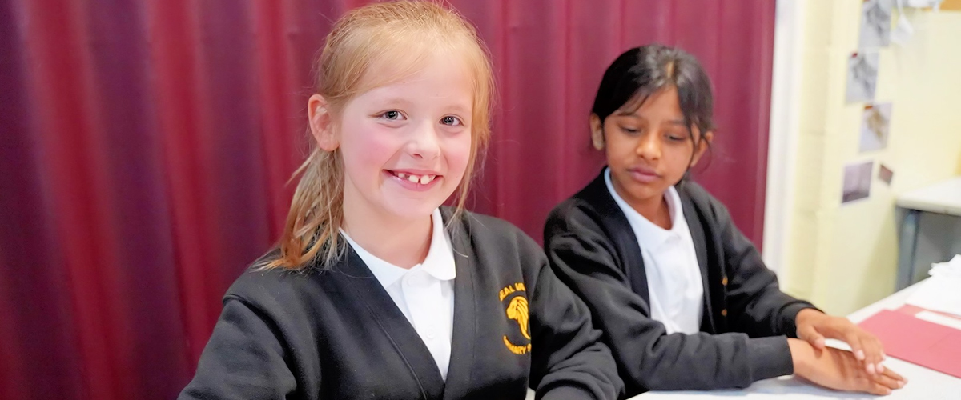

### *****Learning is for Life, Enjoy the Journey!*****

**Beal Vale Primary School**

Salts Street,  
Shaw,  
Oldham,  
OL2 7SY

<https://bealvaleprimary.com/>

**Message from Chair of Governors**

Dear Applicant

On behalf of all of the Governors I would like to thank you for your interest in the Headteacher position at Beal Vale Primary School

Beal Vale is a popular primary school located in Shaw which borders the beautiful moorland and hills of Saddleworth. We are easily accessible via the M62.

We are a single form entry school and have 191 children currently on role. Our most recent OFSTED in February 2015 rated us as good with outstanding early years provision. We are part of the Crompton House Multi Academy Trust together with one other local secondary school: Crompton House Church of England High School.

We have an extremely experienced senior leadership team and a team of talented and enthusiastic teachers, teaching assistants and support staff. Our children are well behaved and keen to learn. Aside from academic achievements that compare well with national averages, we have a rich offer of extra-curricular activities that truly enhance the school community. We all strongly believe in our school motto of “*Learning is for Life, Enjoy the Journey*”.

We would like to appoint someone who shares our vision and can also take us to the next level of excellence.

Please do come and visit the school informally and see for yourself what a wonderfully supportive environment we have. You can make an appointment through our Business Manager, Tania Tushingham, by calling [0161 770 5752](https://www.google.com/search?q=beal+vale&oq=bea&aqs=chrome.0.69i59l3j69i57j69i60l3j69i65.2686j0j4&sourceid=chrome&ie=UTF-8) or by email [t.tushingham@beal-vale.oldham.sch.uk](mailto:t.tushingham@beal-vale.oldham.sch.uk)

You will also find more information on our website <https://bealvaleprimary.com/>

I look forward to meeting you and thank you for your interest,

Yours faithfully,

C. Richards

Chris Richards

Chair of Governors

# Overview of Beal Vale Primary

We are a mixed primary school for children between the ages of 4 -11. Our school has community at its heart and values the individual.

We want our children to be confident in their own abilities and to reach their fullest potential in all areas of life and development. We nurture a supportive community where every child and adult are worthy of understanding and respect.

## School Ethos and Values

The Governors and Staff of Beal Vale Primary School believe that we provide the vital transition from home to the outside world, and another step in the learning process which begins the moment a child is born. We believe that Learning is for Life.

Our school motto is:

***Learning is for Life, Enjoy the Journey!***

We hope to lay the foundation for academic learning, fostering a love of knowledge and a desire to achieve that gives all children the best possible learning opportunities, matched to their individual needs, within a happy and safe environment.

We are committed to providing equal opportunities for all.

We recognise and  value diversity within our school, community and the wider world.

Whilst academic achievement is important, we  recognise our role in developing the “whole child”. Therefore, we aim to promote not just intellectual growth but his/her physical, social, moral, spiritual, emotional, creative and aesthetic development, as well as raising self-esteem, encouraging a sense of responsibility, initiative, and self-discipline.

As a school we continually strive to improve and aim to prepare our pupils to make a positive and responsible contribution to life in our ever-changing and increasingly technological world.

We aim to develop a strong partnership with parents and encourage all our pupils to develop as citizens of the school and wider community.

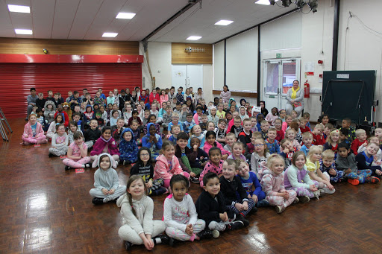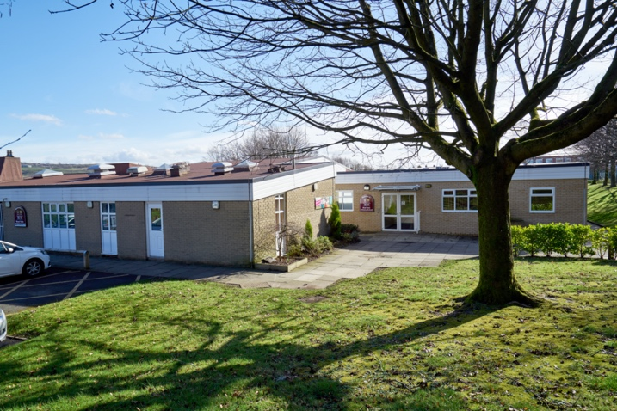

**Headteacher Advert**

Post Title: Headteacher (Permanent and full time)

Salary: Leadership 16 – 22 (dependent on experience) £59,528 -£68,851

The children, parents, staff and governors of Beal Vale Primary School are seeking to appoint a passionate and inspirational Headteacher to lead our great school. The current leadership of the school has undergone a period of change and we are now in a position to recruit a Headteacher who will lead us through the next phase of our school improvement journey. One of the key areas for the new Headteacher is to promote the school, using a range of means, to ensure that we become the local school of choice.

You will either be a current, serving Headteacher or a Deputy looking for an exciting new challenge. You will have a solid understanding of the requirements of the new Ofsted framework and will be excited by the opportunity to further develop the school’s curriculum.

Beal Vale Primary School is a single form entry school that has community at its heart and values the individual. We want our children to be confident in their own abilities and to reach their fullest potential in all areas of life and development. We nurture a supportive community where every child and adult are worthy of understanding and respect.

In 2019, the Governors agreed to convert the school to academy status, joining a multi-academy trust alongside a successful and very popular secondary school with whom we work closely. We are currently at an exciting stage of the Trust’s journey and are looking to strengthen collaboration and to further opportunity for both pupils and staff.

We are looking for someone who:

* Has a clear commitment to the development of the whole child
* Will drive forward teaching and learning so all our children can reach their full potential
* Will be committed to the safeguarding and well-being of all children
* Is a strategic, creative and innovative thinker with outstanding leadership and management skills
* Is a good team player who wants to enthuse and involve the people around them
* Has the ability to adapt to an ever-changing educational landscape
* Has excellent communication skills at all levels
* Is able to work collaboratively with all stakeholders
* Is able to drive forward school improvement
* Will work with the Trust CEO to strengthen the primary offer and to identify and work with other schools who are considering joining the trust

We can offer:

A safe and stimulating environment where success is celebrated and where children feel confident to explore, take risks in their learning and gain from their experiences.

* Enthusiastic, well-behaved children who are keen to learn and are proud of their school
* An extremely hard working, committed and high-quality team of staff
* An active, strong and supportive governing body and trust board
* Close links with the local authority and other local schools within the wider network.

Visits to the school are warmly welcomed and encouraged. Please arrange appointments through Tania Tushingham, Business Manager on [0161 770 5752](https://www.google.com/search?q=beal+vale&oq=bea&aqs=chrome.0.69i59l3j69i57j69i60l3j69i65.2686j0j4&sourceid=chrome&ie=UTF-8).

The school is committed to safeguarding and promoting the welfare of children and expects all staff and volunteers to share this commitment. The successful candidate will be required to undertake a criminal record check via the DBS.

If you feel this may be the career opportunity you are looking for, please contact us for an application form. Email: [j.rankin@cromptonhouse.org](mailto:j.rankin@cromptonhouse.org)

Closing Date for Applications: Monday 14 September 2020 at 12.00 noon

Interviews week commencing 21 September 2020

Start date: 1st January (However this is negotiable)

## Headteacher

## Job Description

Post Title: Headteacher (Permanent and full time)

Salary: Leadership 16 – 22 (dependent on experience) £59,528 -£68,851

Job Purpose: The core purpose of the Headteacher is to raise standards of achievement for all pupils by providing professional leadership and management for Beal Vale Primary School. The Headteacher must establish high quality education by leading teaching and learning, having high aspirations and developing all staff.

The Headteacher is the leading professional in the school. Accountable to the CEO and governing body, the Headteacher provides vision, leadership and direction for the school and ensures it is managed and organised to meet the aims and ambitions established by the governors, the trust board and the community the school serves. The Headteacher is responsible for monitoring and evaluating the school’s performance and identifying priorities for continuous improvement. The Headteacher's priorities will include raising standards for all children and ensuring equality of opportunity for all by developing effective policies and practices. The Headteacher will deploy resources efficiently and effectively to achieve the school’s aims and objectives. The Headteacher will be responsible for the effective day to day management, organisation and administration of the school. The Headteacher secures the commitment of the wider community to the school by developing and maintaining effective partnerships.

With the governing body, the Headteacher is responsible for creating a productive learning environment, which is engaging and fulfilling for all pupils.

**Reporting to:** The Governing Body and the CEO of the Trust

**Responsible for:** All staff within the school

The Headteacher will carry out his/her professional duties with responsibility to the Governors and the CEO of the Trust for the conduct, management and administration of the School, subject to any policies which the DfE/ESFA and the Governors or Trust may implement. The job description is subject to annual review.

**Key Areas of Responsibility:**

To undertake the professional duties of a Headteacher, as set out in the current School Teachers’ Pay and Conditions Document and National Standards for Headship, which focus on: -

**1. Shaping the Future**

Working with the governing body to create a shared vision and strategic plan which inspires and motivates pupils, staff and all other members of the school community.

**The Headteacher of Beal Vale Primary School will:**

* Ensure the vision for the school is clearly articulated, shared, understood and effectively acted upon by all.
* Work within the school community to translate the vision into agreed objectives and operational plans, which will promote and sustain school improvement.
* Demonstrate the vision and values in everyday work and practice.
* Motivate and work with others to create a shared, positive culture.
* Ensure creativity, innovation and the use of appropriate new technologies to achieve excellence.
* Work in partnership and collaboration with other schools and early years’ providers and the Oldham Education Partnership.

**2. Leading Teaching and Learning**

The Headteacher in Beal Vale Primary School will have a central responsibility for raising the quality of teaching and learning, for pupils’ achievement, setting high expectations and monitoring and evaluating learning outcomes

**The Headteacher of Beal Vale Primary School will:**

* Ensure a consistent and continuous school-wide focus on pupils’ achievement, using data and benchmarks to monitor progress in every child’s learning.
* Ensure that learning is at the centre of strategic planning and resource management.
* Establish creative, responsive and effective approaches to teaching and learning which meet identified needs.
* Ensure a culture and ethos of challenge and support where all pupils can achieve success and become engaged in their own learning.
* Demonstrate and articulate high expectations and set stretching targets for the whole school community.
* Implement strategies that secure high standards of behaviour and attendance.
* Determine, organise and implement a diverse, flexible curriculum and implement an effective assessment framework.
* Take a strategic role in the development of new and emerging technologies to enhance and extend the learning experience of pupils.
* Monitor, evaluate and review classroom practice and promote improvement strategies.
* Challenge under-performance at all levels and ensure effective intervention and follow-up action.

**3. Developing Self and Working with Others**

The Headteacher of Beal Vale Primary School will build a professional learning community that enables others to achieve.

**The Headteacher of Beal Vale Primary School will:**

* Treat people fairly, equitably and with dignity and respect to create and maintain a positive school culture.
* Build a collaborative learning culture within the school and actively engage with other schools to build effective learning communities.
* Develop and maintain effective strategies and procedures for staff induction, professional development and appraisal.
* Ensure effective planning, allocation, support and evaluation of work undertaken by teams and individuals, ensuring clear delegation of tasks and devolution of responsibilities.
* Acknowledge the responsibilities and celebrate the achievements of individuals and teams.
* Develop and maintain a culture of high expectations for self and for others and take appropriate action when performance is unsatisfactory.
* Regularly review their own practice, set personal targets and take responsibility for their own personal development.
* Manage their own workload and that of others to allow an appropriate work/life balance.

**4. Managing the Organisation**

The Headteacher of Beal Vale Primary School will ensure that the school and the people and resources within it are organised and managed to provide an efficient, effective and safe learning environment.

**The Headteacher of Beal Vale Primary School will:**

* Create an organisational structure which reflects the school’s values, and enables the management systems, structures and processes to work effectively in line with legal requirements.
* Produce and implement clear, evidence-based improvement plans and policies for the development of the school and its facilities.
* Ensure that policies and practices take account of national and local circumstances, policies and initiatives.
* Manage the school’s financial and human resources effectively and efficiently to achieve the school’s educational goals and priorities.
* Recruit, retain and deploy staff appropriately and manage their workload to achieve the vision and goals of the school, implement successful performance management processes with all staff.
* Manage and organise the school environment efficiently and effectively to ensure that it meets the needs of the curriculum and health and safety regulations.
* Ensure that the range, quality and use of all available resources is monitored, evaluated and reviewed to improve the quality of education for all pupils and provide value for money.
* Use and integrate a range of technologies effectively and efficiently to manage the school.

**5. Securing Accountability**

The Headteacher of Beal Vale Primary School is accountable to a wide range of groups, particularly pupils, parents, carers, governors and the Local Authority. The Headteacher is legally and contractually accountable to the Governing Body for the school, its environment and all its work.

**The Headteacher of Beal Vale Primary School will:-**

* Fulfil commitments arising from contractual accountability to the Governing Body.
* Develop a school ethos which enables everyone to work collaboratively, share knowledge and understanding, celebrate success and accept responsibility for outcomes.
* Ensure individual staff accountabilities are clearly defined, understood and agreed and are subject to rigorous review and evaluation.
* Work with the Governing Body (providing information, objective advice and support) to enable it to meet its responsibilities.
* Develop and present a coherent, understandable and accurate account of the school’s performance to a range of audiences including governors, parents, carers and the Local Authority.
* Reflect on personal contribution to school achievements and take account of feedback from others.

**6. Strengthening Community**

The Headteacher of Beal Vale Primary School will work collaboratively at both strategic and operational levels with parents and carers and across multiple agencies for the well-being of all children. They will collaborate with other schools, to share expertise and bring positive benefits to their own and other schools. The Headteacher will share responsibility for leadership of the wider educational system.

**The Headteacher of Beal Vale Primary School will:**

* Maintain and develop the school's position at the heart of the community.
* Create and maintain an effective partnership with parents and carers to support and improve pupils’ achievement and personal development.
* Collaborate with other agencies in providing for the academic, spiritual, moral, social, emotional and cultural well-being of pupils and their families.
* Ensure a range of community-based learning experiences.
* Seek opportunities to invite parents and carers, community figures, businesses or other organisations into the school to enhance and enrich the school and its value to the wider community.
* Ensure learning experiences for pupils are linked into and integrated with the wider community.
* Create and promote positive strategies for challenging prejudices and dealing with bullying and harassment.
* Contribute to the development of the education system by, for example, sharing effective practice, working in partnership with other schools and promoting innovative initiatives.

**6. Strengthening the Multi Academy Trust (MAT)**

The Headteacher of Beal Vale will work with the CEO to strengthen and grow the Trust.

**The Headteacher of Beal Vale Primary School will:**

* Promote the values of the School and the MAT
* Advise the CEO in matters relating to early years and primary education
* To work with the CEO on strategies to assist with the growth plans of the MAT
* Work with the leadership of the MAT to promote collaborative working across all schools

**7. Safeguarding Children & Safer Recruitment**

Beal Vale Primary School is committed to safeguarding and promoting the welfare of children and young people as required under the Education Act 2002 and expects all staff and volunteers to share this commitment.

**The Headteacher of Beal Vale Primary School will:**

* Ensure that the policies and procedures adopted by the governing body are fully implemented and followed by all staff.
* Ensure that sufficient resources and time are allocated to enable the designated person and other staff to discharge their responsibilities, including taking part in strategy discussions and other inter-agency meetings, and contributing to the assessment of children.
* Ensure that all staff and volunteers feel able to raise concerns about poor or unsafe practice in regard to children, and such concerns are addressed sensitively and effectively in a timely manner in accordance with agreed whistleblowing practices.
* Co-operate and work with relevant agencies to protect children.

Beale Vale Primary School is committed to safeguarding and promoting the welfare of children and young people and requires all staff to share this commitment. Applicants must be willing to undergo all the relevant pre-employment checks as laid out in *Part three: Safer Recruitment section of Keeping Children Safe in Education 2019.*

## Headteacher Person Specification

|  |  |  |  |
| --- | --- | --- | --- |
|  | **Criteria** | **Essential (E) Desirable (D)** | **How Assessed** |
| **Education & Qualifications** | Qualified Teacher Status  Degree or equivalent  Evidence of continuing professional development including preparation for a senior management role | E  E  E | Application Form |
| **Work related experience** | Experience as a Head or Deputy Head  Experience of working in more than one school at a senior level  Experience of teaching across all the primary phases  Experience of successful strategies for raising pupils’ achievement  Experience of promoting pupils spiritual, moral, social and cultural development and their good behaviour  Experience of implementing and overseeing successful school improvement initiatives  Experience of the strategies for improving the quality of teaching and learning including promoting excellence and challenging poor performance  Experience of monitoring and evaluating the effectiveness of teaching and learning including its outcomes in terms of standards, achievement, personal development and well being  Experience of current good practice in assessment techniques and curriculum development  Experience of analysing comparative data, together with information for pupils’ prior attainment, to establish benchmarks and to set targets for improvement in teaching and learning  Experience of strategies for curriculum enrichment that have shown successful impact for all age groups  Experience of and strategies for effectively managing a wide range of staff  Experience of thinking and planning strategically for the future  Experience of leading innovation, creativity and change in school  Experience of the impact of equality of opportunity and inclusion policies on pupils and staff | E  D  D  E  E  E  E  E  E  E  E  E  E  E  E | Application Form  Application Form  Application Form  Application Form/Selection process  Selection process  Application Form/Selection process  Application Form/Selection process  Application Form/Selection process  Application Form/Selection process  Application Form/Selection process  Application Form/Selection process  Application Form/Selection process  Application Form/Selection process  Application Form/Selection process  Application Form/Selection process |
| **Skills & Abilities** | Able to nurture, inspire, challenge and motivate pupils and staff  Able to be an exemplary role model to pupils and staff  Able to establish and sustain effective organisational structures, systems, policy and practice, including safeguarding    Able to think creatively to anticipate and solve problems and demonstrate balanced and fair judgement  Able to consult and negotiate to achieve the best possible outcomes for children and their families  Able to build and sustain effective relationships with all stakeholders that will enhance the education of all pupils at Beal Vale Primary School  Able to work in partnership and accept appropriate support from all stakeholders in Beal Vale Primary School | E  E  E  E  E  E  E | Selection process  Selection process  Selection process  Selection process  Selection process  Application Form/Selection process  Application Form/ Selection process |
| **Knowledge** | Knowledge of the principles and practice of Quality Assurance systems including school review, self-evaluation and appraisal | E | Application Form/Selection process |
| **Work Circumstances** | Requirement to work flexibly to meet the demands of the post including some evening and weekend work  An enhanced DBS disclosure is required | E | Selection process |

**Application Details**

Thank you for your interest in the Headteacher post at Beal Vale Primary School. Details of how to apply can be found below.

### How to Apply

Should you wish to apply for the post, please complete and return an application form highlighting how your skills and abilities demonstrate your suitability for this role. The application form can be obtained and returned to Julie Rankin [j.rankin@cromptonhouse.org](mailto:j.rankin@cromptonhouse.org)

Applications can also be submitted by post, for the attention of Karl Newell, MAT CEO, to the following address:

Crompton House Church of England Multi Academy Trust

Rochdale Road

Shaw

Oldham

OL2 7HS

### Application Forms

Closing Date for Applications: Monday 14 September 2020 at 12.00 noon

Interviews week commencing 21 September 2020

Start date: 1st January (However this is negotiable)

Candidates shortlisted for interviews will be asked to undertake a series of selection tasks and activities. More information on the format and any preparation needed will follow after shortlisting.

It is our normal policy to take up three references for headship appointments. In the case of applicants who are currently employed as a Headteacher, we will expect these to be from:

* The local authority or academy trust where you are currently employed;
* Your Chair of Governors;
* Another referee who is able to support your application for the post of Headteacher.

In the case of applicants who are not currently employed as Headteacher, we will expect referees to be:

* The Headteacher in your current or most recent school, or if you are not currently employed in a school, your current line manager;
* Another referee who can attest to your professional skills, including leadership and management skills;
* Another referee who is able to support your application for the post of Headteacher.