Welfare Rights Officer (Mental Healh) - Temporary
Service: |  | Welfare Rights and Debt Advice | Grade: | 3B | Salary: |  |  | £26,470 to £29,055
Reporting to: |  | Senior WRO ( Service Manager) | Location: | Civic Centre, Swinton | Hours: |  |  | 36
About the role |  |  |  |  |  |  | Our priorities
- To provide an accessible and high quality Welfare Rights advice service to people with mental health problems. This includes home visits, hospital visits and interviews in a variety of health and social care settings.  - To carry out Welfare Rights casework that arises from this work including representation at Appeal Tribunals.  - Duty cover of the general telephone and email welfare rights service  - Use case recording systems to keep accurate and up to date case notes and uploading of documents  - To provide a consultancy service to community mental health teams, Assertive Outreach and crisis teams.  - To contribute to the design and delivery of welfare rights training for community mental health teams  - To develop and maintain referral systems with community mental health teams and other agencies.  - To publicise/promote take-up work and the Service through talks and contact with community and service user groups. |  |  |  |  |  |  | 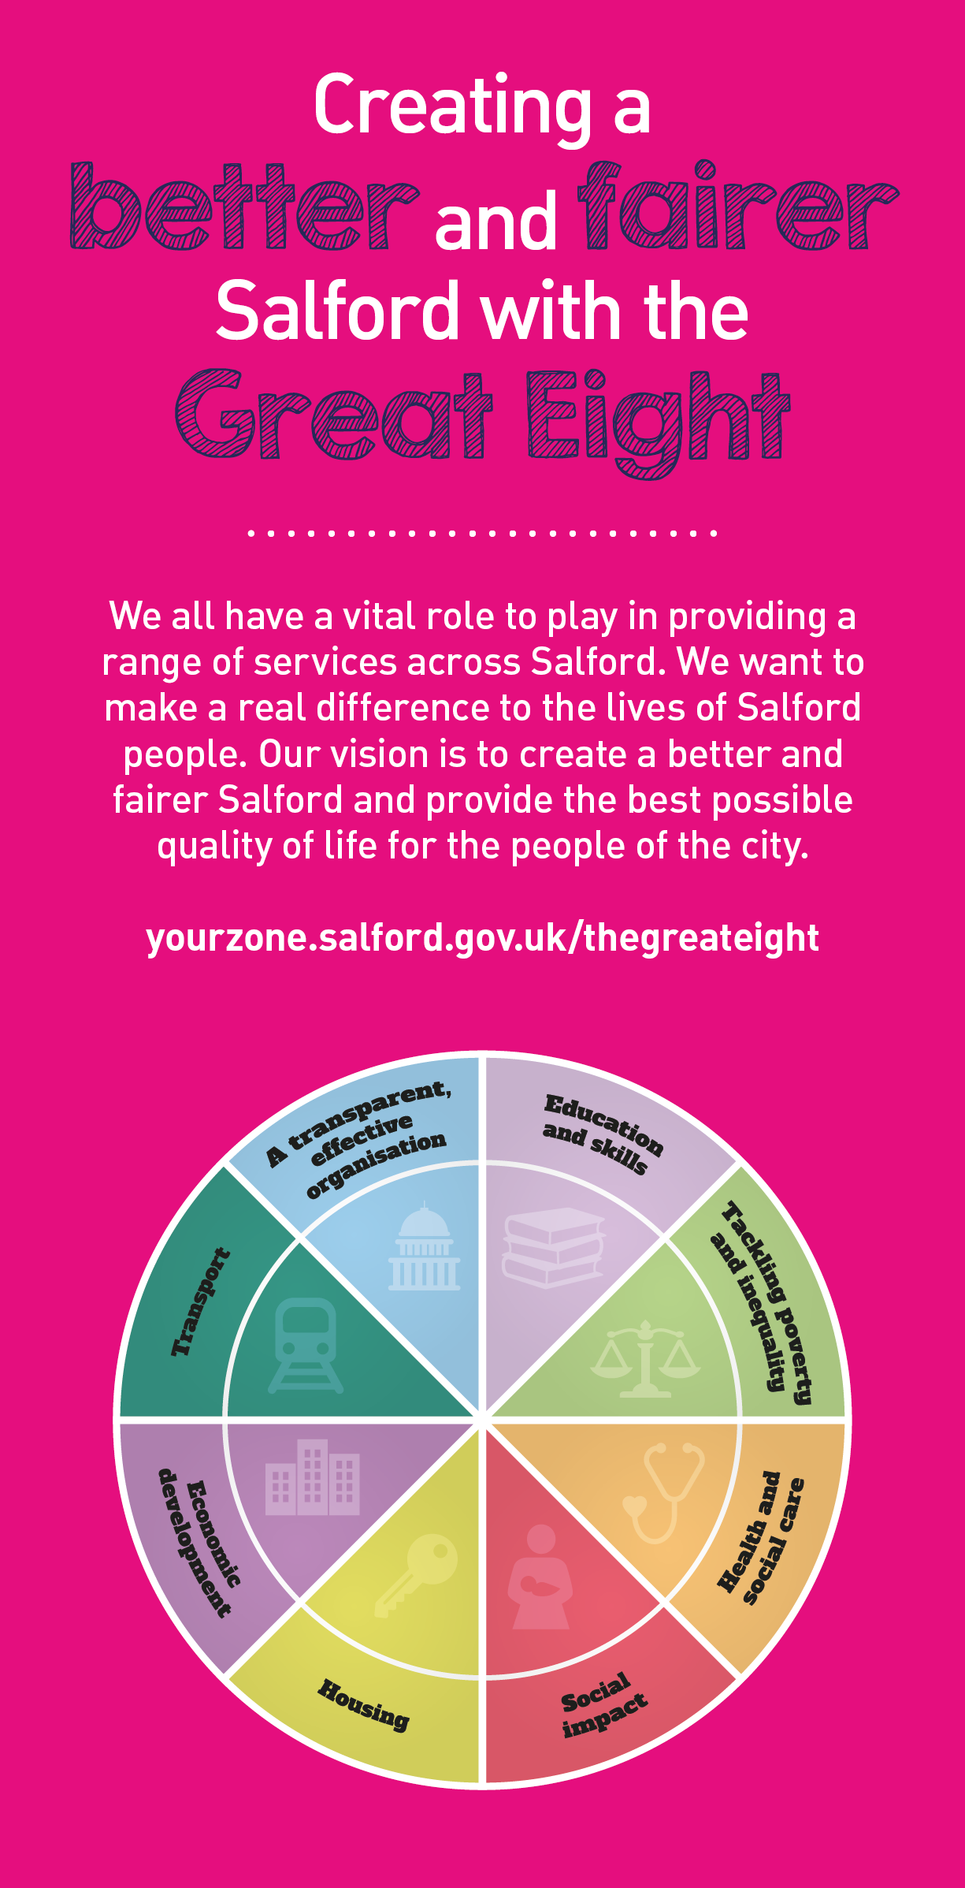
 | Key outcomes
- The reduction of poverty and ineqality, and enhanced quality of life of the people of Salford.
- The delivery of a high quality comprehensive specialist welfare rights advice service that meets the needs of and increases access to advice for people with mental health problems in Salford
- Improved mental health and a high level of client satisfaction.

What we need from you |  | Our values
- Proven technical skills and ability in the role with a record of accomplishment for delivering outcomes
- Professional credibility through proven relevant experience
- Models and demonstrates our values
- Up to date proven experience and expertise in benefits case work including representation at appeals
- Expert knowledge of social security law, ability to identify relevant case law
- A good appreciation of mental health and the benefit issues that relate to people with mental health problems
- Strong written and verbal communication skills especially with vulnerable people
- Good literacy, numeracy and IT skills .
- Good administraive and organisational skills.
- An ability to work alone as well as part of team.
- Ability to establish effective relationships with service users, colleagues and staff in other agencies
- A comittment to the promotion of anti-poverty work.

Application guidance

We are a values based organisation so reflecting our values or a values based approach in your evidence will support your application.

The ‘Key outcomes’, ‘What we need from you’ and ‘our leadership behaviours’ sections of the Role Profile are there to give you an understanding of what we would like to see reflected in your application. Don’t give up if you are not able to reflect all of these in your application.

