

**Children with Disabilities Social Worker**



**Advert**

**The role**

As children with disabilities social worker, you will be joining a multi-agency team supporting disabled children and their families. You will be working alongside colleagues from multi-disciplinary professions including health and education who are also passionate about delivering the best possible services for disabled children.

Your role will include undertaking assessments underpinned by the Signs of Safety Model, child focused plans and reviewing short break care packages. Your caseload will range from child in need and child protection to looked after children where you may be working with a child until they reach 18 years of age and coordinate their transition to adult services

**About you**

We are looking for an experienced social worker who can undertake effective assessments of need in an innovative way with the ability to co-ordinate the provision of the appropriate services

**About us**

We recognise that our staff are our most important resource and asset.

You will receive regular supervision and work in a supportive culture where we are ambitious about delivering effective social work practice and supporting you to be the very best you can be.

In Tameside we like to look after our employees and also offer a fantastic range of employee rewards and benefits, including:

* Minimum of 28 days leave each year, with the option to buy additional leave
* 36 hours working week
* Health and wellbeing support
* Salary sacrifice schemes
* Family friendly policies, including maternity, paternity and adoption leave
* Access to the Local Government Pension Scheme
* Discounts at local shops, health & fitness clubs, restaurants and much more

**Be that difference and find out more information why you should work for us** [**here**](https://www.tameside.gov.uk/childrensocialcarejobs)

For further details about this role or informal discussion, please get in touch with Kerry Dalston, our Team Manager on 07970 027 462 or [kerry.dalston@tameside.gov.uk](mailto:kerry.dalston@tameside.gov.uk)

**2**

**3**

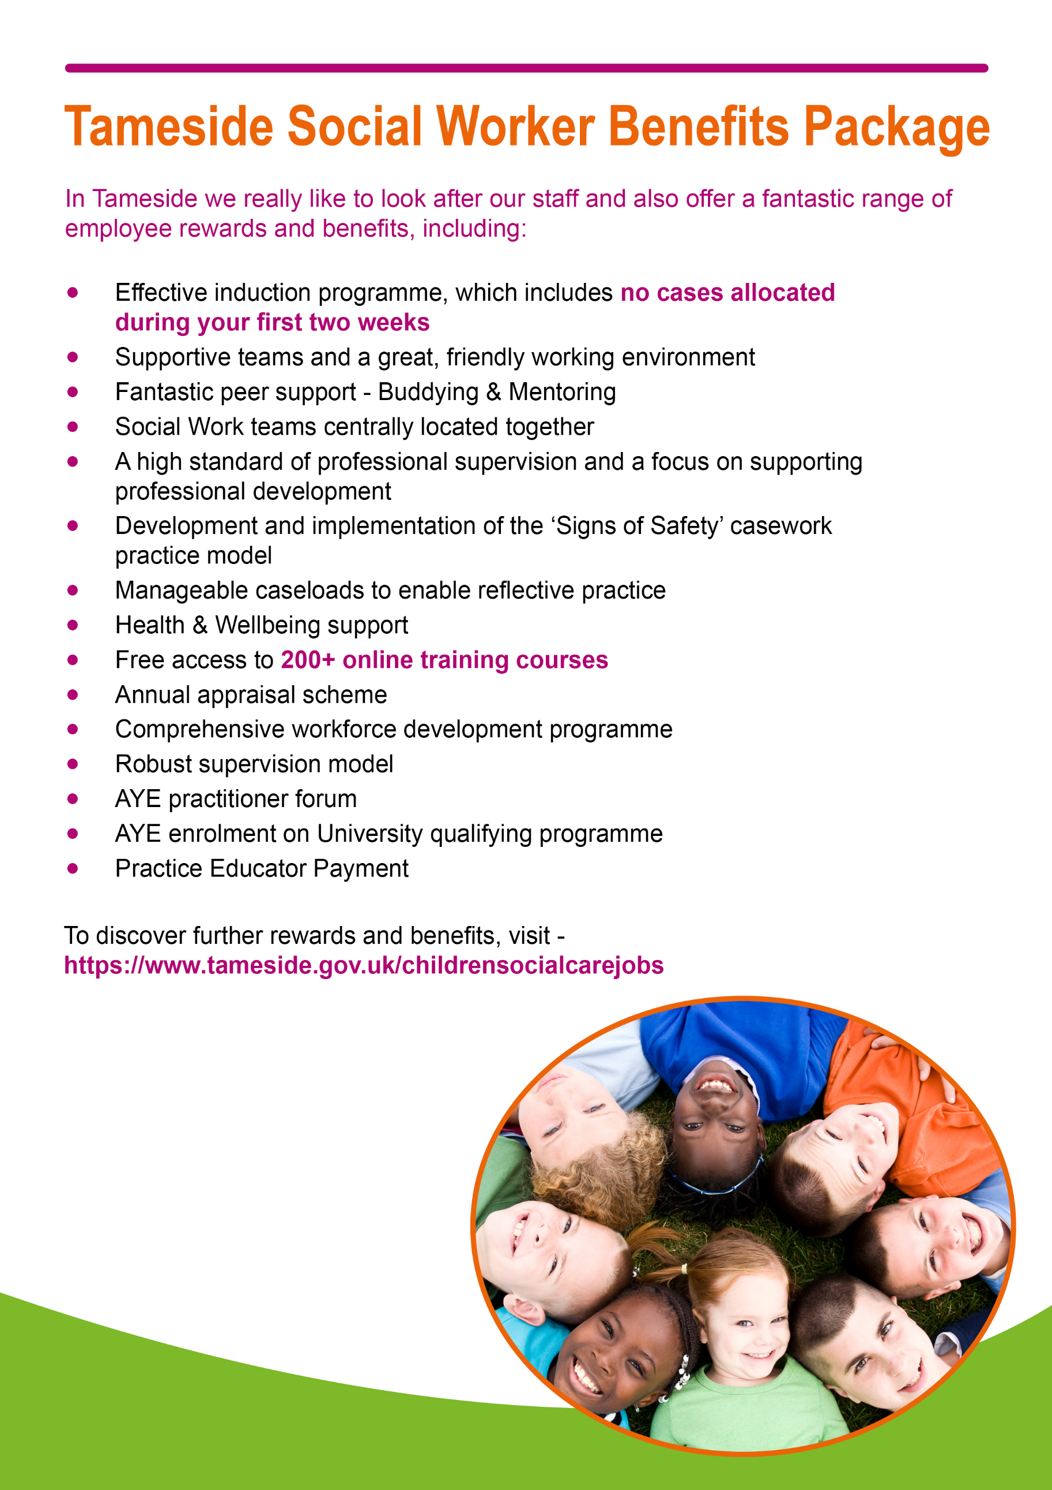

**4**

**Children with Disabilities Social Worker**

**Working arrangements:** Hours to be worked flexibly to meet the needs of the service

**Post Objectives:** To promote and safeguard the welfare of children with additional needs, looked after children and children in need of safeguarding by means of an effective assessment of need and the co-ordination and provision of appropriate services.

**Main duties and responsibilities:**

* To carry out assessments of children in need, including those in need of protection and looked after children.
* To co-ordinate service provision to meet the needs of those children.
* To carry out reviews and statutory visits in accordance with statutory and service procedures.
* To carry out direct work with children with additional needs using a variety of communication methods including work with their families in order to meet their assessed need.
* To respect and promote the needs of children arising from their disability, racial, cultural, religious and linguistic background.
* To supervise children on behalf of Authority, as directed by the court.
* To recruit, assess and develop foster/kinship carers and adoptive parents as required.
* To engage parents, carers and children in meaningful and open working relationships, to encourage their full participation in meeting the needs of the children.
* To support the development of parents and carers as required in order to achieve best outcomes for disabled children.
* To undertake such work jointly within a multi-disciplinary team and from other agencies.

**5**

* To observe all statutory regulations.
* To meet the Standards set by the Social Work England and available at <https://www.socialworkengland.org.uk/standards/professional-standards/>
* To attend meetings as required.
* To prepare and present information (both written and oral) to Panels, the Court and other agencies.
* To maintain up-to-date records on all work carried out and to ensure good and effective communication with other professionals involved.
* To attend all regular supervision sessions with the Team Manager as required, taking an active part and preparing for each meeting.
* To participate in all training as required.
* To observe all Council and service policies and procedures in respect of administration and professional practice.
* To contribute to policy making within the service and to the evaluation and review of services.
* To undertake such duties commensurate with the level of responsibility for this post.

**Tameside Council is committed to safeguarding and promoting the welfare of children and young people and expects all staff and volunteers to share this commitment.**

**65**

**Children with Disabilities Social Worker**

|  |  |
| --- | --- |
| 1. **Educational standard/qualifications/membership of professional body** | **Category** |
| Social work degree/CQSW/Dip.SW/CSS | Essential |
| SWE registration | Essential |
| Full driving licence essential unless precluded by disability when reasonable adjustments will be considered. | Essential |
|  |  |
| 1. **Specialised training** |  |
| Completed Assessed and Supported Year of Employment (ASYE) | Essential |
| Post qualification training | Desirable |
| Children Act training | Essential |
| Achieving Best Evidence training | Desirable |
| Adoption Act training | Desirable |
| Foster care recruitment training | Desirable |
|  |  |
| 1. **Experience** |  |
| Direct work with disabled children using a range of communication methods | Desirable |
| Direct work with children including children who have been abused | Desirable |
| Work with parents and carers where abuse has occurred | Desirable |
| Experience of court and statutory proceedings | Desirable |
| Experience in joint working arrangements with other agencies | Desirable |
| Experience of working with looked after children and their carers | Desirable |
| Child care social work experience | Essential |
| Experience in recruitment, assessment and support of substitute carers/adopters | Desirable |

|  |  |
| --- | --- |
| 1. **Key Skills** |  |
| Skills in needs assessment and risk assessment | Essential |
| Ability to work effectively in a multi-disciplinary system | Essential |
| Ability to work jointly across the service and with other agencies | Essential |
| Ability to communicate openly and honestly with children, parents and carers | Essential |

**7**

**8**

|  |  |
| --- | --- |
| Ability to maintain up-to-date accurate information using IT database | Essential |
| Ability to relate with children with additional needs effectively | Essential |
| Ability to work as a member of a team | Essential |
| Ability to communicate effectively in writing and produce good quality reports | Essential |
| Able to present information to the public and groups | Desirable |
| Ability to fulfil all spoken aspects of the role with confidence through the medium of English | Essential |
|  |  |
| 1. **Key knowledge** |  |
| Understanding of theory of child development | Essential |
| Understanding of theory of communication with children and families | Essential |
| Understanding of Children Act 1989 and 2004, Children and Adoption Act 2002, Working Together, child care law and wider legal basis for Social Work intervention relating to disabled children. | Essential |
| Understanding of counselling theory | Essential |
| Knowledge and understanding of child protection procedures | Essential |
| Understanding of anti-discriminatory practice | Essential |
| Understanding of the mental health needs of looked after children | Desirable |
| Family functioning and dysfunction | Essential |
| Knowledge of Fostering Service regulations/guidance | Desirable |
| Knowledge of Adoption Service regulations/guidance | Desirable |
|  |  |
| 1. **Key aptitude and personal qualities** |  |
| Ability to be non-judgemental | Essential |
| Aware of self and own values | Essential |
| Ability to be assertive | Essential |
| Self confidence and personal resilience | Essential |
| Clarity of thought | Essential |
| Ability to seek out and develop own learning | Essential |
|  |  |
|  |  |
| **For information:** | |
| **Category** | |
| (E) essential requirement without which the candidate would be unable to carry out the duties of the post | |
| (D) desirable features which would normally enable the successful candidate to perform the duties and tasks better and more efficiently than one who did not have the qualifications, training, experience, etc. | |

|  |
| --- |
|  |

**8**

**9**



**Contract Type**: Permanent

**Salary**: Grade H. Scale 29 - £37,336 to Scale 34 - £42,403 with a professional bar at Scale 31- £39,186**

**Hours**: 36 hours per week

**Base Location**: Jubilee Gardens, Gardenfold Way, Droylsden, M43 7XU

This post requires an Enhanced DBS Disclosure.

This post is a designated customer facing role under the fluency duty and requires a specified level of spoken English in the person specification.

All appointments will be to the bottom salary point in the grade with annual incremental progression each April until the grade maximum is reached.  Where an individual can provide evidence that their existing salary in a relevant role surpasses the grade starting salary, a higher entry salary will be considered, subject to the professional grade development criteria also being met if that point is higher than the bar point.

** This post is classified as being in a professional job category.  As such the grade for the job has a professional grade development bar which employees can progress through subject to meeting the following criteria:

1. Relevant professional qualification for the job role at Level 6 or above, AND

2. Minimum of 2 years post qualification experience in the role, AND

3. Maintained membership of a regulated body where this is a requirement to practice in the role where applicable, AND

4. Professional standards practised to the highest expected level.

Click [here](https://www.greater.jobs/content/12967/discover-tameside) to download the dscvr mobile app today to discover what Tameside has to offer.

**10**

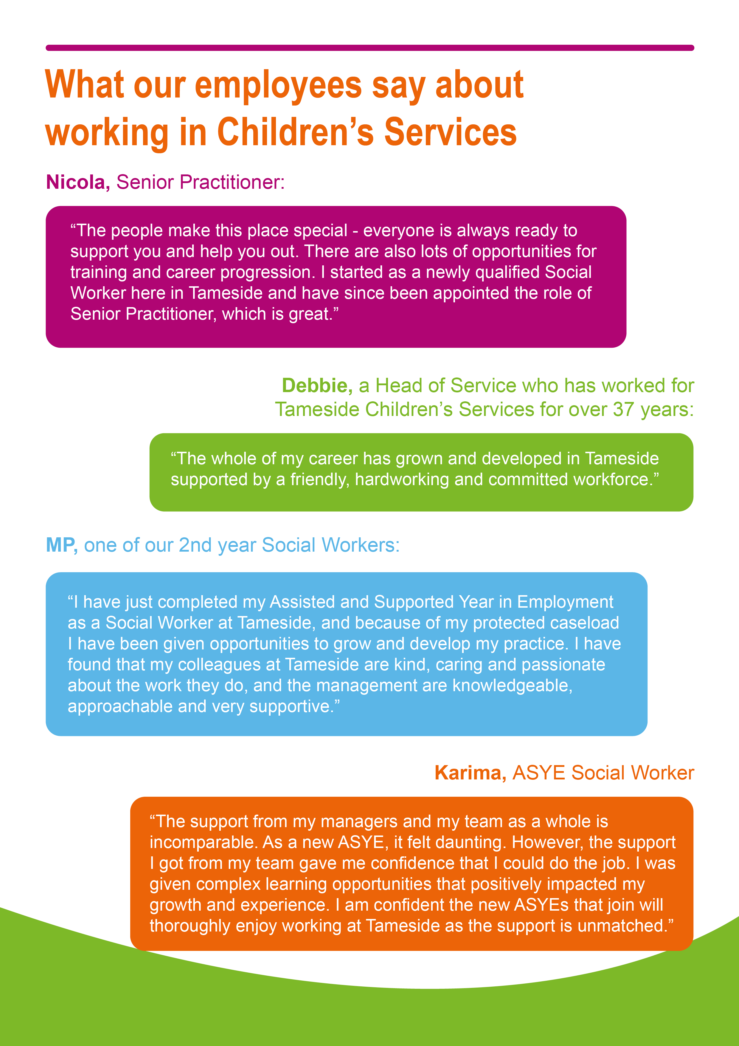

**11**

**11**

**9**

**11**