Head of YJS
Service: |  | People Directorate | Grade: J |  |  |  | Salary: £50,574 |  |  |  | - £52,833
Reporting to: |  | Assistant Director | Location: | Civic Centre Campus |  |  | Hours: |  |  |  | 36 hours
About the role |  |  |  |  |  |  |  |  |  | Our priorities
- Take a Strategic role lead for Youth Justice Services across children’s social care, being a catalyst for change and ensuring outcome focused practice is embedded.  - Provide professional, operational and strategic leadership for practice within the Youth Justice Service, engaging and working with people who use services, families and carers and using this experience to influence strategic decision-making across the People Directorate.  - Identify, respond to and successfully implementing new initiatives and changes in legislation and government policy with a particular focus upon the Youth Justice framework.  - Establish professional networks locally, regionally and nationally to identify and influence practice improvements and take a lead to implement these locally.  - Influence and maintain partnership arrangements with a range of stakeholders within and across organisations.  - Promote and play an active role in developing research projects across and outside of the organisation, working in partnership to ensure that developments reflect the needs of the City.  - Lead a culture of learning that inspires employees and provide management support within the division, motivating and supporting all employees to attain the highest professional standards, skills, knowledge, attributes and competencies required to fulfil their duties.  - Lead, manage and develop a range of multi-professional staff within the Youth Justice service to improve practice and outcomes for children and Young people.  - Lead and manage Salford’s Youth Justice service and support risk reduction strategies for children and young people.  - Promote the council vision and priorities internally and externally, being accountable to the Assistant Director for children’s services.  - Be a key part of the management team and contribute to the strategic leadership of services, developing and implementing standards to ensure a cohesive and high performing social work workforce which embraces cultural change and improves systems and processes.  - Contribute to effective people management across the division, encouraging a positive employee relations climate and active employee and trade union engagement.  - Take a strategic approach to innovation and transformation across the service, ensuring a focus on the continual improvements in service delivery and model’s of practice. |  |  |  |  |  |  |  |  | l | 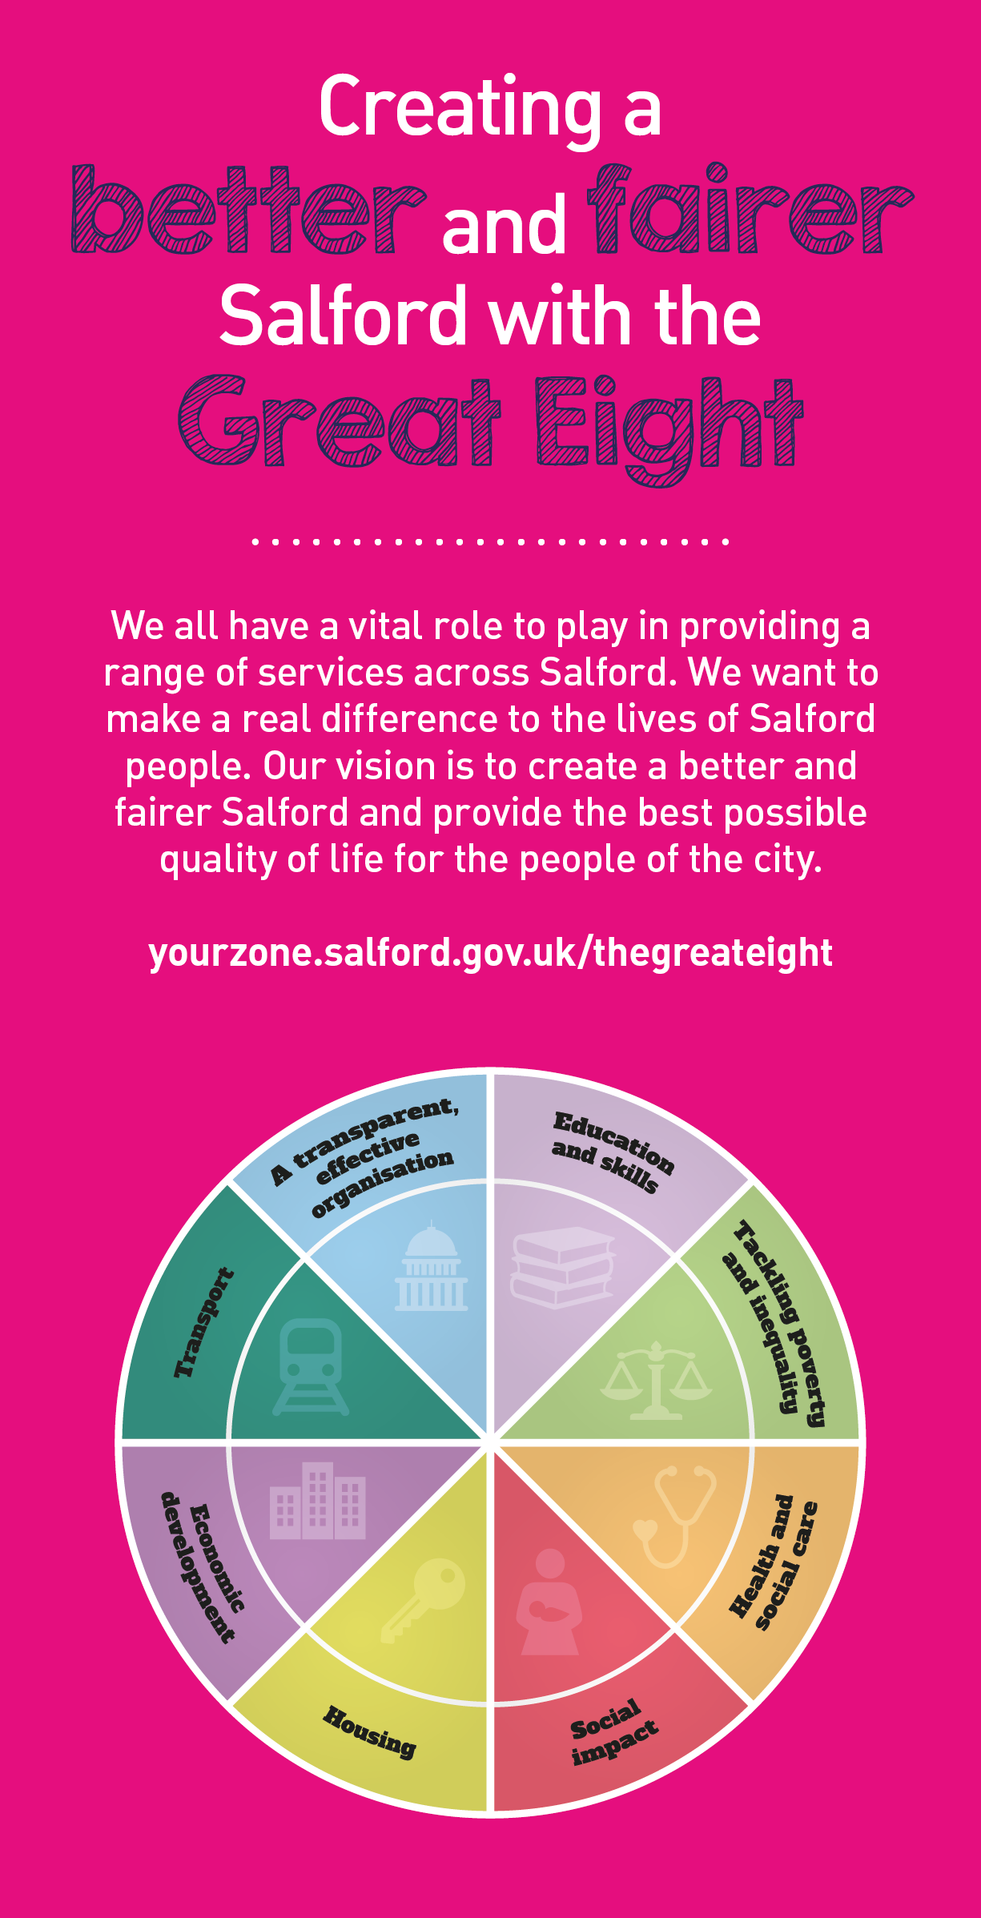
 | Key outcomes
 | - Strategically manage, develop and co-ordinate the Local Authorities partnership response to youth crime and to lead/manage Salford’s Youth Justice Service.  - Support and enable innovation approaches to become embedded in practice alongside the senior leadership team.  - Support the Senior leadership team with the process of keeping internal policies and procedures relevant and in line with best practice  - Support audits as required locally and nationally, and provide an independent view on individual or collective case work practices which may arise from complaints, investigations, case audits and case reviews  - Embed the importance of relationships with children and evidenced based social work practice through working with the wider senior leadership team to redesign services and initiate appropriate interventions. |  |  |  | l | - Support the Quality Assurance framework  - Champion and embed systemic working across Children’s Services and with partners.  - Ensure frontline practitioners are involved and co-design organisational systems and procedures/policies to ensure the best outcomes for children and families in the city.  - Support the development and implementation of a range of procedures and tools to be used to promote safe social work practice e.g. supervision policy, observations of practice, Social Worker Toolkit, direct work with children and families and performance management.  - Be the lead representative for the Council at regional and national forums and oversee national developments in the Innovation programme.  - Influence government policy and practice by taking an active part in professional networks.
 | What we need from you
 | - Proven technical skills and ability in the role with a record of accomplishment for delivering outcomes  - Professional credibility through proven relevant experience  - Model and demonstrates our values and leadership behaviours  - Using imagination and creative skills to find solutions to support systemic problem  - Offer specialist/expert opinion and professional advice both within the organization and to others  - Establish a network of internal and external colleagues, including those at senior and strategic levels, from whom to seek advice and expertise  - Build productive working relationships and communicate effectively.  - Use professional judgement, to employ appropriate interventions, promoting self-determination, support, protection and positive change.  - Promote a culture which supports empathetic compassionate relationships with other professionals, people who use services, and those who care for them.  - Share information consistently in ways that meet legal, ethical and agency requirements. |  |  |  |  | - Work effectively as a member of a team, demonstrating the ability to develop and maintain appropriate professional and inter-professional relationships, managing challenge and conflict with support.  - Model effective engagement with a wide range of people in challenging situations and support others to develop and maintain effective engagement, including in situations of hostility and risk  - Ability to share information consistently in ways that meet legal, ethical and agency requirements  - Ability to contribute to workforce planning to ensure that talent is managed in line with career paths and succession planning  - Ability to lead on the development and maintenance of practice standards across the service  - To undertake developmental projects with the Social Work and support teams to ensure Social Work Practice is of the highest quality  - A recognised professional qualification in a discipline related to the work of the Youth Justice: Degree in Social Work / Youth Work / Teaching, Youth Justice Foundation Degree, Diploma in Probation Studies or passed the Police Inspectors exam or willingness to work towards a qualification
Our leadership behaviours |  |  |  |  |  |  |  |  | Our values
As a values-based leader you will:  - Model the values and embed them in the way your team delivers services  - Hold people accountable for delivering the values  - Respect and care for others, treating everyone fairly, recognising the importance of ensuring equality of opportunity for all, and listening and acting on the things people say  - Be honest, taking responsibility for your actions and decisions  - Use resources that you are trusted with wisely |  | To lead and develop people you will:  - Listen to understand, not to defend  - Give people the freedom to use their initiative  - Provide opportunities for people to discuss and solve problems and issues  - Regularly provide coaching and support to others to help them achieve their objectives and potential  - Appreciate and build on people’s strengths  - Motivate, engage, encourage and inspire others in order to be the best they can be
To create a performance and development culture you will:  - Be visible, inject pace, vigour and purpose  - Expect high standards; mediocrity is not acceptable  - Take an evidence and whole system approach in making decisions  - Maximise technology and models to deliver quicker, easier, better services  - Have a digital mindset, fully utilising digital systems and solutions to deliver services differently  - Set context and challenging goals that will motivate people to take ownership, maximise performance, and develop |  | To build and communicate a vision for the future you will:  - Be optimistic and ambitious for the city and its people, helping others to understand the need to transform public services  - Build strong collaborative relationships to find creative ways to make services more sustainable and flexible  - Recognise and values the strengths of people and places, taking a strengths-based approach to make the most of opportunities  - Support people through change, in undertaking new things, and taking risks  - Take a place and whole system approach in designing, delivering and leading services  - Ensure an inclusive approach with the aim of reflecting the increasing diversity of Salford

Application guidance

We are a values based organisation so reflecting our values or a values based approach in your evidence will support your application.

The ‘Key outcomes’, ‘What we need from you’ and ‘our leadership behaviours’ sections of the Role Profile are there to give you an understanding of what we would like to see reflected in your application. Don’t give up if you are not able to reflect all of these in your application.

Click here to enter text.

