Health Development Officer
Service: |  | Health Improvement Service | Grade: | 4A |  |  | Salary: |  |  |  | £33,782 - £36,922
Reporting to: |  | Health Improvement Manager | Location: | Civic Centre |  |  | Hours: |  |  |  | 36
About the role |  |  |  |  |  |  |  |  |  | Our priorities
- Provides the skills, knowledge and experience to design, develop and implement multiple short, medium and long term evidence based internal and external, high quality health improvement projects, programmes or strategies using robust project management methodologies, with an evidence based approach to positively impact individual and population health outcomes and reduce inequality  - Provides leadership in service advancement through income generation. Planning and exploring external funding opportunities to secure ongoing investment for service sustainability in writing funding proposals, bids and tenders  - Influences service redesign and organisational change in response to identified community need, within the council, primary care and other agencies. Showing an ability to negotiate effectively with stakeholders and commissioners to ensure service delivery expectations related to SLAs and contracts are realistic and evidence based  - Ensures effective communication using a range of methods with a wide range of people including commissioners, senior managers, frontline staff, local people and outside agencies like health services and voluntary sector agencies; in order to effectively implement service delivery.  - Provides analytical skills to use complex demographic information and data, as well as local knowledge gained through stakeholder engagement/asset mapping to shape the future direction of the service’s work to reduce health inequalities  - Provides specialist theoretical, practical and procedural knowledge relating to the NHS Health Check and CVD risk management best practice and guidance to manage the NHS Health Check delivery programme effectively in relation to employee and public safety.  - Ensures the calibration, external quality control testing, service contracts and appropriate storage and maintenance of a large amount of high value specialist clinical equipment.  - Ensures a high quality and varied specialist training programme by acting as the service training lead for both internal staff and external organisations.  - Provides operational management and ensures the safe use of the HIS mobile unit. Including managing the storage, maintenance, repair, booking and equipping of this very high value asset to deliver front line health Improvement services/campaigns across the North West.  - To ensure the development of a service social media strategy and being responsible for taking the necessary actions to ensure the aims of the strategy are met for maximum service reach and engagement. This requires the knowledge and implementation of communication and marketing techniques. |  |  |  |  |  |  |  |  |  | 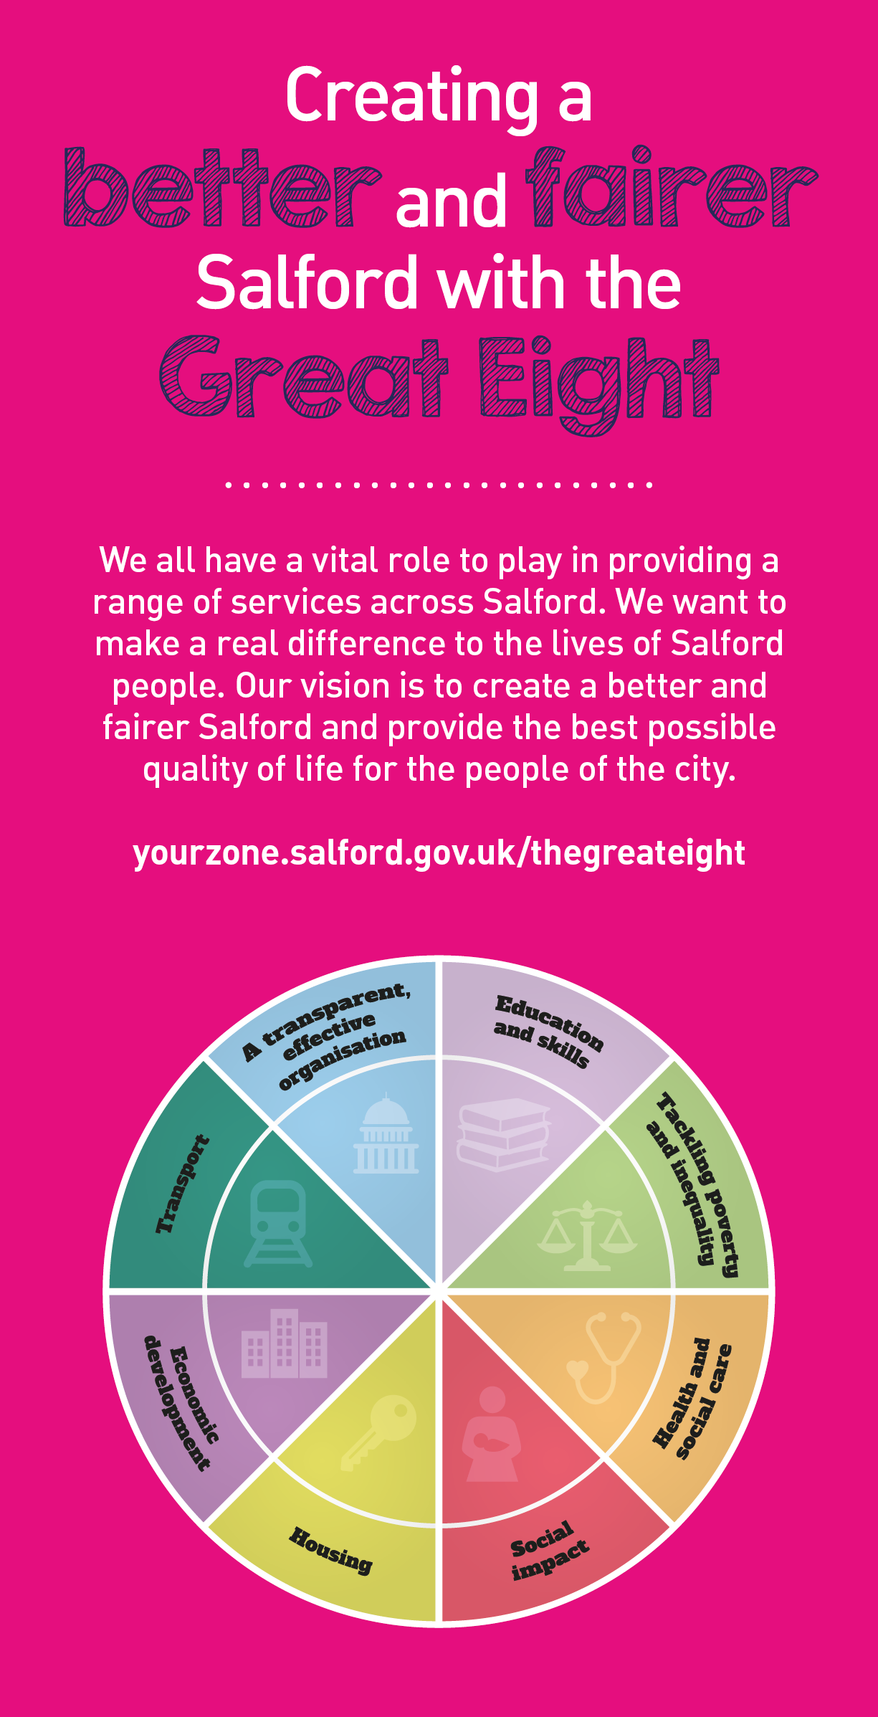
 | Key outcomes
 | - Ensures the delivery of multiple public health projects and programmes of work simultaneously with competing deadlines that can alter at short notice.  - Provides a range of options for the resolution of highly complex issues in order to assist effective decision-making, monitor interdependencies and risks between projects and escalating risks of potential conflicts where necessary  - Provides and updates as appropriate project management products/documentation, including but not exclusively PIDS, SOPs and team work plans.  - Ensures that budgets on all individual projects or programmes of work, stay within acceptable parameters.  - Produce, or co-design as appropriate, detailed pathways and processes in relation to high risk/complex programmes of work to ensure a safe, high quality, value for money service  - Ensures the Communication of complex ideas to others in an understandable format using a wide variety of communication tools, tailoring to the needs of the audience who may have barriers to understanding. |  |  |  |  | - Acts a key member of a team to provide concise, effective business cases/proposals in relation to any potential bids or tenders for new contracts or programmes of work  - Provides coordination of the service workplace health programme offer, actively seeking, liaising and negotiating with and recruiting new clients  - Provides leadership to develop the skills of a social media team of staff responsible for social media output and subsequent engagement  - Ensures the development of fully evidence based, high standard, and up to date training packs for the full portfolio of RSPH qualifications  - Liaises with external customers, negotiating costings and developing and designing appropriate bespoke training packages where necessary, utilising experience and knowledge of Public Health and behaviour change  - Ensures that all frontline staff and the workforce as a whole have the required knowledge and skills to deliver all the areas of work that are required of them, by having access to the up to date evidence based resources and training.  - Provides high quality performance reports relating to all projects responsible for, and dissemination of learning
 | What we need from you
 | - Proven technical skills and ability in the role with a record of accomplishment for delivering outcomes  - Professional credibility through proven relevant experience  - Models and demonstrates our values and leadership behaviours  - Demonstrable experience in managing successful complex projects involving a wide range of stakeholders, achieving outcomes to time and scope  - Demonstrable experience of developing and delivering high quality training to a wide range of audiences  - There is a requirement to travel regularly across the North West and less frequently across the UK to negotiate and deliver contracts.  - The ability to make decisions autonomously, when required, working to tight and often changing timescales in an environment of change  - The ability to link strategy to policy to meet internal and external requirements  - Experience of working with clinicians and other health professionals  - Experience of undertaking service evaluation, interpreting its relevance and identifying opportunities for implementation  - Experience of effectively leading teams and directing individuals |  |  |  |  | - The ability to innovate and bring about radical change in delivering health improvement within communities, the council and other agencies using person centred approaches.  - Contribute to both the local and national evidence base by contributing to evaluation, submitting learning to conferences and disseminating models of best practice.  - A sound knowledge and understanding of the wider Greater Manchester health and social care transformation agenda, change management and the principles of public sector reform.  - Knowledge and understanding of the wider determinants of health, public health principles, health promotion and the ability to apply the principles of community involvement, participation and development  - A strong commitment to team working and ability to manage conflict and persuade others of own point of view and defend own and/or services position in a logical, sensitive way.  - Experience of presenting to a wide range of audiences using a variety of different communication methods and/or devices
Our leadership behaviours |  |  |  |  |  |  |  |  | Our values
As a values-based leader you will:  - Model the values and embed them in the way your team delivers services  - Hold people accountable for delivering the values  - Respect and care for others, treating everyone fairly, recognising the importance of ensuring equality of opportunity for all, and listening and acting on the things people say  - Be honest, taking responsibility for your actions and decisions  - Use resources that you are trusted with wisely |  | To lead and develop people you will:  - Listen to understand, not to defend  - Give people the freedom to use their initiative  - Provide opportunities for people to discuss and solve problems and issues  - Regularly provide coaching and support to others to help them achieve their objectives and potential  - Appreciate and build on people’s strengths  - Motivate, engage, encourage and inspire others in order to be the best they can be
To create a performance and development culture you will:  - Be visible, inject pace, vigour and purpose  - Expect high standards; mediocrity is not acceptable  - Take an evidence and whole system approach in making decisions  - Maximise technology and models to deliver quicker, easier, better services  - Have a digital mindset, fully utilising digital systems and solutions to deliver services differently  - Set context and challenging goals that will motivate people to take ownership, maximise performance, and develop |  | To build and communicate a vision for the future you will:  - Be optimistic and ambitious for the city and its people, helping others to understand the need to transform public services  - Build strong collaborative relationships to find creative ways to make services more sustainable and flexible  - Recognise and values the strengths of people and places, taking a strengths-based approach to make the most of opportunities  - Support people through change, in undertaking new things, and taking risks  - Take a place and whole system approach in designing, delivering and leading services  - Ensure an inclusive approach with the aim of reflecting the increasing diversity of Salford

Application guidance

We are a values based organisation so reflecting our values or a values based approach in your evidence will support your application.

The ‘Key outcomes’, ‘What we need from you’ and ‘our leadership behaviours’ sections of the Role Profile are there to give you an understanding of what we would like to see reflected in your application. Don’t give up if you are not able to reflect all of these in your application.

