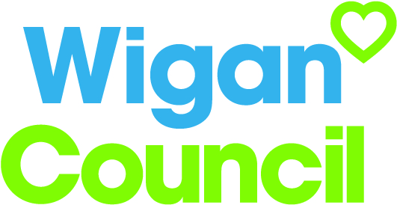
Job specification
Job title: | Statutory Compliance Inspection Officer- Electrical
Service: | Resources- Corporate Contracts and Assets
Grade:  Salary Range: | G8  £27,688-£31,601
Reporting to: | Building Services Statutory Compliance Manager

Your job
You will assist and support the building services statutory compliance manager in ensuring that compliance related statutory requirements governing the housing, corporate and if bought back school stock with specific duty of electrical testing, inspection and management.

You will identify and evaluate the risks and current practices relating to electrical compliance for the council and suggest strategies to manage this.

Provide advice and guidance and compile the necessary policies and procedures relating to the specific area of work and legislation. Develop and implement a corporate electrical inspection management policy for the council to ensure compliance with the current regulations

Act as the appointed person/ responsible officer for the council in relation to electrical inspections duty holder.

In this job you will
Within the first 12 – 18 months you will:

- Assist with the management of compliance related documentation, including the company’s statutory certification, ensuring that asset lists are routinely validated and records kept upto date and shared appropriately-
- Support the building service statutory compliance manager to work pro-actively with key stakeholders, including employees, contractors and customers to shape services, develop policies and share information and improve communication that will deliver on our corporate objectives and achieve our obligations as a landlord on going over the first year.
- In the first six months assist in the auditing of the specific statutory servicing programmes arranged by the council’s partner organisations and ensure value for money and compliance.
- Attend meetings relating to the specific section of statutory compliance covered by housing and corporate stock-
- Provide advice to the building service statutory compliance manager on how to ensure statutory compliance and changes in legislation when they arise and report findings on any serious breaches of compliance- ensuring transparency in the first three months and on- going.
- Explore and generate ideas to increase the buy back income annually plus maintaining service
- To make suggestions that will drive forward compliance and health and safety as a corporate unit. Being positive and aware of budget constraints.
- To offer appropriate training and guidance to all employees and partners involved in compliance management and associated service delivery within the first year. Ensure that the team’s training are up to date and complies with their individual roles.

In this job you will need
You must be able to demonstrate the following essential requirements:

- Hold the appropriate certification of professional qualification relevant to the role or equivalent experience- ONC or equivalent in electrical engineering or related subjects.
- Extensive experience of electrical inspections/ or supervision of electrical projects in the public or private sector.
- The ability to work corporately and represent the service including the ability to provide training and guidance to elected members and Officers.
- The ability to identify and maximise opportunities for efficiencies and revenue savings and implement improvement plans as necessary.
- The ability to plan own workload competently with minimum supervision and to strict deadlines and a willingness to take appropriate responsibility to act on own initiative to positively influence clients as part of a wider service team.
- A detailed knowledge of the law and practice likely to arise in building management and maintenance and the ability to carry out effective research and guide the team to do the same.
- Be confident in liaising with contractors and other sectors of the organisation relating to statutory compliance. Be confident in challenging behaviours that could cause risk.
- Display the Wigan behaviours as outlined above.
- Research skills with the ability to analyse facts and figures and to convert into concise reports and able to present findings and recommendations in a clear and coherent way both verbally and in writing.

Our culture
For us, it’s not just about all we achieve as an organisation, but how we do it. Therefore, all employees are expected to display our Be Wigan behaviours.
Be Positive… take pride in all that you do

Be Accountable… be responsible for making things better

Be Courageous… be open to doing things differently

Individuals with line management responsibilities are also expected to …
Inspire…lead by example and help others to see the big picture

Care… show genuine concern for people as individuals and value their contributions

Engage… I connect with others both within and beyond the organisation

Staff Deal
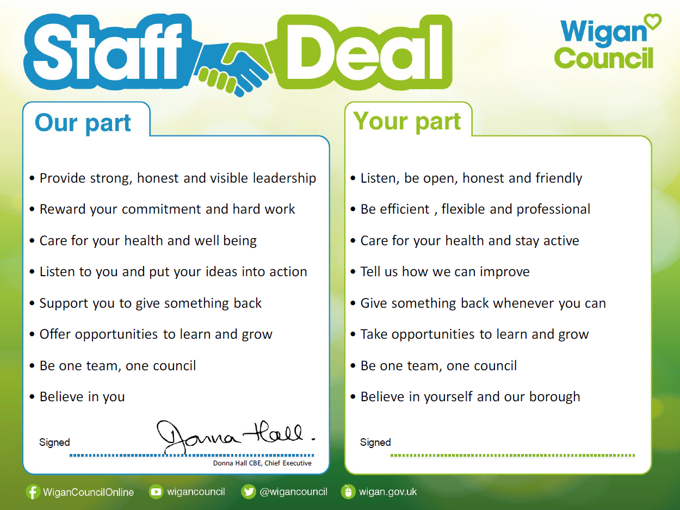
Our Staff Deal is an informal agreement with all staff. It outlines what you can expect from us, and in return what we expect from you

