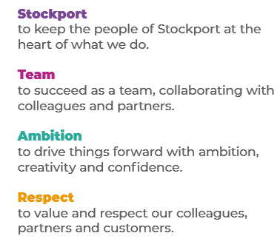
Job Profile and Working for Stockport Council
Our Council
Our employees are our greatest asset. We’re proud of the way we provide vital frontline services every day and work together, as one team.
Our 4 core values as shown above, run through everything that we do, and we aim to stay true to them regardless of the challenges that we may face.
To support our values, we have policies, guidance and procedures around health, safety and welfare, customer care, emergency planning and security that all our colleagues are adhering and working to.
We also pride ourselves on our commitment to wellbeing and inclusivity of our colleagues and residents.
You can find out more about working for Stockport Council and some of the benefits that we offer our employees at https://greater.jobs/locations/stockport/

Role: |  | Mental Health Social Worker
Service Area: |  | Working Age Mental Health Team
Directorate: |  | Services to People - Adults
Salary Grade: |  | S02
About the Job

Main Purpose of the Job
The post holder will be accountable on a day to day basis to the Team Manager, who will allocate, monitor and review all work through regular informal and formal supervision. The post holder will also be professionally supported by other social workers within the mental health team.

The Social Worker will have a key role to play in relation to supporting the delivery; both the personalisation and social inclusion agendas, ensuring quality public facing services including health and social care services. The role will involve assessing; accessing and implementing a range of social care services and providing guidance/advice and information for adults with mental health needs and their carers.

Key Responsibilities
- The post holder will be required to be an integrated and supportive member of a team, planning, actioning, monitoring and evaluating work with the supervision of an experienced Social Worker.

- The post holder is responsible for supporting the delivery of health and social care functions for adults/carers within the Community and where relevant Hospital/ Inpatient settings providing social work knowledge and expertise within the domain of assessments, care and support planning, reviews and requests for information, advice and guidance.

- The post holder is responsible for working collaboratively with our Pennine NHS Trust colleagues and services, to provide seamless care for adults/carers on defined care and support pathways.

- The post-holder is responsible for working in partnership with agencies external to the Council supporting adults/carers to access services/support in the independent and non-statutory sector.

- The post holder will be responsible for upholding evidence-based approaches, obtaining and recording with care by providing up to date/accurate case notes and assessments.

- To work positively and inclusively with colleagues and customers so that the Council provides a workplace to deliver a service that does not discriminate against people on the grounds of their age, disability, gender reassignment, marriage, civil partnership, pregnancy, maternity, race, religion, belief, sex, or sexual orientation.

- To fulfil personal requirements, where appropriate, with regards to Council policies and procedures, standards of attendance, health, safety and welfare, customer care, emergency, evacuation, security and promotion of the Council’s priorities.

Additional Information
The responsibilities set out in this document, in the advert and any additional information are intended to provide a flavour of the work you will carry out. It is not possible to include everything you will be asked to undertake, and we expect all colleagues to work flexibly according to business needs and to enhance your own development. Your skills, abilities and training needs will be taken into account and discussed with you when any significant changes to your role are needed. In line with our flexible approach you may be required to work from home for a proportion of your time or from any of the Council's sites across the borough.
The Council is an inclusive employer and holds the Disability Confident and Armed Forces Covenant accreditations. If you have a disability, we will support you by implementing reasonable adjustments to enable you to perform your role.

About You
Please use your application to tell us how well you meet the criteria listed below as these are the key skills, experience, technical expertise and qualifications needed to be successful in the role. We will then use all the information you provide in your application to help us decide whether you are shortlisted for interview. Any interview questions or additional assessments such as tests or presentations may also be broadly based on these criteria:
- Working to the Council’s values and behaviours by:
- Keeping the people of Stockport at the heart of what we do
- Succeeding as a team, collaborating with colleagues and partners
- Driving things forward with ambition, creativity and confidence
- Showing value and respect to our colleagues, partners and customers.

