Head of Development
Service: |  | Regeneration | Grade: | Band F |  |  | Salary: |  |  |  | £66,460
Reporting to: |  | Assistant Director Regeneration | Location: | Salford Civic Centre |  |  | Hours: |  |  |  | 36
About the role |  |  |  |  |  |  |  |  |  | Our priorities
- Build and maintain positive working relationships with developers/investors/partners to develop and deliver investment in the physical regeneration of Salford.  - As Head of Service for the Development Team, provide strong leadership, clear direction and support to the team and instil integrity coupled with an entrepreneurial spirit to deliver on the City Mayor’s priorities for our City.  - Lead, inspire and provide senior management support to employees within the team, motivating and supporting them to attain the highest professional standards, skills, knowledge, attributes and competencies required to fulfil their duties and work programmes.  - Work closely with colleagues across the Council and with partners to deliver close liaison and maximise the opportunities to deliver sustainable and inclusive growth within our City.  - Work closely with elected members and senior leadership to ensure the effective delivery of services in line with the City Mayor’s and City Council priorities  - Provide visible, strategic leadership for the team as part of the Regeneration Senior Management Team and leadership team within the Place Directorate, and embody the City Council’s Leadership Framework  - Ensure effective people management across the team, encouraging a positive employee relations climate and active employee engagement and trade union consultation  - Ensure appropriate arrangements are in place for preparing and monitoring budgets and associated income for the team and adhere to the standing orders and financial arrangements of the Council  - Through personal example, commitment and action develop an inclusive, supportive and constructive environment where everyone is treated with dignity and respect and diversity is valued in the workplace, in service delivery and communications  - Ensure the Council meets its legal and statutory obligations for the service’s areas of responsibility. |  |  |  |  |  |  |  |  |  | 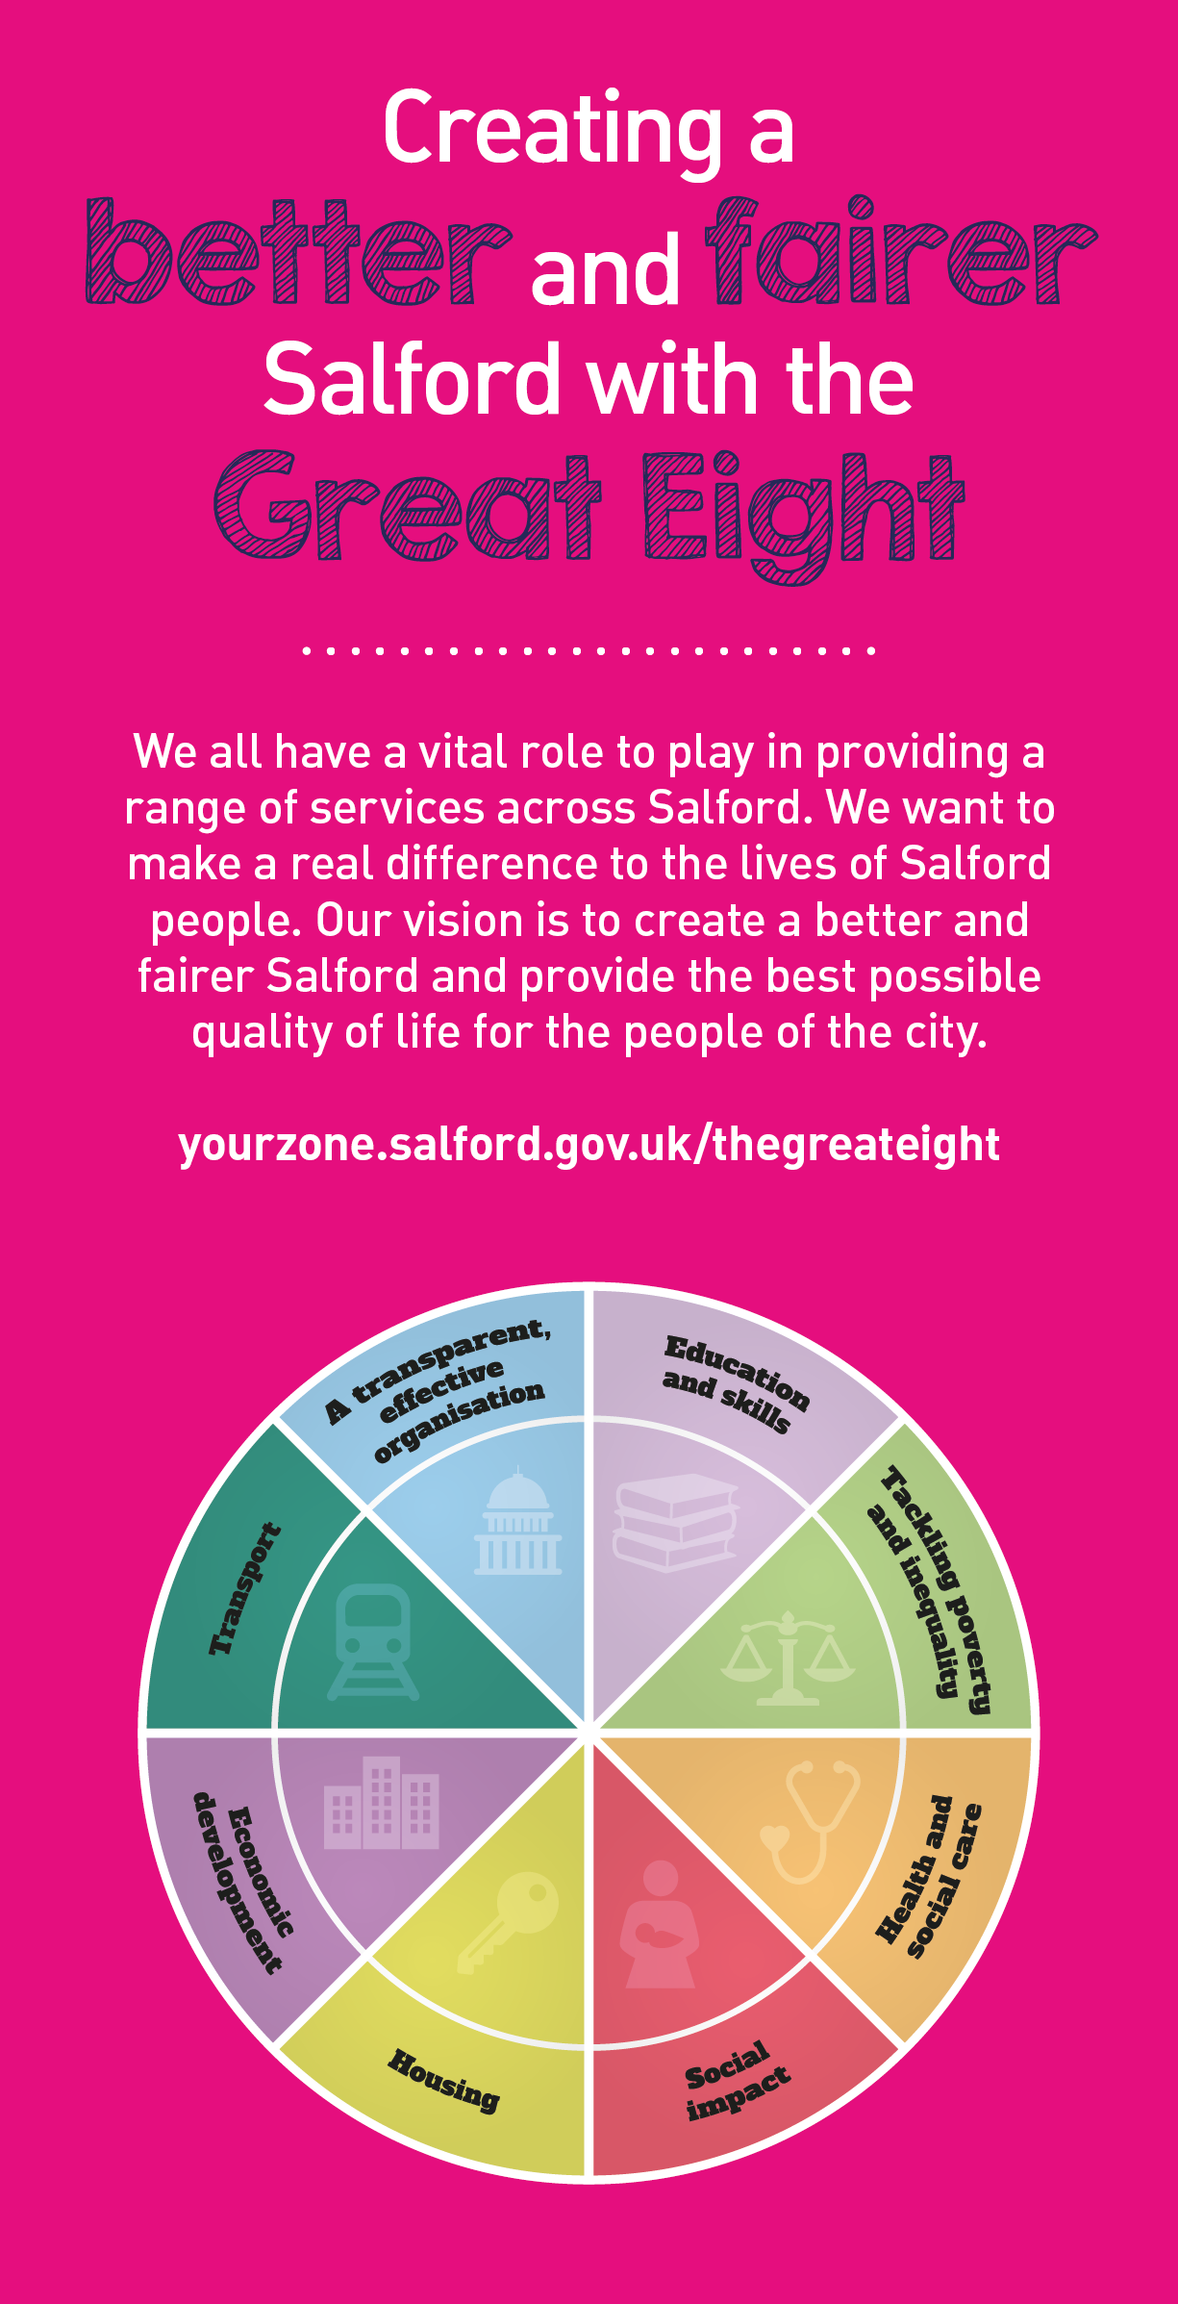
 | Key outcomes
 | - Take a leading and dynamic role in promoting and driving the continued growth of the City and maximising its investment opportunity working with a range of public and private sector regeneration partners, funding agencies, Greater Manchester partners, other AGMA authorities and international investors  - Lead, develop, co-ordinate and deliver major investment and development opportunities across the City.  - Provide commercial and market awareness expertise and a market driven approach to regeneration working closely with private sector developers and the construction industry.  - Build relationships with developers and investors interested in building growth across the City, promoting collaboration and joined-up thinking and co-ordinating inputs and support across service groups to maximise outcomes and outputs that support the growth agenda.  - Work with public and private sector partners to develop and deliver innovative ways to secure commercial and public finance and investment funding to deliver tangible benefits that promote growth and transformation. |  |  |  |  | - Provide strategic input to regeneration policy and programmes and to research, prepare and present strategic and high level reports and papers for consideration by the City Mayor’s Office, Members, Chief Executive, Strategic Director Place and other senior management and political team members  - Maintain an understanding of the national and regional growth initiatives and regeneration agenda to enable the City to drive its regeneration agenda locally, regionally and nationally.  - Manage and co-ordinate multi-disciplinary teams in the design, development and delivery of major capital regeneration projects.  - Provide strategic programme and project leadership to major cross-cutting capital investment projects and programmes across the City, overseeing the work of the Development Team.  - Oversee the strategic management of the Regeneration Team’s programme portfolio and substantial three year capital programme in conjunction with the Assistant Director for Regeneration, contributing to service planning, providing robust financial and performance management and ensuring continuous improvement, value for money and best value are delivered.
 | What we need from you
- Proven technical skills and ability in the role with a record of accomplishment for delivering outcomes
- Professional credibility through proven relevant experience
- Models and demonstrates our values and leadership behaviours
- Relevant and evidenced experience of leading, implementing and managing a range of policy and strategy initiatives, programmes and/or projects to deliver physical and economic transformation and growth.
- Relevant and evidenced experience of inspiring, leading, managing and supporting a multidisciplinary team involving both internal, cross directorate and with external partners.

Our leadership behaviours |  |  |  |  |  |  |  |  | Our values
As a values-based leader you will:  - Model the values and embed them in the way your team delivers services  - Hold people accountable for delivering the values  - Respect and care for others, treating everyone fairly, recognising the importance of ensuring equality of opportunity for all, and listening and acting on the things people say  - Be honest, taking responsibility for your actions and decisions  - Use resources that you are trusted with wisely |  | To lead and develop people you will:  - Listen to understand, not to defend  - Give people the freedom to use their initiative  - Provide opportunities for people to discuss and solve problems and issues  - Regularly provide coaching and support to others to help them achieve their objectives and potential  - Appreciate and build on people’s strengths  - Motivate, engage, encourage and inspire others in order to be the best they can be
To create a performance and development culture you will:  - Be visible, inject pace, vigour and purpose  - Expect high standards; mediocrity is not acceptable  - Take an evidence and whole system approach in making decisions  - Maximise technology and models to deliver quicker, easier, better services  - Have a digital mindset, fully utilising digital systems and solutions to deliver services differently  - Set context and challenging goals that will motivate people to take ownership, maximise performance, and develop |  | To build and communicate a vision for the future you will:  - Be optimistic and ambitious for the city and its people, helping others to understand the need to transform public services  - Build strong collaborative relationships to find creative ways to make services more sustainable and flexible  - Recognise and values the strengths of people and places, taking a strengths-based approach to make the most of opportunities  - Support people through change, in undertaking new things, and taking risks  - Take a place and whole system approach in designing, delivering and leading services  - Ensure an inclusive approach with the aim of reflecting the increasing diversity of Salford

Application guidance

We are a values based organisation so reflecting our values or a values based approach in your evidence will support your application.

The ‘Key outcomes’, ‘What we need from you’ and ‘our leadership behaviours’ sections of the Role Profile are there to give you an understanding of what we would like to see reflected in your application. Don’t give up if you are not able to reflect all of these in your application.

