JOB DESCRIPTION
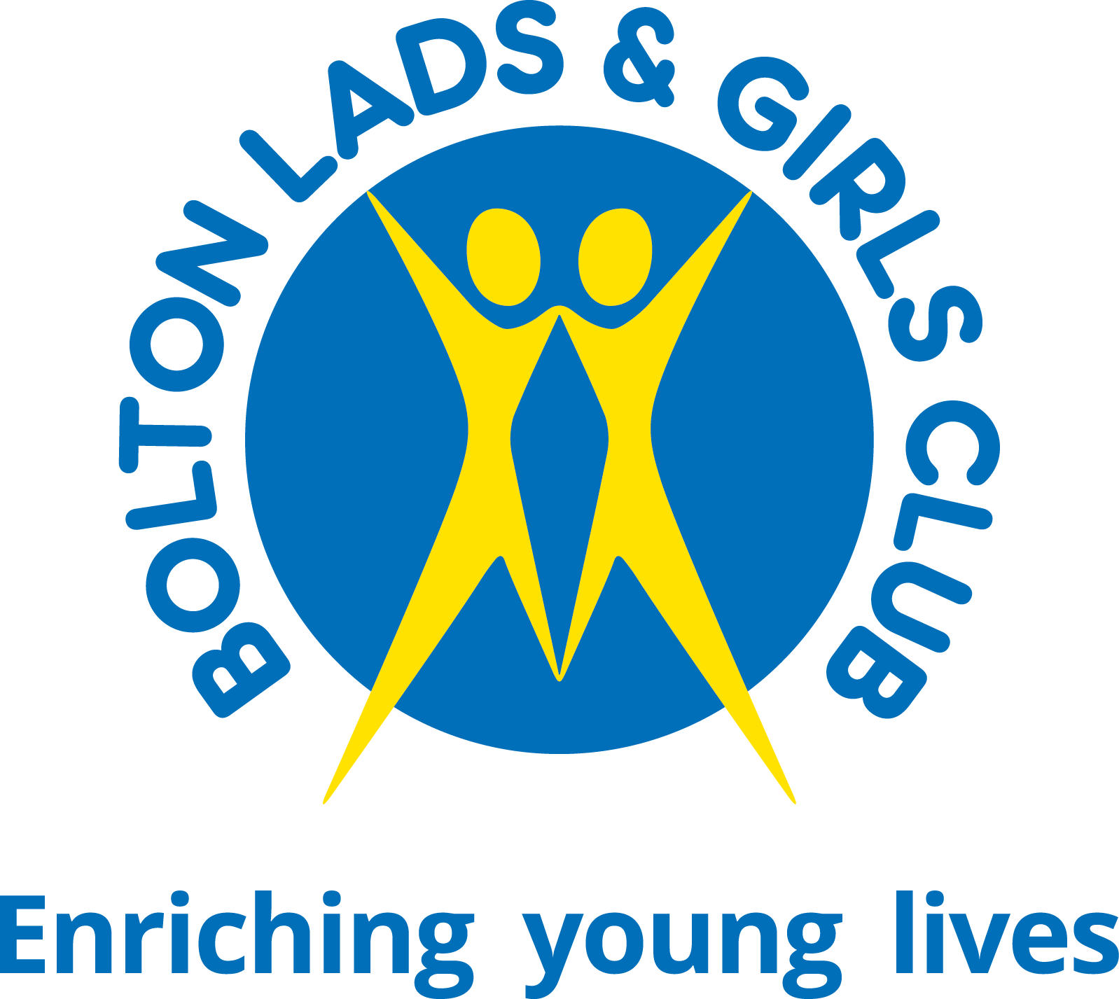

Job Title: | Mental Health Practitioner (psycho-social support)
Department: | Targeted Youth Service
Responsible to: | Head of Targeted Youth Services
Status | Fixed Term for one year, subject to funding
Hours of Work: | Various hours available. Please note we require successful candidates to be able to work a minimum of 3 days / 21 hours per week. Full time hours are 35 hours per week.
Location: | Schools/Community & Office based work in localities across Bolton

_______________________________________________________________________________________
About Bolton Lads and Girls Club:

Bolton Lads and Girls Club is a registered children and young peoples’ charity, and an award winning youth club centrally located in Bolton. Over 130 years ago, we were one of the first organisations in the North West to recognise the importance of providing young people with a safe haven to spend their free time.

We are one of the largest youth clubs in the United Kingdom, with a membership of over 3,500 young people. Based in Bolton’s town centre, we are open 7 days a week, 52 weeks a year and welcome all young people aged 8 to 19 years old (up to 21 for young people with disabilities).

We offer a range of targeted and universal provision including Sports, NCS, Arts, Targeted Youth Support, Employability, Mentoring, Befriending, Emotional Health and Wellbeing and Community Outreach work. Our state-of-the-art Youth Club in the heart of Bolton provides young people with access to a selection of activities, all offering young people the opportunity to try new things, meet new friends and gain support from friendly, warm and positive staff and volunteers.

Why work for us?
We were the first youth organisation to be awarded ‘Youth Organisation of the Year’ by UK Youth and are the proud recipients of the Queens Award. Our organisation has a strong reputation both within the borough, regionally and nationally, for a high quality, innovative offer and exceptional talent development.
All staff have free access to our high-quality gym, during the day, you will also be enrolled into our pension plan and there is free holiday club care for our employees’ children aged 8-12. We have a track record for professional development and training opportunities, and we are committed to developing our team. Come and join us in a fun working environment, where no two days are the same!

Our Vision and Values

Vision: Every young person in Bolton has the opportunity to be the best they can be.

Mission: We will provide great places to go, positive things to do, and people that care.

Our Principles:
- Keep things simple
- Always do the right thing
- Offer excellent customer service
- Provide an environment for people to be the best they can be
- Be exceptional in the moments that matter.

Our Values:
Driven - We don’t give up and we do whatever it takes.

Caring - Genuine people who care make the difference.

Empowering -We enable people to be the best they can be.

Excellence - We aim to deliver the highest standards of service and continuously improve through robust quality assurance and innovation.

Fun - If you enjoy what you do, you do it better! Work is serious and we do it with a smile on our face.

Main Purpose of the Role:

To provide 1-1 psycho-social support to young people in schools (age 11 years plus) or at one of our BLGC sites and work using a holistic and young person friendly approach. To work in a transparent and empowering manner ensuring all relevant paper work and procedures are followed.

Key Responsibilities – Specific to the post holder

- To deliver initial meetings so as to make appropriate initial assessments of the mental health needs of young people aged 11 years plus. This will be a holistic needs focused assessment including an assessment of risk.

- As part of assessment and ongoing work, to identify and assess risks collaboratively with young people and manage risk issues through full risk assessment, the development of action plans and appropriate liaison with relevant services e.g. statutory crisis team.

- To ensure that all assessment work with young people aged 11 years plus proactively engages with issues of equality, inclusion and the social model of mental health.

- To establish relationships with and provide individual support, with built-in reviews, to young people experiencing a wide range of mental health difficulties. This work includes individual support, preventative work and work with young people who may have had considerable contact with mental health services.

- To offer a range of short, medium and long term support to young people in line with assessed need and outcomes of regular reviews.

- To be involved in the planning, delivery and evaluation of group work which responds to the needs of young people. This will include co-delivery of ongoing drop-ins and groups.

- To work with other staff to continue to develop an accessible and appropriate individual support service at BLGC.

- To ensure that the services provided are accessible and responsive to the needs of Black, LGBTQ+ and other minoritised young people.

- To liaise and network, if requested to do so, with identified groups, agencies and individuals who may be in contact with young people. For example, Schools, CAMHS, Children’s Services, GPs, Youth and Community Services and Parents/Carers.

- To play a role in the development and sharing of good practice in responding to the mental health needs of young people at BLGC and externally.

- To play an active part in the evaluation of your work and to respond to the changing needs of young people by developing new areas of work.

- To work at our Spa Road base and at secondary schools/ community venues across Bolton, dependent on the access needs of young people.

- Ensure that the vision and values underlying BLGC’s mental health and emotional wellbeing support with young people are maintained and developed. These include an active commitment to anti-discriminatory practice and to ensuring that services are accessible to those young people who are often excluded from such services, e.g. black, disabled, gay, lesbian, bi-sexual and trans young people.

- Be aware of and ensure compliance with legal requirements and internal policies with particular reference to information governance, data protection, confidentiality, health and safety and safeguarding children and vulnerable adults.

- Ensure the maintenance of standards of practice according to BLGC policies and any regulating professional and accrediting bodies

- Contribute to the development of BLGC through active involvement in team meetings, consultations and other relevant systems and structures.

- Maintain all relevant information systems including monitoring and evaluation, recording and personnel systems.

- Participate in managerial and external supervision and have an active involvement in professional development opportunities at BLGC.

- Maintain safe systems of work at all times and take care of your own safety, and that of colleagues and others who may be affected by your activities.

- Undertake any other duties that may be required which are commensurate with your role.

- Provide some of your work at times other than office hours so that the service is accessible – which could mean evening and weekend work.

- The main responsibilities are not an exhaustive list of duties, only a general guide to the post. In consultation with the post-holder, the duties may change from time to time to reflect the changing needs of the service.

Person Specification: Mental Health Practitioner (Psycho-Social Support)
Note to applicants: The ideal post holder should meet all the essential requirements detailed below.

Selection Criteria  A=Application / I=Interview | Essential or Desirable | Method of Assessment A/I
Qualifications/Experience - The successful candidate will have:
A relevant professional qualification in Social Work or Youth & Community Work at Graduate Level or the equivalent. | E | A
Minimum of 2 years’ experience working in a Community Health/Social Care/Voluntary sector setting with children or young people. | E | A/I
Experience of providing effective and empowering individual support to young people (11 plus years) under stress / with mental health difficulties. | E | A/I
Experience of delivering psycho-social support to young people with learning disabilities, Autism Spectrum Disorders and Aspergers | D | A/I
Experience of providing effective short term | E | A/I
Experience of assessing the mental health needs of young people from diverse backgrounds. | E | A/I
Experience of working with young people with mental health difficulties in a group setting, and an ability to deal with difficult and challenging group dynamics. | E | A/I
Experience of assessment and working with young people who self-harm and/or experience suicidal feelings. | E | A/I
Experience of delivering individual therapeutic support to young people in the context of an online service. | D | A/I
Experience of developing, monitoring and evaluating projects or services. | E | I
Experience of delivering presentations. | D | A
Skills – the successful candidate will be able to:
Engage young people individually using creative and imaginative methods, models and processes. | E | A/I
Have proficient ICT skills including use of Office applications and ability to self-serve in administrative tasks. | E | A
Liaise and network with a range of agencies including statutory and voluntary sector organisations. | E | A/I
Work in a way that engages and demonstrates consistent commitment to issues of equality and diversity. | D | A/I
Develop and deliver external training for a variety of audiences. | D | A
Effective and positive communicator, both in person and in writing. | E | A/I
Ability to work on own initiative, manage time effectively, prioritise own workload and work to tight deadlines. | E | A/I
Articulate and self-confident, ability to converse professionally with Young Carers, Schools, Colleges and other professionals. | E | A/I
Knowledge – the successful candidate will be able to demonstrate knowledge & understanding of:
The mental health needs of young people including an awareness of issues of diversity, the social context of their lives and of the different ways they may express stress. | E | I
Knowledge of all GDPR requirements relating to the processing and retaining of children’s data. | D | I
Knowledge of child protection and safeguarding procedures. | E | A
Other
Ensuring that issue of equality and a respect for diversity is reflected in all aspects of work with a non-judgemental attitude. | E | A
Recognition of the need to be accountable for work through supervision, performance management and other relevant processes. | E | A/I
Prepared to work unsocial hours e.g. evenings / weekends where required. | E | A/I
Ability to hold confidential information and willing to work towards a high threshold of confidentiality. | E | I
Continued professional development through undertaking training and participating in other learning opportunities. | E | A/I
To work within the Vision and Values of Bolton Lads & Girls Club. | E | I
Must be a driver with a full licence and have access to a car. | E | A

Special Requirements:
In accordance with our Child Protection and Safeguarding procedures, this position requires an Enhanced DBS.

