Brownlow Fold

Deputy Head Teacher
Recruitment Information

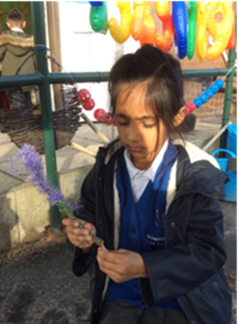
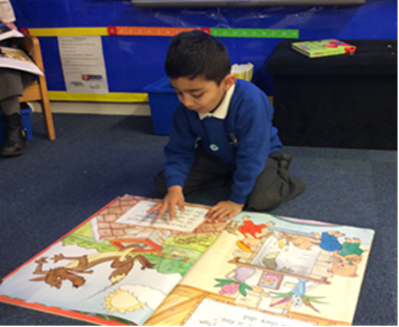

Contents

What makes Brownlow Fold special
Letter from the Chair of Governors
Job Description
Person Specification
Application and Selection Process

Staff at Brownlow Fold are redefining possible! We are a school that makes a difference to the lives of our children and families. We are a situated in an area of deprivation in Halliwell. Over three quarters of our pupils are from minority ethnic backgrounds and the majority of our pupils start school significantly below age related expectations. At Brownlow Fold we teach our children to love challenges, be intrigued by mistakes, enjoy effort, and keep on learning (even when they find something challenging).
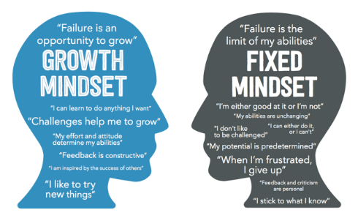

Practising a Growth Mindset at Brownlow Fold is a crucial part of our ethos and beliefs. Our core purpose is to ensure that we improve the educational outcomes for all our pupils and ensure that pupils leave us well prepared academically, socially and emotionally for the next stage of their education. Adopting a Growth Mindset approach offers an optimistic view about what is achievable for each and every one of us.

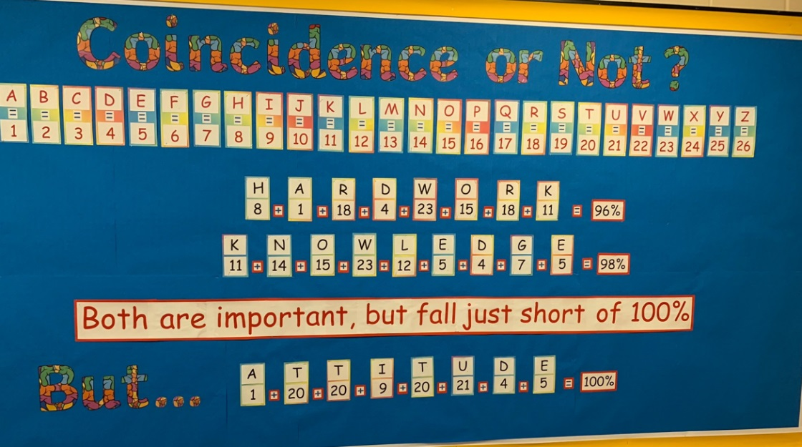
We offer our children a lot more than just the National Curriculum and focus on so much more than ‘just doing well in tests.’ Skills such as honesty, integrity, resilience, empathy and being a good friend are life skills that are necessary for society and every work place. Learning at Brownlow Fold is about helping our children to develop their interests and abilities, providing valuable learning experiences both inside and outside the classroom and promoting their independence and social skills. Our ethos is characterised by high expectations and aspirations for all pupils. All staff are committed to achieving high standards for all pupils in order that they can attain the highest levels of achievement and personal development. We regularly share best practice between colleagues both within our school and local schools. This is helping us to embed a collaborative system and ethos, with all stakeholders working towards the common purpose of improving pupil outcomes. Leadership in a school is far from being the sole province of the headteacher. The journey that we are offering is a chance to develop leadership qualities in all, empowering all staff through the practices of distributed leadership.
We work with a wide range of agencies to support our pupils and staff have a good understanding of the potential sources of support for our pupils and parents. We believe integrated working is about ensuring that children and families receive appropriate and coordinated services at the earliest point. We regularly host a variety of workshops such as the Triple P parenting Class or Talk English (ESOL) classes that enable us to engage with parents and agencies to support our families.

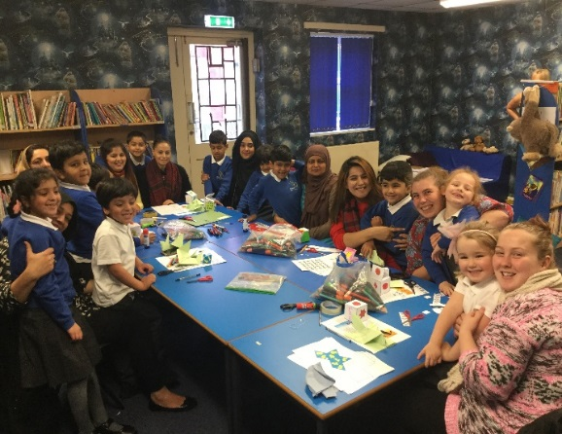
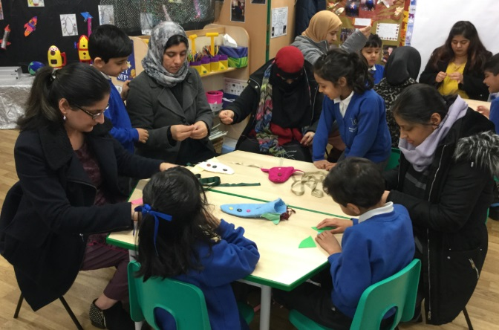

Over recent years we have improved pupil outcomes. More importantly we have raised aspirations not only for our pupils but for the whole Brownlow Fold community. Our focus has been to truly embed a Growth Mindset and encourage our pupils to believe that anything is possible with hard work and dedication.
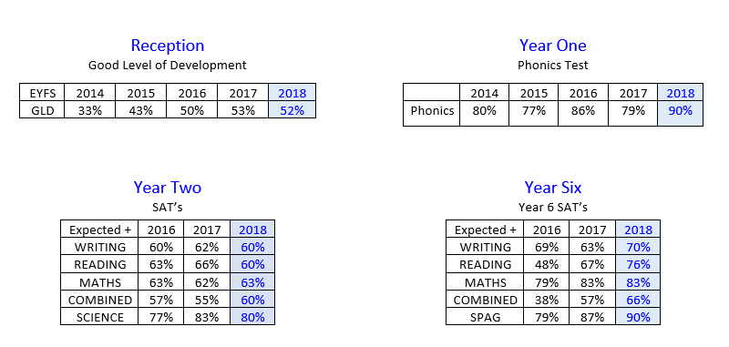

As the Deputy Headteacher you will play a significant role in leading the staff, pupils, parents and governors in establishing our aims, values and ways of working; embedding current good practice and implementing innovative new strategies to help us raise achievement across the school. This role will involve a teaching commitment (which will be reviewed annually according to the needs of the school). You will be working with a team of friendly, dedicated and hard-working staff along with supportive governors. We are all driven by a real desire to change children‘s lives for the better and to help them to reach their full potential. We hope this is what drives you too. Our school is a happy and inclusive place where everyone is valued and encouraged to excel.
We are seeking to appoint a dynamic, inspirational and committed leader to work in partnership with our experienced and dedicated staff, to build on our successes and drive the school forward in future development and growth. If you are an outstanding practitioner with an established reputation for raising standards, coupled with relentless drive and resilience then we want to hear from you. An informal visit to the school is encouraged and warmly welcomed. We recommend that visits take place during the school day then you are able to meet the children and staff and get a real flavour of what life at Brownlow Fold is like. Please contact Louise Vickers, School Business Manager on 01204 333511, to arrange.
Yours faithfully
Julie Hignett Headteacher

Letter from Chair of Governors

Dear Applicant,

I would like to thank you, on behalf of the governors of Brownlow Fold P rimary School, for your expression of interest in becoming our Deputy Headteacher.
We are extremely proud of our happy and friendly school, where expectations are high. The children, along with their parents, benefit from and contribute to a happy, safe environment. Should you be successful in your application then you will find a team of dedicated and friendly teachers and support staff, as well as the support of a committed governing body and of the parents and carers.
We are looking for a Deputy Headteacher who can support the Headteacher to inspire the school community to continue its development. It is a role that will contribute to maintaining an atmosphere of support and collaboration in order to raise standards and build on the school’s existing strengths.
The majority of the pupils are from minority ethnic groups, some with English as an additional language. In excess of twelve different languages are used in school by pupils and parents. The governing body represents the diversity within the school family. All the governors take an active role in school and support the leadership team and staff. School works in close partnership with all of the parents, many of whom are regular visitors to the school and are involved in a number of activities to help support the children in their learning.
To assist with your application, I should like to draw your attention to the school’s website – www.brownlow-fold.bolton.sch.uk . On here you will find various pieces of information about the school, including, but not limited to, the latest OFSTED reports and the school prospectus.
You are welcome to make an informal visit to the school so as to better acquaint yourself with the school and its people. If you should wish to take advantage of this opportunity then please contact the business manager, Louise Vickers, on 01204 333511 to make the necessary arrangements.
Once again, I should like to thank you for your expression of interest and wish you the best of luck should you decide to apply for the post.

Kind regards,

Chris Kehoe
Chair of Governors.

Brownlow Fold Community Primary School

Post of Deputy Headteacher – Job Description

Job Title | Deputy HeadTeacher
Grade | L8 – L12
The primary purpose of the job | The primary purpose of the job is to assist and when necessary deputise for the Headteacher in leading and managing the school effectively and efficiently, in order to provide the highest quality education possible for each child entrusted to our care.
Responsible to | The Head Teacher and the Governing Body
Principal Responsibilities | The appointment is subject to the current conditions of employment for Deputy Headteachers contained in the Schools Teachers’ Pay and Conditions Document, the School Standards and Framework Act, the required standards for Qualified Teacher Status and other current educational and employment legislation.

MAIN DUTIES
Strategic direction and development of the school

- Fully and actively supporting the vision, ethos, aims and objectives of the school;
- Develop an effective working relationship with the Headteacher, leadership team and all staff;
- Be an active member of the school’s leadership team;
- Take a lead role in the school’s self-evaluation processes, monitoring progress towards curricular and other targets;
- Work with the Headteacher, governors and staff in the formulation and effective delivery of the School Development Plan;
- Assist the Headteacher in the planning of the annual budget and managing financial delegation
- Make a positive and regular contribution within full governing body and committee meetings;
- To take account of national and local initiatives

Teaching and learning

- Model high standards in what constitutes outstanding classroom practice;
- Co-ordinate aspects of the curriculum throughout school;
- Manage the quality and effectiveness of the curriculum through the co-ordination of teaching and learning throughout the school, and spread good practice of effective teaching and learning styles;
- Lead strategies aimed at raising standards and achievements throughout the school, including standards of core subjects, and attendance;
- Have a clear overview of assessment, recording and reporting throughout the school;
- Lead the co-ordination of a subject area throughout the school;
- Be prepared to teach in any age group(s) in school in both planned and unplanned situations;

Leading and managing staff
- Model positive leadership and teamworking behaviours, treating all members of the school community with equal respect;
- Work with the Headteacher to establish distributed leadership throughout the school;
- Provide help and support for colleagues, and have a positive impact on classroom practice through coaching, evaluation, feedback and staff development programmes;
- Take a lead role in the delivery of the school’s Professional Review/Appraisal policy, and encourage a positive attitude towards it.

Pupil support
- Take a share in the leadership of discipline and pastoral care for pupils;
- Lead collective worship including deputising for the Head Teacher.

General
- Carry out the professional duties as outlined for Deputy Headteachers in the Teachers’ Pay and Conditions document;
- Promote the school in the community, playing a proactive role in the local educational community at cluster and LA levels;
- Ensure effective internal communication throughout the school and external communications with parents and other groups;
- Show commitment to the extra-curricular activities of the school;
- Undertake any professional responsibility delegated to the post

Customer Care - To continually review, develop and improve systems, processes and services in support of the School’s pursuit of excellence in service delivery. To recognise the value of its people as a resource.
Promoting equality and diversity - To accept everyone has a right to his or her distinct identity.
To treat everyone with dignity and respect and to ensure that what our customers tell us is valued by reporting it back into the organisation. To promote and participate in the council’s work to eliminate discrimination; advance equality of opportunity; and foster good relations between our diverse communities.
Developing Self and Others - To use processes and put processes in place to generate a learning environment. To focus on the strengths and requirements of all individuals and enable them to further their skills and knowledge. To actively pursue your own development. To be self-aware and role model continuous self-development.
Safer Recruitment - The school is committed to safeguarding and promoting the welfare of children and young people and expects all staff and volunteers to share this commitment.

Brownlow Fold Community Primary School

Post of Deputy Headteacher – Person Specification

MINIMUM ESSENTIAL REQUIREMENTS | METHOD OF ASSESSMENT
Skills and Knowledge
- To be an excellent classroom practitioner with knowledge of what contributes to excellent teaching and learning.  - Ability to work positively in a team.  - Experience of monitoring, involvement in school self evaluation, and planning for improvement in order to raise achievement.  - To have an up to date knowledge of relevant legislation and guidance in relation to working with, and the protection of, children.  - Ability to extract, analyse and evaluate issues from data, and to implement strategies for improvement for all pupil groups.  - Ability to communicate effectively with staff, parents and governors.  - Proven track record of contributing to the effective raising of standards through innovative teaching and learning strategies.  - Experience of successful current leadership and staff development.  - Knowledge of the importance of tracking progress and target-setting in order to bring about improvement. | Application, Interview and Assessment Centre

Personal Qualities
- Ability to lead, motivate and influence others.  - To have excellent time management and organisational skills.  - Decisiveness, a positive attitude and a creative outlook.  - Dynamic leadership, drive, commitment and enthusiasm.  - Excellent communication and interpersonal skills.  - Think creatively to anticipate and solve problems. | Application, Interview and Assessment Centre

Approach to work
- To show a commitment to working in partnership with parents, governors and the LA to provide the best education possible for our pupils.  - Passionate about children’s learning.  - Think strategically and contribute to creating a coherent school vision.  - High expectations of self and others. | Application and Interview

Experience/Qualifications/Training etc.
- Qualified teacher status.  - To have a good understanding of Safeguarding responsibilities willing to undertake L3 training  - To be able to demonstrate recent professional development relating to the assessment and tracking pupil progress.  - A track record of success at middle/senior leadership level.  - To be able to show leadership and curriculum development in a core subject.  - To have an excellent understanding of current theory/research and best practice in teaching and learning, particularly as it relates to achieving high rates of progress of children. | Application Form

Application and Selection Process

Timeline

- Closing date for applications is: 23 April 2019 at 10.00 am
- Shortlisting will be on: 29 April 2019
- Lesson Observations: 7 May 2019
- Assessment Centre: 8 May 2019
- Interview: 9 May 2019

An informal visit to the school is encouraged and warmly welcomed. We recommend that visits take place during the school day then you are able to meet the children and staff and get a real flavour of what life at Brownlow Fold is like. Please contact Louise Vickers, School Business Manager on 01204 333511, to arrange.

Following the shortlisting process, successful candidates are invited for interview.

The selection process will involve a number of assessed exercises which can range from a one to one exercise to a written exercise and a panel interview.

The successful candidate will be informed soon after the decision has been ratified by the Governing Body.

Unsuccessful (shortlisted) candidates will get the opportunity to obtain verbal feedback from the Headteacher once the process is completed.

If after reading the information provided you feel that you meet the specification for the post, we would like to hear from you.

Please email your completed application form, together with your Equal Opportunities Monitoring form and a supporting statement to tanya.johnson@bolton.gov.uk School’s HR Manager, Bolton Council

