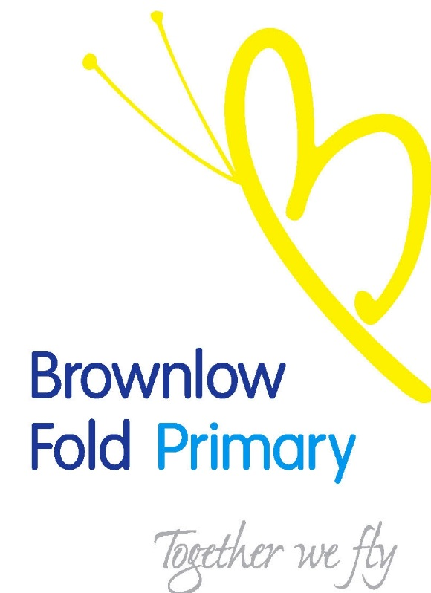

Brownlow Fold
Community Primary School

Recruitment and Selection of

EYFS / KS1 TEACHER

MAY 2017

Brownlow Fold School
Darley Street
Bolton
BL1 3DX

Contents

Covering letter from Headteacher

Details of Application & Selection Process

Fixed Term EYFS / KS1 Teacher Post

Job Description and Person Specifications

Application Form

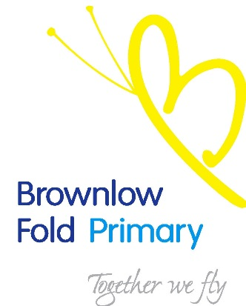

23rd May 2017

Dear Applicant,

Post of: Fixed Term EYFS / KS1 Teacher

Thank you for your interest in this post at our school.

The Governors and Head teacher are looking to appoint an excellent, enthusiastic and dedicated teacher to work within our EYFS / Key Stage One.

We are looking for a teacher who:
- Has high expectations of children’s achievements and behaviour.
- Has a passion for learning
- Is well organised
- Enjoys working as part of a team.
- Has a variety of curriculum strengths and interests.

Brownlow Fold is a friendly and truly diverse community where:

“The progress that children make in the early years remains good and is improving.”

“The leaders of English and the early years have an accurate and detailed understanding of the areas they lead. They have a clear vision and passionate commitment to ensuring that pupils get the best education possible. Their actions are appropriate and have a positive impact.”

“Pupils receive well-matched challenges that develop good attitudes to learning and result in better achievement, particularly in mathematics and writing.”

“Pupils are attentive and eager learners who demonstrate good conduct and manners.” (all Ofsted 2016).

Our children are polite and well mannered and our staff are very hardworking, we are committed to enabling our children to achieve their very best.

Although we have tried to make the information in this pack as helpful as possible in telling you about the school prospective candidates are warmly invited to visit the school. Please ring to arrange an appointment.

We look forward to hearing from you.

Miss J. Hignett,
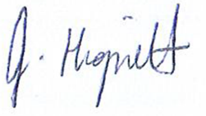
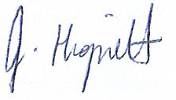
Headteacher

Details of Application and Selection Process:

Full Time, Fixed Term Post EYFS / KS1 Teacher

Key Deadlines:

- Closing date for applications is Noon on Monday 5th June
- Shortlisting will be on Monday 5th June
- Observations will be on Friday 9th June
- Interviews will be on Monday 12th June

Following the shortlisting process, successful candidates will be invited for interview.

The interview process will involve a panel interview.

The successful candidate will be informed soon after the decision has been made.

Unsuccessful candidates will get the opportunity to obtain verbal feedback from the Head Teacher.

If after reading this documentation, you feel that you meet the specification for the post, and can meet the challenges facing the school, we would like to hear from you.

Please send your completed application form, together with a supporting statement to:

Miss J Hignett
Brownlow Fold School
Darley Street
Bolton
BL1 3DX
Tel: 01204 33351 E-mail: office @brownlow-fold.bolton.sch.uk

BROWNLOW FOLD PRIMARY SCHOOL

JOB DESCRIPTION

Title Class Teacher – Full Time
Salary Grade Main Scale

Purpose of the Job
- To be a primary school teacher

Directly responsible to:
- The Head Teacher, the Deputy Head Teacher and the Governing Body.

Principal Responsibilities
- The professional duties of a teacher are those set out in the current Teachers' Pay and Conditions document.

Main Duties
- Those duties listed in the current Teachers' Pay and Conditions document.
- Meeting Performance Management objectives

Pastoral Duties
- To take a role with regard to discipline and pastoral care within the framework of the agreed and adopted policies
- To offer support and guidance to staff, parents and pupils

Academic Duties
- To act as lead subject co-ordinator for a designated area throughout school
- To work collaboratively with a subject based team if appropriate

Customer Care
- To provide quality services that are what our parents/carers and pupils want and need
- To give parents/carers and pupils the opportunity to comment or complain if they need to
- To work with parents/carers and pupils and do what needs to be done to meet their needs
- To inform the Head Teacher about what parents/carers and pupils say in relation to the services delivered

Continuing Professional Development
- To make every effort to access development opportunities and ensure you spend time with the school CPD co-ordinator or your staff development team leader in order to identify your development needs.
- To be ready to share learning with others
- To participate in five staff training days each academic year

Valuing Diversity
- To accept everyone has a right to their distinct identity.
- To treat everyone with dignity and respect and to ensure that what all members of our school tell us is valued by reporting back to the school
- To be responsible for promoting and participating in the achievement of the school valuing diversity ethos

The post holder may reasonably be expected to undertake other duties commensurate
with the level of responsibility that may be allocated from time to time.

Signed : ______________________________________ Date : ______________

BROWNLOW FOLD PRIMARY SCHOOL

PERSON SPECIFICATION

Disabled candidates are guaranteed an interview if they meet the essential criteria

MINIMUM ESSENTIAL REQUIREMENTS

Professional Values and Practice

- Effective communication skills to develop the partnership with pupils, parents/carers and colleagues;
- Awareness of the school environment, including links with the local community;
- Awareness of the professional values and behaviour expected of teachers;
- Commitment to professional development using targets agreed during induction.

Knowledge and Understanding

- Secure knowledge of the National Primary Strategy and the National Curriculum;

Or for Foundation Stage Teachers

- Secure knowledge of the six areas described in the Curriculum Guidance for the Foundation Stage;
- Experience of using ICT effectively both in curriculum planning and teaching;
- Understanding of your responsibilities under the SEN Code of Practice;
- Knowledge and experience of developing a purposeful learning environment;
- Respect for pupils’ social, cultural, linguistic, religious and ethnic backgrounds with an understanding of how these may affect their learning.

Planning, Expectations and Targets

- Knowledge and experience of applying a framework of curriculum planning which:
  - Includes long and short term plans,
  - Requires learning objectives to be identified for classes, groups and individuals,
  - Enables monitoring, assessment and recording of pupils’ progress.
- Understanding the role of other professionals in maximizing pupils’ learning.

Teaching and Class Management

- Organisational and time management skills to enable effective teaching of whole class, groups and individual pupils;
- Knowledge and experience of interactive teaching methods and collaborative group work, which enable pupils to take responsibility for their own learning;
- Experience of enabling pupils with different learning needs and of varying abilities (including EAL) to maximise their learning through provision of differentiated activities;
- Awareness of equality issues, including maximizing opportunities to explore and promote equality and raise awareness of diversity through teaching and learning;
- Using a range of strategies to promote good behaviour and to deal with inappropriate behaviour within school policies.

Qualifications

- To have completed DFES recognized initial teacher training course leading to Qualified Teacher Status;
- To have trained, or being trained for the appropriate age group.

