Practice Manager- Safeguarding and Quality Assurance Unit (SQAU)
Service: | Children’s | Grade: | 5A |  |  | Salary: |  |  | £42,683 - £44,632
Reporting to: | Head of Service Social Work Improvement | Location: | Unity House, Swinton |  |  | Hours: |  |  | Up to 36 Hours
About the role |  |  |  |  |  |  |  | Our priorities
- To be a part of Children’s Services manager team, ensuring that the needs of children and young people in Salford are met and their full potential is being met.  - To support and develop innovative practice within Children’s Services, focused on improving outcomes.  - To lead and supervise social care staff in line with the supervision policy and associated council policies.  - To support the implementation and embedment of an asset based and restorative approach to practice within the service. Ensuring the service facilitates high support and high challenge.  - To oversee and develop the practice of social work practice  - To support the Ofsted Preparation within Children Services, working closely with Partners.  - To undertake Human Resource processes where needed, ensuring all staff are fully supported and can offer a good service to children, young people and families.  - The post holder will be required to undertake the role of Practice Manager in any of the service areas across the Directorate, dependant upon the skills, knowledge and competency requirements of that role.  - Work with full regard to Salford City Council’s Values, Equal Opportunities, Health & Safety and Community Strategy policies. |  |  |  |  |  |  |  | 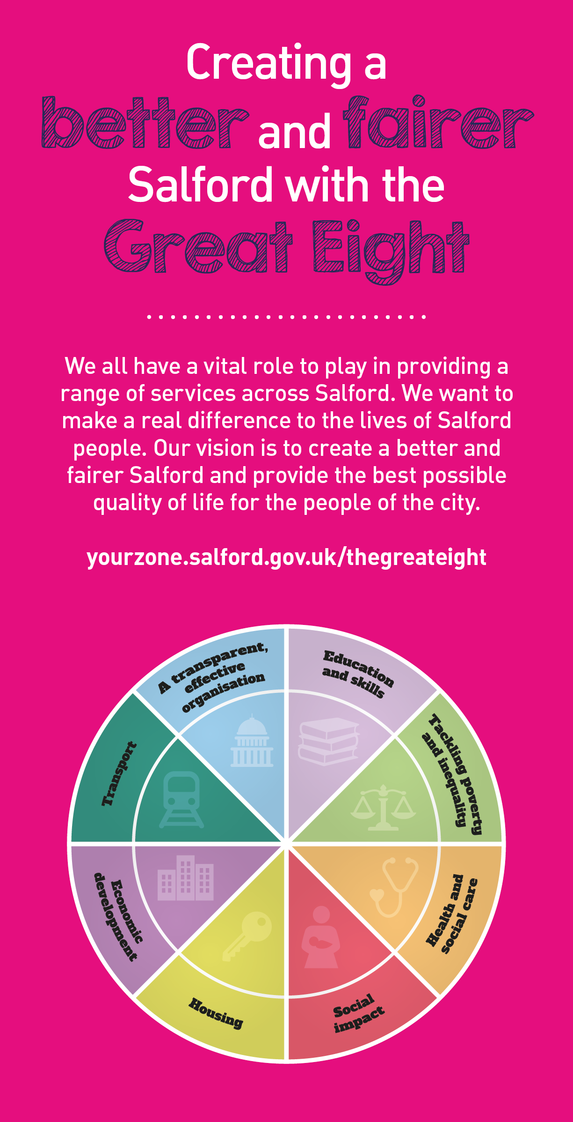
Key outcomes
- You will have oversight and management of the day to day delivery of all aspects of the Social Work service. Your role will have a focus on the quality and improvement of social work and service delivery  - You will ensure the service is facilitating effective participation of children, young people and families and that their lived experiences are known, understood and inform plans.  - You will be accountable to the HOS for social work improvement for staff supervision, care and development of team.  - You will effectively address the areas of learning from the recent Ofsted inspection, to support good and outstanding services are in place for all children, young people and families.  - You will manage organisational change and development requirements in light of internal and external trends and influences, by keeping up to date with all new legislation, guidance and Corporate and Directorate policies and procedures  - You will be responsible for ensuring documentation, record keeping, accounting and communication is maintained and effective information strategies and systems are in place to enable appropriate sharing of data and information. Including responding to complaints.  - To contribute towards the preparation and updating of polices and procedures. |  |  |  |  | - You will be accountable to the HOS for Social Work Improvement for the development and delivery of effective service provision and to inform strategic plans and priorities.  - To undertake observation of practice and case audits, contributing to the Quality Assurance Framework within children’s services.  - To confidently enforce a high support, high challenge culture within our outcomes resolution duties.  - You will work collaboratively and inclusively with colleagues, partners and members of the public ensuring equality of opportunity for everyone and eliminate direct or indirect discriminatory practices/behaviour  - You will ensure the regular and effective analysis, monitoring, measurement and maintaining of the performance of the team to ensure impact on outcomes for children and families is understood.  - To ensure that systems are put in to place to effectively recruit and train employees appointed to the service and in line with the Safe Recruitment Policy.  - You will ensure that you develop and maintain excellent working relationships with service areas and external partners to ensure good practice is maintained and improved.  - To undertake such additional duties as are reasonably commensurate with the level of the post and deputise on behalf of the Service Manager and Head of Service as required.

What we need from you
- Professional credibility through proven relevant experience.  - Model and demonstrates our values and behaviours  - Experience of managing and supervising others.  - Detailed knowledge of legislation and law in relation to children and families  - Detailed knowledge and understanding of the implementation and management of complex casework process and procedures.  - Ability to translate complex ideas and information into meaningful and ‘user-friendly’ information; ability to ‘tell the story’ to bring people along and ensure all audiences understand the key messages.  - Ability to motivate, engage and develop people to deliver shared outcomes.  - To be an excellent communicator using various mediums to achieve the best results.  - To build strong, collaborative relationships to find creative ways to make services more sustainable and flexible.  - Ability to address complaints effectively by acting as an investigating officer when required.  - Undertake effective audits of practice and ensure these impact positive on staff and outcomes. |  | - To remain strength focused under challenging circumstances  - To demonstrate initiative, confidence and personal responsibility for action especially where solutions or ways forward are not clear.  - To be a skilled communicator who communicates with clarity, conviction and enthusiasm and is able to demonstrate integrity, create rapport and build trust and confidence.  - Ability to contribute to the development of positive and supportive team working relationships.  - To be determined and consistently persist with actions to achieve outcomes  - To bring together multi-faceted activities and teams to improve performance and/or resolve business critical issues.  - Analytical skills and using insight to inform change and plans.  - Hold a current HCPC registration  - Hold a recognised social work qualification  - Excellent knowledge of Microsoft Office Systems.

Application Guidance |  | Our values
We are a values based organisation so reflecting our values or a values based approach in your evidence will support your application.

The ‘Key outcomes’ and the ‘What we need from you’ sections of the Role Profile are there to give you an understanding of what we would like to see reflected in your application. Don’t give up if you are not able to reflect all of these in your application.

Please submit a CV and a cover letter (no more than 4 sides of A4) outlining how you meet the requirements and what you bring to the role.

