Service Manager – Early Help
Service: |  | People | Grade: | 5C |  |  |  | Salary: |  |  | £47,769 - £49,608
Reporting to: |  | Assistant Director | Location: | Citywide |  |  |  | Hours: |  |  | Up to 36 hours per week
About the role |  |  |  |  |  |  |  |  |  | Our priorities
- To have a strategic role in the Early Help Management team, to contribute to the overall management of the service to ensure the needs of children and young people in Salford are met.  - To have strategic overall responsibility for the management of the Early Help Service, teams and performance within their responsibility and operational delivery of a key frontline service within the Children’s Services Directorate.  - To lead and develop innovative practice within Early Help, focused on improving outcomes.  - Support in the strategic and operational development of neighbourhood/place base working across the city and across partners  - To lead and supervise staff in line with the supervision policy and associated council policies, ensuring all staff are fully supported and can offer a good service to children, young people and families.  - To support high quality evidenced based practice, ensuring the service facilitates high support and high challenge.  - To undertake Human Resource processes where needed, ensuring all staff are fully supported and can offer a good service to children, young people and families.  - To support the Ofsted Preparation within Children Services, working closely with Partners.  - The post holder will be required to undertake the role of Service Manager in any of the service areas across the Directorate, dependent upon the skills, knowledge and competency requirements of that role.  - Work with full regard to Salford City Council’s Values, Equal Opportunities, Health & Safety and Community Strategy policies. |  |  |  |  |  |  |  |  |  | 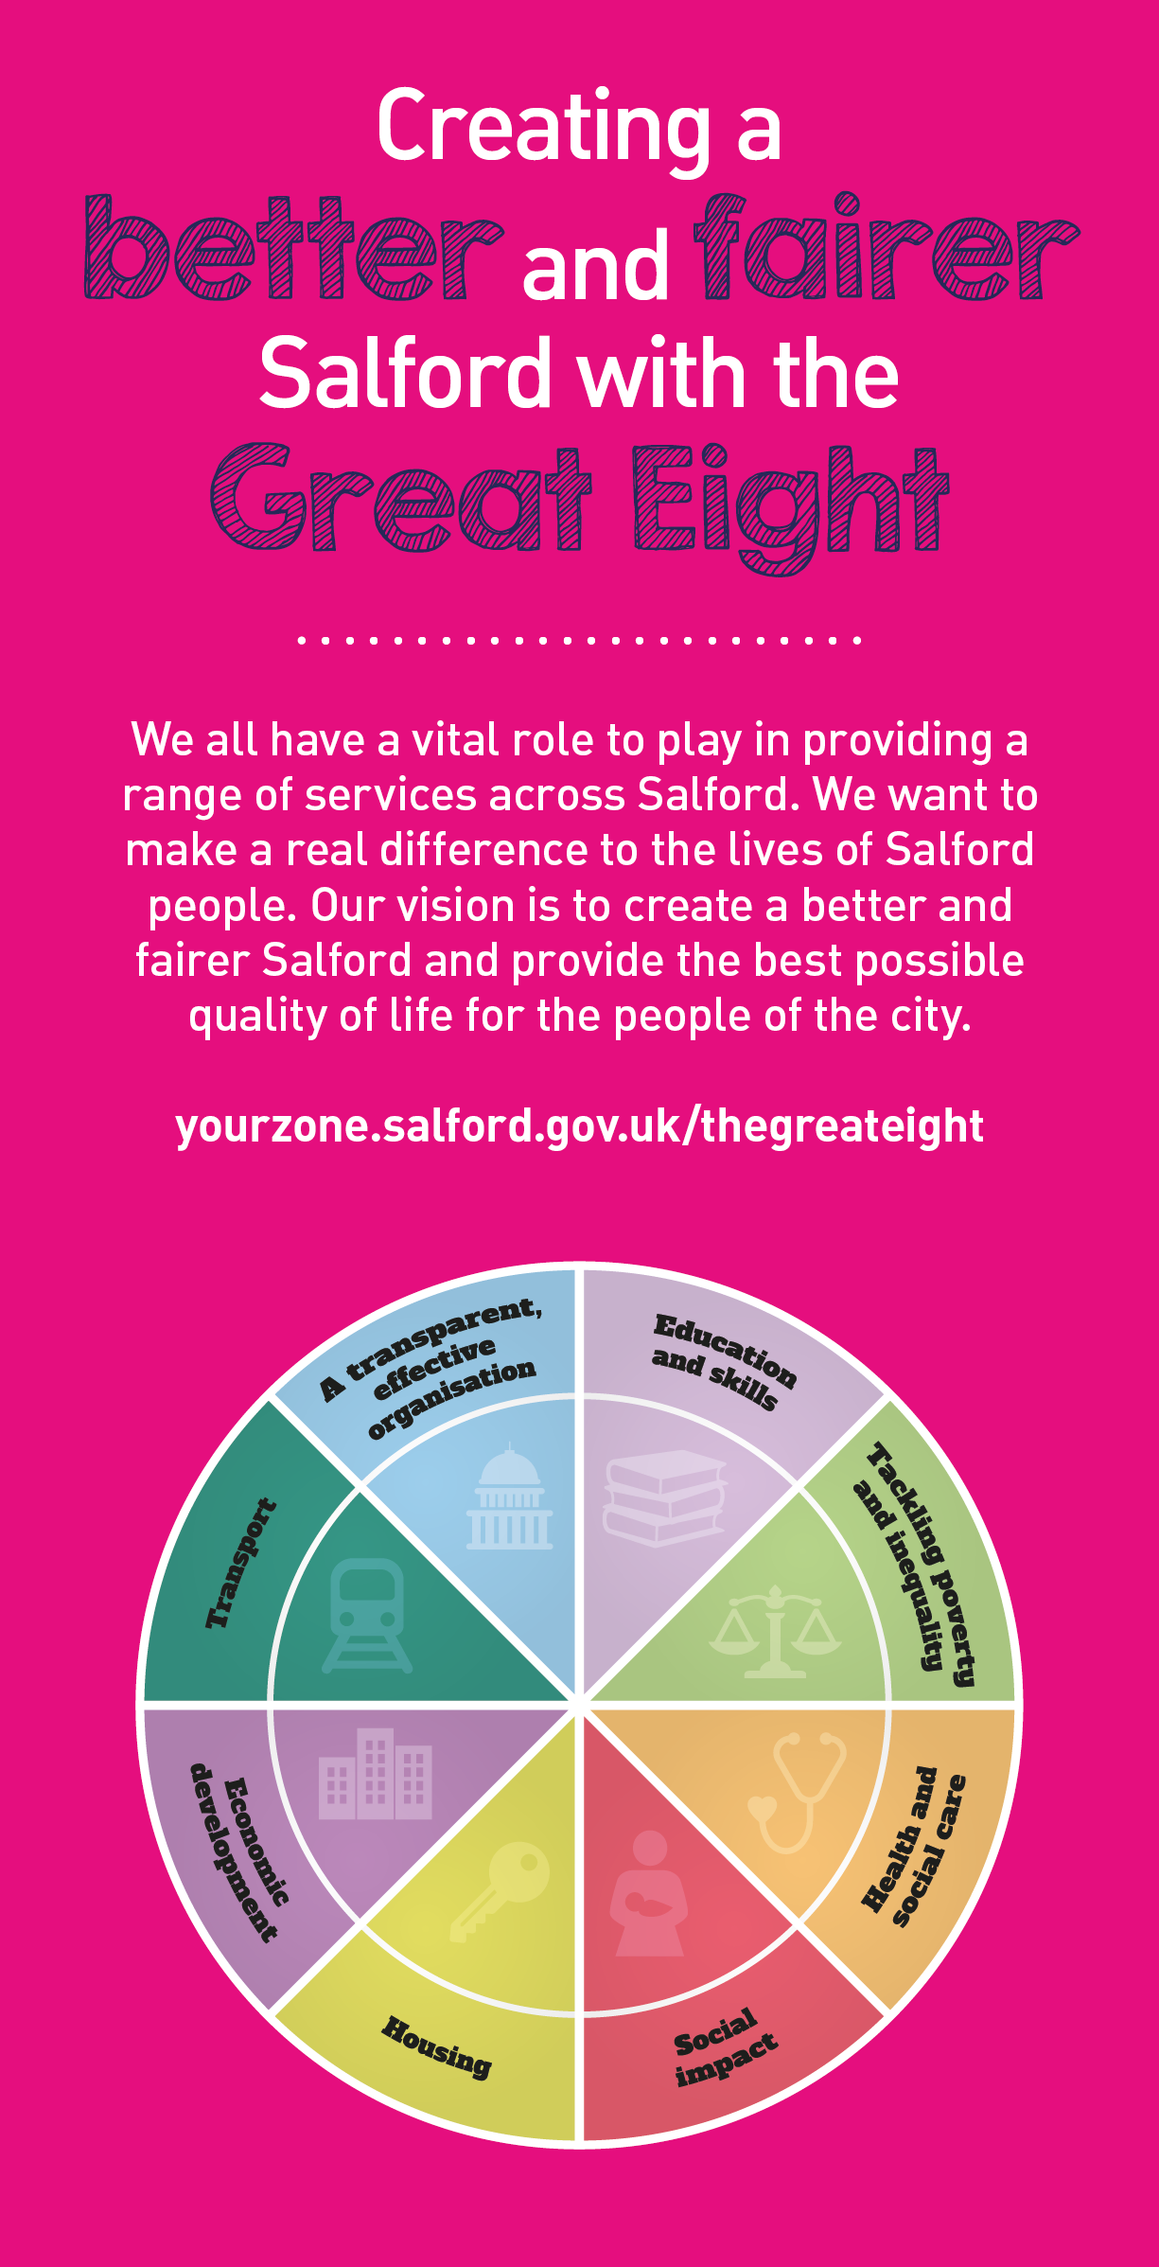
 | Key outcomes
 | - You will have oversight and management of the day to day delivery of all aspects of the Early Help service. Your role will have a focus on the quality and improvement of Early help service delivery  - You will lead on organisational changes and service contingency plans to support sustainability. This will focus on ensuring all work is outcome based and achieved within agreed expectations.  - You will be accountable to the Assistant Director for the development and delivery of effective service provision and to inform strategic plans and priorities.  - You will be accountable to the Assistant Director for staff care and development of team, for the health and safety of staff and individuals, and the safety of equipment and operations within the team.  - You will lead on effectively addressing the areas of learning from the Ofsted inspection, to ensure good and outstanding services are in place for all children, young people and families.  - You will be responsible for ensuring documentation, record keeping, accounting and communication is maintained and effective information strategies and systems are in place to enable appropriate sharing of data and information.  - You will ensure that services are targeted, developed and delivered within policy and legal obligations and that budget management is maintained.  - You will manage organisational change and development requirements in light of internal and external trends and influences, by keeping up to date with all new legislation, guidance and Corporate and Directorate policies and procedures.  - To contribute towards the preparation and updating of policies and procedures. |  |  |  |  |  | - To confidently enforce a high support, high challenge culture within our outcomes resolution duties.  - You will contribute positively to the Business Plan Objectives and vision, by implementing and monitoring performance of strategic plans and ensuring that objectives within all relevant plans are met.  - You will work collaboratively and inclusively with colleagues, partners and members of the public ensuring equality of opportunity for everyone and eliminate direct or indirect discriminatory practices/behaviour  - You will ensure the regular and effective analysis, monitoring, measurement and maintaining of the performance of the team to ensure impact on outcomes for children and families is understood.  - To analyse monitor and support of each member of the teams contribution towards these in order to secure continuous improvement in the services provided and address any issues which may affect service delivery.  - To ensure that systems are put in to effectively recruit and train employees appointed to the service and in line with the Safe Recruitment Policy.  - You will ensure that you develop and maintain excellent working relationships with service areas and external partners to ensure good practice is maintained and improved.  - To deputise on behalf of the assistant director as required and carry out any other appropriate duties as may be assigned by the Directorate.
 | What we need from you
 | - Professional credibility through proven relevant experience.  - Model and demonstrates our values and behaviours.  - Experience of managing and supervising others, including attendance management and appraisals.  - Detailed knowledge of legislation and law in relation to children and families.  - Detailed knowledge and understanding of the implementation and management of complex casework process and procedures.  - Detailed understanding of the challenges of delivering early help to children and families.  - Ability to translate complex ideas and information into meaningful and ‘user-friendly’ information; ability to ‘tell the story’ to bring people along and ensure all audiences understand the key messages.  - Ability to motivate, engage and develop people to deliver shared outcomes.  - To be an excellent communicator using various mediums to achieve the best results.  - To build strong, collaborative relationships to find creative ways to make services more sustainable and flexible.  - Ability to address complaints effectively by acting as an investigating officer when required.  - Undertake effective audits of practice and ensure positive impact on staff and outcomes. |  |  |  |  |  | - To remain strength focused under challenging circumstances  - To demonstrate initiative, confidence and personal responsibility for action especially where solutions or ways forward are not clear.  - To be a skilled communicator who communicates with clarity, conviction and enthusiasm and is able to demonstrate integrity, create rapport and build trust and confidence.  - Ability to contribute to the development of positive and supportive team working relationships.  - To be determined and consistently persist with actions to achieve outcomes  - To bring together multi-faceted activities and teams to improve performance and/or resolve business critical issues.  - Analytical skills and using insight to inform change and plans.  - Social Work qualification desirable, not essential.  - Excellent knowledge of Microsoft Office Systems.
What we can offer you
Your ongoing professional development and success in your role is important to us, and that is why we provide a variety of learning and development opportunities. Within the sections below you will find development options tailored to you which will enable you to further develop your existing skills and learn new ones at a pace that suits you best. If you are joining us now, your development will form part of ongoing discussions with your manager. If you are an existing employee, you should use your Personal Development Reviews to discuss your career options with your manager and create your development journey. It’s important you also take full advantage of any informal learning available to you during the course of your work, including coaching, mentoring and shadowing. Please discuss these options with your line manager.

- Online Learning - Develop your knowledge across a wide range of areas through our Me-Learning platform, with over 200 free courses to choose from. To have the best possible start and comply with current legislation, you must complete the following modules: Welcome to Salford, Health and Safety in Office, Equality Essentials, GDPR, and Safeguarding Children and Adults. You may also benefit from a variety of courses in categories such as Business Skills, IT and Project Management, Leadership and Management which are available to learn at your own convenience and pace.  - Developing your digital skills – Our ambition is to provide our workforce with the right level of digital capabilities needed to be successful. Whatever your current digital abilities are, we can provide development ranging from essential workplace skills to specialist workplace skills’. These will be delivered through our Digital Skills Academy using both self-directed and guided learning opportunities to enable you to develop. Additionally, you can access free online courses through the iDea website.  - Sharing your digital skills – Our goal is to support you to share your digital knowledge with other people. Our Digital Eagles programme has been designed to cover basic digital skills and build your confidence to assist others. By the end of this programme you will join hundreds of staff members who already are digital eagles, and be able to help colleagues, customers, residents, or people in your personal life with all things digital. |  |  |  |  |  | - Developing your leadership skills – We want to equip our leaders with the knowledge, skills and behaviours outlined in our #LeadingSalford programme. Our aim is to support you to lead highly engaged, motivated teams in today’s rapidly changing environment. This will be achieved through our core Master Classes: Breakthrough Conversations, Engage for Success, Values to Action, and Coaching for Performance and Potential. The Master Classes are designed to help you meet the expectations that we have of our Salford leaders. In addition to the core Master Classes, we also provide courses such as Management Essentials, Health and Wellbeing at Work, Strengths-Based Conversations, and Financial Skills for Non-Financial Managers.  - Professional Development – Gain role specific skills and time to learn through a wide range of development opportunities. Learn whilst working and get support towards your qualification through an apprenticeship standard. Access professional development ranging from entry level to master’s type qualifications, including achieving a role appropriate qualification. Details can be found on the Institute of apprenticeships website.

Our leadership behaviours |  | Our values
As a values-based leader you will:  - Model the values and embed them in the way your team delivers services  - Hold people accountable for delivering the values  - Respect and care for others, treating everyone fairly, recognising the importance of ensuring equality of opportunity for all, and listening and acting on the things people say  - Be honest, taking responsibility for your actions and decisions  - Use resources that you are trusted with wisely |  | To lead and develop people you will:  - Listen to understand, not to defend  - Give people the freedom to use their initiative  - Provide opportunities for people to discuss and solve problems and issues  - Regularly provide coaching and support to others to help them achieve their objectives and potential  - Appreciate and build on people’s strengths  - Motivate, engage, encourage and inspire others in order to be the best they can be
To create a performance and development culture you will:  - Be visible, inject pace, vigour and purpose  - Expect high standards; mediocrity is not acceptable  - Take an evidence and whole system approach in making decisions  - Maximise technology and models to deliver quicker, easier, better services  - Have a digital mindset, fully utilising digital systems and solutions to deliver services differently  - Set context and challenging goals that will motivate people to take ownership, maximise performance, and develop |  | To build and communicate a vision for the future you will:  - Be optimistic and ambitious for the city and its people, helping others to understand the need to transform public services  - Build strong collaborative relationships to find creative ways to make services more sustainable and flexible  - Recognise and values the strengths of people and places, taking a strengths-based approach to make the most of opportunities  - Support people through change, in undertaking new things, and taking risks  - Take a place and whole system approach in designing, delivering and leading services  - Ensure an inclusive approach with the aim of reflecting the increasing diversity of Salford

Application guidance

We are a values based organisation so reflecting our values or a values based approach in your evidence will support your application.

The different sections of this role profile are there to give you an understanding of the purpose of the role. The ‘what we need from you’ section outlines the minimum criteria you will need to meet within your application.
Please submit a CV and a cover letter (no more than 2 sides of A4) outlining how you meet the requirements and what you bring to the role.

