Click here to enter text.
Service: |  | SEN team | Grade: | 2C |  |  | Salary: |  |  | £21598-23836
Reporting to: |  | SEN Manager / principal officer | Location: | Burrows House |  |  | Hours: |  |  | Full time (36 h/w)
About the role |  |  |  |  |  |  |  |  | Our priorities
- The role is about contributing towards the delivery of a high quality SEN service to the children and young people of Salford and their families.  - The role involves working with a fluctuating caseload across the Local Authority, managing the statutory Education, Health and Care Plan (EHCP) process for children and young people with special educational needs and disabilities (SEND) and working towards co-production of EHCPs with professionals and families.  - Being responsible for the administration of the procedures for the assessment, drafting and amending of EHCPs, and for the placement and review of children and young people (0-25) with SEND  - Providing advice and support to schools and settings, governors, young people and parents / carers on matters relating to children and young people with SEND requiring an EHCP  - To ensure that EHCPs clearly detail the needs of the child / young person, have clear actions and are outcome focussed with realistic timeframes. Liaise with schools, professionals, children / young people and parents / carers to compile EHCPs that are aspirational and outline the opportunities needed to achieve these aspirations and outcomes. Ensure that the voice of the child is clear throughout the plan, and that targets are clearly matched to need.  - To deal with correspondence and telephone queries concerning the statutory assessment, drafting of EHCPs, placements and review procedures for children / young people with SEND  - Ensure that the process, from initial application to final EHCP, meets the statutory timescales, and that the council meets its statutory duties in relation to the Children and Families Act (2014), the SEND Code of Practice (2015) and the Equality Act (2010)  - To work with education providers and settings across the LA to secure suitable placements through negotiation and liaison with Headteachers, Officers both in the LA and other Local Authorities, and other appropriate agencies / providers.  - To maintain detailed and accurate records for each child / young person, ensuring records are co-ordinated and compiled using the appropriate database(s), and that these are up to date and all necessary correspondence is sent in a timely manner to schools / settings and parents / carers.  - To attend statutory review meetings and other multi-agency meetings relating to children and young people with SEND where necessary, give advice concerning SEN procedures, provide notes / minutes, take appropriate follow-up action and convey recommendations to senior colleagues. Through the annual review process ensure that schools are held accountable for providing the support detailed within and EHCP. |  |  |  |  |  |  |  |  | 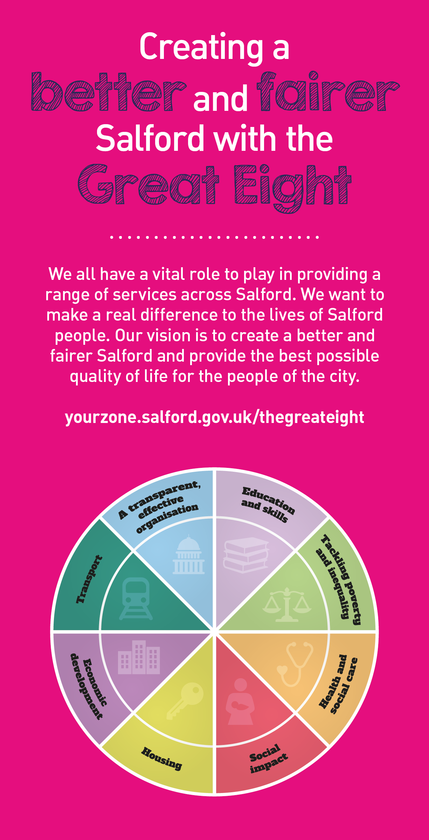
 | Key outcomes
 | - You will help to ensure that every child / young person realises their right to achieve their potential and the best educational outcomes they can, and will be as well equipped for adult life as possible.  - You will help to ensure that every child / young person requiring the support and protection of an EHCP experiences a smooth journey from assessment to final plan within statutory timeframes.  - You will help to improve the educational outcomes for children and young people with EHCPs and SEND  - By challenging schools and ensuring they are held to account you will help all children / young people access appropriate educational provision, in the most optimum environment for their needs  - By working with professional colleagues across education, health and social care you will help ensure that advice is received from agencies in a timely manner to ensure all statutory deadlines are met, from initial assessment to annual reviews  - By working closely with parents and engaging in co-production of EHCPs you will improve the experience of children / young people and their families, and consequently increase their engagement with SEN services. |  |  |  |  | - By ensuring EHCPs are written in a timely manner with appropriate targets and outcomes, you will help children access educational settings within the LA can meet their needs, helping to reduce the number of children and young people who need to access educational provision outside of the LA.

What we need from you

- Proven technical skills and ability in the role with a record of accomplishment for delivering outcomes  - Professional credibility through proven relevant experience  - Models and demonstrates our values and behaviours  - Ability to work both on own initiative and manage own workload, and also be part of a team  - Excellent communication skills, to be able to work effectively with a wide variety of people, and the ability to build positive working relationships based on professionalism and challenge  - Ability to be both flexible, but also to be able to prioritise and work to specific deadlines  - The ability to work collectively and collaboratively with colleagues within Peoples Directorate, with schools / settings, other agencies and professionals and the voluntary sector  - Proven experience of working with children / young people with SEND and their families, possibly within an educational setting  - Knowledge and understanding of the SEND code of practice and the underpinning values of the Children and Families Act (2014) |  | - Knowledge of the principles of EHCP assessment and processes and the ability to work in an outcome focused way  - Knowledge of how different educational settings (early years settings / PVIs, primary and secondary schools and FE colleges) operate in relation to children and young people with SEND  - Experience of being part of a multi-agency workforce, working collaboratively in an outcome focussed way.  - Experience of working with a variety of computer packages and databases  - A full driving licence and access to a car for business purposes  - Commitment to continued professional development

Application Guidance |  | Our values
We are a values based organisation so reflecting our values or a values based approach in your evidence will support your application.

The ‘Key outcomes’, ‘What we need from you’ and ‘our leadership behaviours’ sections of the Role Profile are there to give you an understanding of what we would like to see reflected in your application. Don’t give up if you are not able to reflect all of these in your application.

Click here to enter text.

