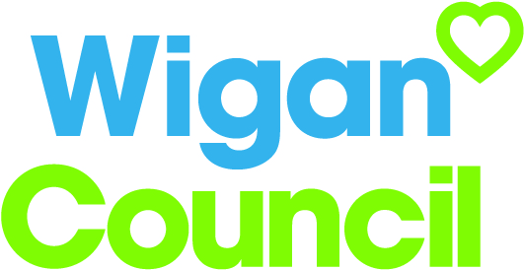
Job specification
Job title: | Joint Intelligence Manager
Service: | Strategy and Transformation
Grade:  Salary Range: | G12  £42,899 - £46,236
Reporting to: | Service Manager – Strategy and Intelligence

Your job

You will lead and manage a team of research professionals who provide needs analysis and research products, information management processes and systems for the council and partners

You will assist the Service Manager and Assistant Director by contributing towards developing strategies, programmes, processes and policies for the effective planning, management and delivery of corporate and partnership objectives within a collaborative framework

You will lead, develop and implement approaches for performance management, customer and performance insight, data quality, intelligence and knowledge management (in partnership with other agencies where appropriate)

You will contribute to the implementation of a joint intelligence function managing direct and virtual resources - delivering shared intelligence in relation to the social, economic, environmental and health needs of Wigan’s communities on behalf of Wigan Council and its strategic partners.

In this job you will
On an on-going basis you will:

- Work with partners on the development and implementation of a shared outcomes framework across the Health Partnership and Single Commissioning Function and other key boards
- To develop the business intelligence reporting in to the Adults and Health Directorate
- Influence and enable Executive/Senior Management to determine service development and performance improvement priorities
- To oversee the submission of statutory reporting
- To plan and manage an annual cycle of research and analysis so that the social, economic, environmental and health needs of Wigan’s communities are identified and used to inform partnership interventions
- Support the Cabinet and Senior Management Team to develop the Council’s corporate and financial strategy and appropriate issues papers and strategies.
- Develop and use innovative models for research, evaluation and customer insight including cost benefit analysis, behavioural economics and risk stratification to lead on evaluation of impact in areas of strategic change
- To develop relationship with academic bodies to jointly produce intelligence products to inform strategic priorities

In this job you will need
You must be able to demonstrate the following essential requirements:

- Relevant degree or equivalent level of significant applicable experience
- To be a strategic thinker with excellent problem solving skills
- Excellent analytical skills with the ability to interpret data and commission analysis, make meaningful conclusions and suggest appropriate actions or recommendations
- Experience and demonstrated examples of producing/co-ordinating strategic knowledge products for organisational and partnership decision making/commissioning purposes
- Experience of applying customer insight to research and intelligence approaches
- Knowledge and awareness of and data protection legislation as it relates to the research and information management within public sector bodies
- Experience of commissioning, developing and delivering performance and research products within and across public sector organisations
- In depth understanding of partnership working and an appreciation of critical success factors needed for a working partnership to function efficiently and effectively
- The ability to identify and utilise appropriate research and analytical methodologies for each knowledge product commissioned
- Able to work evenings and weekends and to work flexibly

Our culture
For us, it’s not just about all we achieve as an organisation, but how we do it. Therefore, all employees are expected to display our Be Wigan behaviours.
Be Positive… take pride in all that you do

Be Accountable… be responsible for making things better

Be Courageous… be open to doing things differently

Individuals with line management responsibilities are also expected to …
Inspire…lead by example and help others to see the big picture

Care… show genuine concern for people as individuals and value their contributions

Engage… I connect with others both within and beyond the organisation

Staff Deal
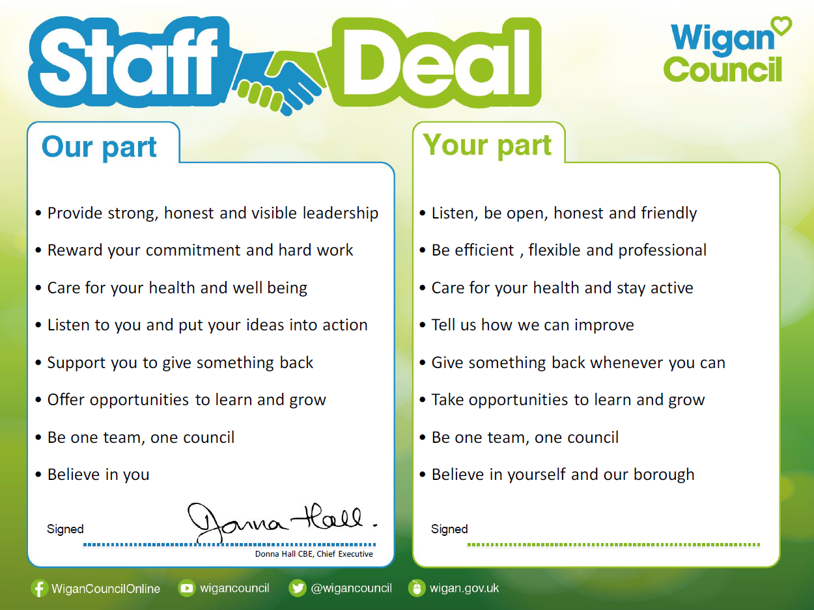
Our Staff Deal is an informal agreement with all staff. It outlines what you can expect from us, and in return what we expect from you

