Job Summary |  |  |  | 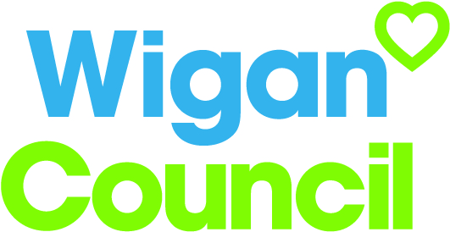
Start Well Worker
Service: |  | People – Children and Families | Grade: | G6 |  | Salary: | £17,917 - £23,935
Reporting to: |  | Start Well Practice Manager | Location: | Various bases across the Wigan Borough |  | Hours: | 32 and 37
Your job
Working within a multi-agency framework and within the key principles of ‘The Deal’, workers will be the designated, accountable lead worker for a child, young person and family with complex needs, working as their champion and advocate to improve aspirations and outcomes by building on strengths in order to reduce dependency on public services. The key worker will adopt an asset based approach and engage in ‘new conversations’ in order to build a positive relationship with children and families. Workers will develop action plans alongside families and coach, challenge and support them to achieve their goals by building resilience within families and communities.
You will |  | Our culture
√ Work within the locality based integrated team acting as key worker for children, young people and their families through the early identification and assessment of strengths and need.  √ Use the Early help framework to provide support according to family’s needs and help them achieve their goals by identifying strengths building on individual, family and community capacity whilst making sure the family, children and young people are fully engaged in the process  √ Ensure the exchange of relevant information between partners e.g. Community services, schools, educational institutions , GP clusters and ‘huddles’ to identify children, young people and families who have support needs.  √ Support young people who are NEET as part of a holistic plan at level 2/3 of the threshold of need.  √ Support and empower partners to deliver Early Help at level 1, ensuring that children and families are supported before needs escalate.  √ Participate fully in both the supervision and employee development process, keeping their line manager informed as to the progress that children, young people and their families are making. Ensure that ‘My Time’ is ‘reflective’ in order to challenge and improve practice. |  | For us, it’s not just about all we achieve as an organisation, but how we do it. Therefore, all employees are expected to display our Be Wigan behaviours.  Be Positive… take pride in all that you do  Be Accountable… be responsible for making things better  Be Courageous… be open to doing things differently  Individuals with line management responsibilities are also expected to …  Inspire…lead by example and help others to see the big picture  Care… show genuine concern for people as individuals and value their contributions  Engage… I connect with others both within and beyond the organisation

Our ideal candidate |  | Staff Deal
- Will be qualified in one of the caring professions or educated to NVQ level 3 or equivalent with experience of working with children and families with complex needs  - Will have a history of continuing professional development and a willingness to maintain this to support service delivery.  - Will have an understanding of the benefits to practicing in an asset based approach  - Will have a good working knowledge of local Safeguarding procedures and local multi agency guidelines on child protection including WSCB priorities  - Will be able to use the Early Help framework whilst working with families to ensure a co-ordinated approach when working with children and families.  - Will be able to use a variety of evidence based tools to support the assessment and measurement of outcomes for children and families.  - Will have a good understanding of the barriers to learning by children and young people and potential strategies to overcome them.  - Will have the ability to connect children and families to community assets, to help them to participate positively in their communities.  - Will genuinely care, be friendly, smile, have a kind heart and be someone that children, young people and families can trust and be confident to challenge and be direct, whilst still being approachable.  - Hold a current driving license or can demonstrate the ability to travel as required using own or public transport in the most effective manner. |  | 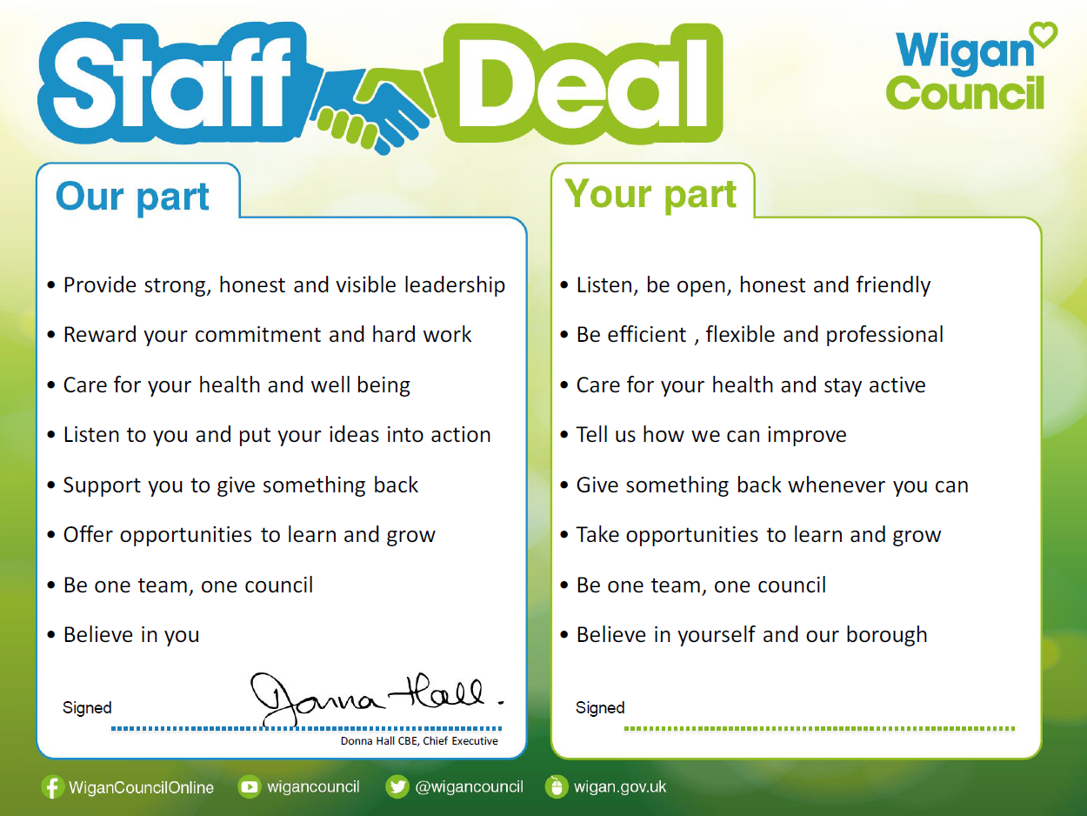  Our Staff Deal is an informal agreement with all staff. It outlines what you can expect from us, and in return what we expect from you

