Health Improvement Officer
Service: |  | Health Improvement Service | Grade: | 3C |  |  | Salary: |  |  | £30,451 - £32,910
Reporting to: |  | Health Improvement Manager | Location: | Civic Centre |  |  | Hours: |  |  | 36
About the role |  |  |  |  |  |  |  |  | Our priorities
Promote healthy lifestyles in a defined geographical area through community engagement and development and the provision of health related sessions to raise awareness and improve skills and knowledge locally. The post holder will manage a team and lead a multi-agency approach to health and contribute to the Neighbourhood Community Plan:  - Develop and implement long-term evidence-based health action plans and strategies across a range of agencies and community groups  - Provide leadership and management to groups of staff across the service  - Develop and lead a health and wellbeing task group and other relevant local health groups  - Provide project management and delivery, including performance monitoring of services  - Allocate work to the staff, provide daily supervision and support and staff training  - Manage and monitor a delegated budget of at least £5,000, and plan for the future identifying additional resources that need to be secured  - Communicate effectively with a wide range of people including senior managers, frontline staff, local people and outside agencies like health services and voluntary sector agencies. This could include presentations to large groups of people.  - Influence service redesign and organisational change in response to identified community need at strategic and operational levels, for example at local CCG’s, locality management teams and Neighbourhood management teams  - Communicate complex ideas to others in an understandable format using a wide variety of communication tools, tailoring to the needs of the audience who may have barriers to understanding, including PowerPoint presentations, newsletters, leaflets, report writing, training sessions, one to one, meetings and networking.  - Monitor and evaluate the impact of these health improvement programmes and adjust accordingly |  |  |  |  |  |  |  |  | 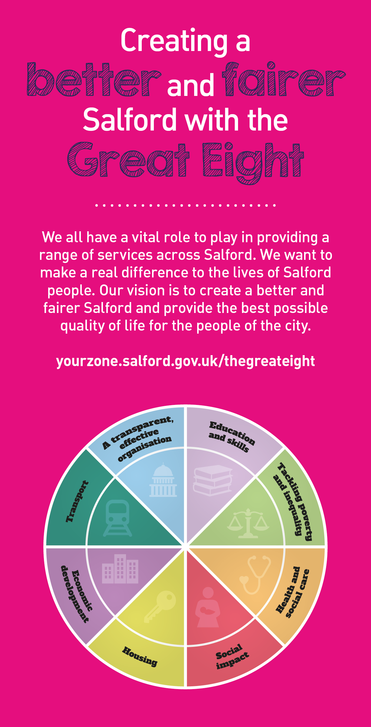
 | Key outcomes
 | - Influence the work of other front-line staff within Council, primary care and partner agencies in order to increase public health capacity to support the delivery of local programmes of work. This may entail providing training as required.  - Produce detailed health action plans, work reports and project plans on a regular basis for colleagues at all levels within the organisation and externally. This involves persuading, motivating and negotiating with partners to achieve consensus over the plan and ensure delivery of the plan is embedded in partners work programmes.  - Innovate and bring about radical change in delivering health improvement within communities, the council and other agencies. |  |  |  |  | - Lead the neighbourhood-based Health and Wellbeing Task Group, identify priorities and develop local joint health improvement programmes of work with partners including the wider local authority, police, primary care, education, voluntary sector agencies, community organisations and local people.  - Deliver a programme of health-related activities in accordance with the service specification  - Lead on and co-ordinate community-based health improvement programmes of work.
 | What we need from you
 | - Graduate and/or post graduate level qualification in Public Health, Community Development, Health Promotion or other relevant field.  - Knowledge and experience of using behaviour change methodology.  - Experience of using Project Management methodology to successfully deliver programmes and service innovations.  - Ability to think creatively to problem solve and come up with innovative solutions.  - Experience in the delivery of health services (or services in a related field) with and within a variety of communities.  - A strong commitment to team working and ability to manage conflict and persuade others of own point of view.  - To understand and be able to apply the principles of community involvement, participation and development. |  |  |  |  | - Knowledge and understanding of the wider determinants of health, and public health principles and policies.  - Passionate and committed to reducing health inequality.  - Knowledge and experience of leading multi-agency partnerships across health, local authority and voluntary and community sectors to work together at a local level  - Ability and experience to motivate and manage a team.  - Excellent communication skills, written and verbal.  - Ability to work on own initiative, manage competing workloads and make decisions autonomously.  - A flexible and positive attitude, there will be a requirement to travel around, to regularly work weekends and evenings, and to work in an environment of change.

What we can offer you
Your ongoing professional development and success in your role is important to us, and that is why we provide a variety of learning and development opportunities. Within the sections below you will find development options tailored to you which will enable you to further develop your existing skills and learn new ones at a pace that suits you best. If you are joining us now, your development will form part of ongoing discussions with your manager. If you are an existing employee, you should use your Personal Development Reviews to discuss your development with your manager and create your development journey. It’s important you also take full advantage of any informal learning available to you during the course of your work, including coaching, mentoring and shadowing. Please discuss these options with your line manager.

- Online Learning - Develop your knowledge across a wide range of areas through our Me-Learning platform, with over 200 free courses to choose from. To have the best possible start and comply with current legislation, you must complete the following modules: Welcome to Salford, Health and Safety in the Office, GDPR, Equality Essentials, Safeguarding Children and Adults, and Safer Recruitment. You may also benefit from a variety of courses in categories such as Business Skills, IT and Project Management which are available to learn at your own convenience and pace.  - Developing your digital skills – Our ambition is to provide our workforce with the right level of digital capabilities needed to be successful. Whatever your current digital abilities are, we can provide development ranging from essential workplace skills to specialist workplace skills’. These will be delivered through our Digital Skills Academy using both self-directed and guided learning opportunities to enable you to develop. Additionally, you can access free online courses through the iDea website. | - Professional Development – Gain role specific skills and time to learn through a wide range of development opportunities. Learn whilst working and get support towards your qualification through an apprenticeships standard. Access professional development ranging from entry level to masters type qualifications. Details can be found on www.instituteforapprenticeships.org/apprenticeship-standards/  - Sharing your digital skills – Our goal is to support you to share your digital knowledge with other people. Our Digital Eagles programme has been designed to cover basic digital skills and build your confidence to assist others. By the end of this programme you will join hundreds of staff members who already are digital eagles, and be able to help colleagues, customers, residents, or people in your personal life with all things digital.

Application guidance |  | Our values
We are a values based organisation so reflecting our values or a values based approach in your evidence will support your application.

The ‘Key outcomes’, ‘What we need from you’ and ‘our leadership behaviours’ sections of the Role Profile are there to give you an understanding of what we would like to see reflected in your application. Don’t give up if you are not able to reflect all of these in your application.

For more information please contact:
Angela Eden
Health Improvement Manager
Angela.eden@salford.gov.uk
07799115451

