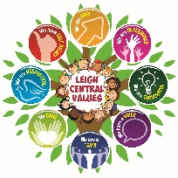
Learning Today for a Better Tomorrow.

Our Mission –
Preparing children today for a better tomorrow, nurturing their dreams, hopes and aspirations.

Our Vision –
We will create a school which is both caring and nurturing, where everyone feels confident and valued.
We will create a learning environment where children are encouraged to be respectful, responsible and independent and are given the necessary skills to succeed in life.
We will encourage everyone to ‘go the extra mile’ and will only accept their best.

Our Aims –
At Leigh Central Primary we aim to –

- Ensure everyone feels happy, safe and secure

- Help children to develop lively, inquisitive minds with a lifelong love of learning

- Involve all our families and the wider community in the life of our school and the education of its children

- Celebrate everyone and their achievements, encouraging them to always be proud of who they are

- Provide an engaging, creative and innovative curriculum which is both relevant and challenging

- Have consistently high expectations of behaviour and achievement for all

- Be part of a community which values and respects all cultures and the wider world beyond our school

- Promote and foster healthy lifestyles (both body and mind)

