Educational Psychologist
Service: |  | Educational Psychology Service | Grade: | Soulbury A (2-7 plus SPA) |  |  | Salary: |  |  | £40,136.00 – £49, 714.00
Reporting to: |  | Claire Jackson | Location: | Unity House |  |  | Hours: |  |  | Full Time
About the role |  |  |  |  |  |  |  |  | Our priorities
1. To be responsible to the Principal Educational Psychologist/Deputy Educational Psychologist.  2. To provide a psychological service based upon a consultative model of service delivery. This service will be provided to staff working in schools, services, parents, children and other professionals working with children.  3. To organise and maintain a regular programme to commissioning schools/ settings/ projects.  4. To negotiate a programme of work within designated schools/ settings and commissioners to work on cases and projects agreed.  5. To liaise and work with other agencies for the benefit of the child.  6. To negotiate a range of problem-solving strategies with all the relevant agencies, establishments and families thus enabling them to resolve issues.  7. To participate in the identification of children with special educational needs.  8. To produce reports and keep records of an acceptable professional standard as a means of advising the local authority, professionals, parents and agencies on the needs of individual children or more general issues.  9. To provide Educational Psychology Advice as required by the Strategic Director of Children’s Services in accordance with the Children and Families Act 2014.  10. To provide psychological information as required by the Children’s Services Directorate on problems presented by individual children, groups of children and institutions. |  |  |  |  |  |  |  |  | 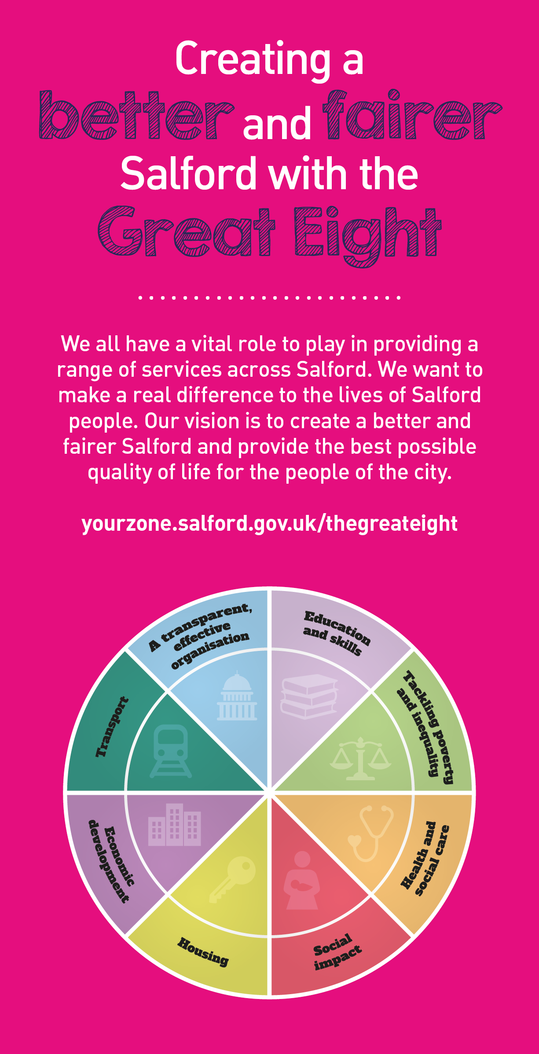
 | Key outcomes
 | - To ensure evidence-based practice and Psychological theory are influencing decision makers and organisations within the network  - To build capacity to meet a range of needs across schools, services and settings  - To generate positive change for children, families and settings at individual group and systems level |  |  |  |  | - To upskill and empower consultees to deliver education and intervention to the highest standards  - To ensure child voice is driving service and standards
 | What we need from you

- Proven technical skills and ability in the role with a record of accomplishment for delivering outcomes  - Professional credibility through proven relevant experience  - To model and demonstrate our values and behaviours  - 1 To be a qualified Educational Psychologist with HPCP registration  - 2 Ability to gather & evaluate complex information from a variety of sources & settings.  - 3 Ability to engage, communicate & work in partnership effectively with children and young people (CYP), carers & members of Children’s Services.  - 4 Ability to form effective working relationships with all commissioners of EP services.  - 5 Ability to apply a wide variety of assessment techniques and interventions across varied settings with CYP 0→ 25 years.  - 6 Ability to plan, prioritise & manage a complex workload effectively within prescribed time-scales.  - 7 Ability to work both independently & as part of different teams.  - 8 Ability to work to an agreed quality standard in terms of report writing & other forms of writing and training.  - 9 Ability to contribute to the ongoing development of the EPS.  - 10 Ability to travel both within and outside Salford in order to complete duties as specified by the PEP  - 11 Willingness to engage in ongoing development of skills in the area’s linked to projects such as of Emotional Well-being/Mental Health / LAC/ Early years and any other appropriate research opportunities |  | 1. Previous experience of writing summative project reports  2. Experience of training adults in areas related to SEN  3 Experience of working a traded model of service delivery

Application Guidance |  | Our values
We are a values based organisation so reflecting our values or a values based approach in your evidence will support your application.

The ‘Key outcomes’, ‘What we need from you’ and ‘our leadership behaviours’ sections of the Role Profile are there to give you an understanding of what we would like to see reflected in your application. Don’t give up if you are not able to reflect all of these in your application.

Click here to enter text.

