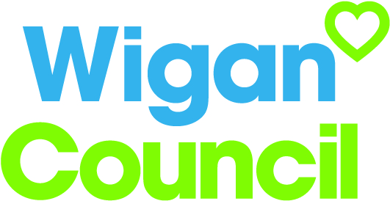
Job specification
Job title: | Lead Officer – Web Development
Service: | Digital Services
Grade: | G7
Reporting to: | Assistant Business Partner – Online Services

Your job
As a Web Development Officer, you will be responsible for building, coding and designing the Wigan Council website, intranet and sub-sites.

You will use innovative ideas, web standards and best practice to make sure we provide residents with access to council services that are responsive to their needs and easy to use.

You will use your knowledge of UX and UI to implement improvements and be passionate about design principles and new technology.

This role covers a variety of aspects of the development life-cycle including design, development, testing and bug fixing.

You must be able to write clean, well-structured and consistent code to ensure templates are simple and re-usable.

We use a .Net Content Management System (CMS) so need someone who is happy developing in that environment.

Reporting to the manager of online services you will work closely with Digital Services colleagues on the website including another web developer, a content officer and a support officer.

You will work closely with colleagues in service departments across the council to make sure we add value to any services being delivered online.

The council’s digital strategy is to encourage self-reliance and enable transformation through technology.

You will contribute to this by enabling residents to transact with us online, helping to improve outcomes for residents of the borough and supporting business growth.

In this job you will
This is a creative and important role within Digital Services on an ongoing basis you will need to:

- Develop new and revise existing templates and page layouts in our CMS
- Recommend technical developments/design enhancements to improve the customer journey, outcome and experience
- Research, implement and test external web resources, frameworks and plugins
- Actively ensure compliance to web standards, W3C validation, accessibility, cross browser compatibility and device responsiveness
- Use analytics to inform/justify changes and developments
- Review and implement changes to site structure, permissions, processes and functions
- Ensure that developments and change requests are prioritised, documented and aligned to the council's strategies and priorities and meet legal requirements
- Help us continue to improve standards by researching trends and developments in mobile and smart technologies ensuring we remain at the forefront of other councils and organisations

In this job you will need
You must be able to demonstrate the following essential requirements:

- Degree in a related field or equivalent level of experience relevant to the role
- Be proficient in HTML, CSS, Javascript/jQuery and have a good understanding of .Net
- Be experienced in writing clean, consistent and well-structured code
- Have significant experience of creating attractive and usable templates
- Demonstrable experience of engaging with customers to transact online
- Demonstrable knowledge and understanding of the Digital First culture and what this means regarding changing customer behaviour and reducing cost to serve
- Excellent knowledge of IT systems and an ability to use functionality to improve a service and the customer experience
- Ability to raise issues, take ownership of problems and actively seek and implement solutions
- Openly share good and bad practice to enhance day to day processes and the customer journey
- Experience of effectively working as a team whilst having an ability to use your own initiative
- Experience of working in a fast paced environment whilst maintaining quality and accuracy.

Our culture
For us, it’s not just about all we achieve as an organisation, but how we do it. Therefore, all employees are expected to display our Be Wigan behaviours.

Be Positive… take pride in all that you do

Be Accountable… be responsible for making things better

Be Courageous… be open to doing things differently

Individuals with line management responsibilities are also expected to …
Inspire…lead by example and help others to see the big picture

Care… show genuine concern for people as individuals and value their contributions

Engage… I connect with others both within and beyond the organisation

Staff Deal
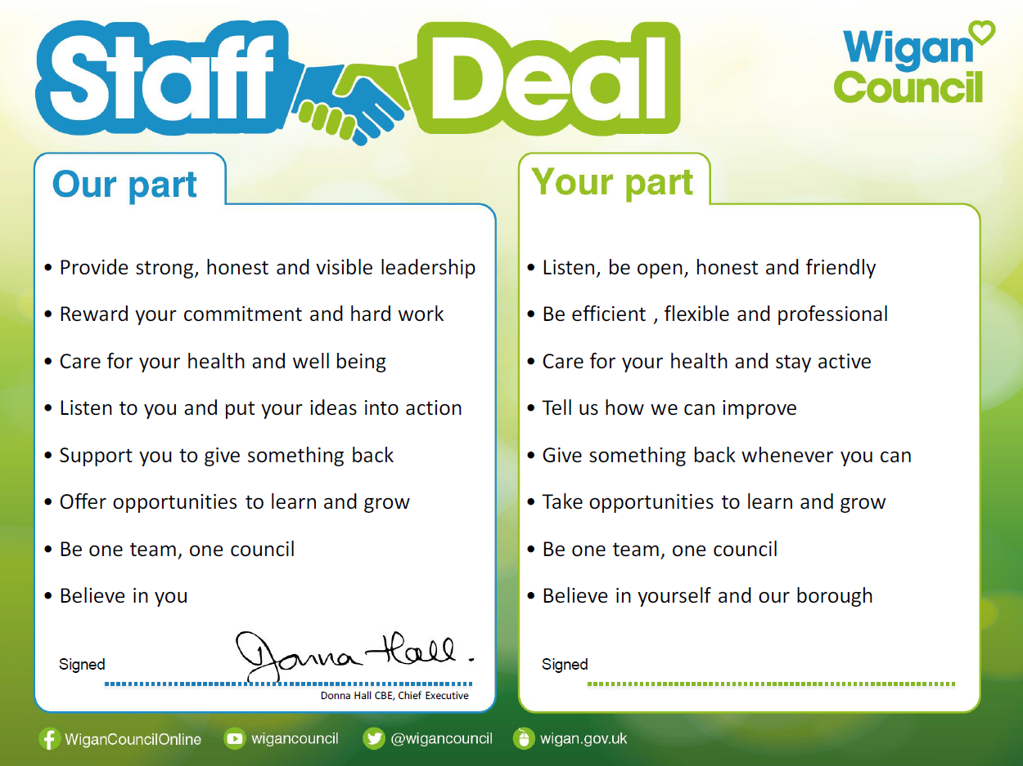
Our Staff Deal is an informal agreement with all staff. It outlines what you can expect from us, and in return what we expect from you

