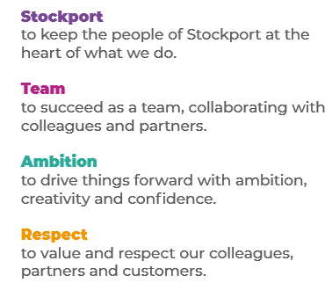
Job Profile and Working for Stockport Council
Our Council
Our employees are our greatest asset. We’re proud of the way we provide vital frontline services every day and work together, as one team.
Our 4 core values as shown above, run through everything that we do, and we aim to stay true to them regardless of the challenges that we may face.
To support our values, we have policies, guidance and procedures around health, safety and welfare, customer care, emergency planning and security that all our colleagues are adhering and working to.
We also pride ourselves on our commitment to wellbeing and inclusivity of our colleagues and residents.
You can find out more about working for Stockport Council and some of the benefits that we offer our employees at https://greater.jobs/locations/stockport/

Role: |  | Internal Auditor (Corporate and Support Services)
Service Area: |  | Internal Audit, Risk and Insurance Services
Directorate: |  | Corporate and Support Services
Salary Grade: |  | 6
About the Job

Main Purpose of the Job
- To undertake a range of audit reviews both individually and as part of a team.
- To deliver professional advice and guidance to the organisation in order to meet statutory requirements and mitigate risks.
- To support the service in order to deliver an efficient, effective and proactive internal audit service to the Council and other customers.
- To ensure that the Council manages its resources effectively, delivering value for money, exploiting opportunities to drive out inefficiencies and generating income where appropriate.

Key Responsibilities
- Delivery of a wide range of audit reviews undertaken both individually and as part of a team.

- Prepare client notifications for all assigned reviews, detailing a terms of reference and reporting arrangements in agreement with the client.

- Preparing reports and working papers and meeting with clients to discuss and explain findings and recommendations and gain agreement to the actions before finalising the report.

- Feed conclusions from audit reports into quarterly report for audit committee.

- Conduct a follow up of all finalised audit reviews to confirm that agreed recommendations have been implemented and report accordingly.

- Provide advice and guidance to clients on matters relating to risk and control.

- To assist, when required, senior members of the service to deliver more strategic and specialist reviews including counter fraud audits and investigations.

- To work positively and inclusively with colleagues and customers so that the Council provides a workplace to deliver a service that does not discriminate against people on the grounds of their age, disability, gender reassignment, marriage, civil partnership, pregnancy, maternity, race, religion, belief, sex, or sexual orientation.

- To fulfil personal requirements, where appropriate, with regards to Council policies and procedures, standards of attendance, health, safety and welfare, customer care, emergency, evacuation, security and promotion of the Council’s priorities.

Additional Information
The responsibilities set out in this document, in the advert and any additional information are intended to provide a flavour of the work you will carry out. It is not possible to include everything you will be asked to undertake, and we expect all colleagues to work flexibly according to business needs and to enhance your own development. Your skills, abilities and training needs will be taken into account and discussed with you when any significant changes to your role are needed. In line with our flexible approach you may be required to work from home for a proportion of your time or from any of the Council's sites across the borough.
The Council is an inclusive employer and holds the Disability Confident and Armed Forces Covenant accreditations. If you have a disability, we will support you by implementing reasonable adjustments to enable you to perform your role.

About You
Please use your application to tell us how well you meet the criteria listed below as these are the key skills, experience, technical expertise and qualifications needed to be successful in the role. We will then use all the information you provide in your application to help us decide whether you are shortlisted for interview. Any interview questions or additional assessments such as tests or presentations may also be broadly based on these criteria:
- Working to the Council’s values and behaviours by:
- Keeping the people of Stockport at the heart of what we do
- Succeeding as a team, collaborating with colleagues and partners
- Driving things forward with ambition, creativity and confidence
- Showing value and respect to our colleagues, partners and customers.

