Customer Services Officer - Universal Services
Service: |  | Service Reform | Grade: | 2A |  |  | Salary: |  |  | £19,698 to £20,493
Reporting to: |  | Team Leader/Manager | Location: | Civic/Localities |  |  | Hours: |  |  | 36 Hours Per Week
About the role |  |  |  |  |  |  |  |  | Our priorities
- To provide a first point of contact for customers of Salford City Council's universal services  - To provide a first response to digital customer enquiries via social media, web chat and telephony by answering universal services enquiries and signposting others to the relevant department  - Providing information, advice and support to customers including booking appointments, taking payments, logging customer enquiries and ensuring all associated administration is completed  - To promote and support customers to access services in line with the customer strategy, delivering a digital first approach  - To understand and apply relevant council policies and procedure  - To have the written and digital skills to record accurate information on systems in line with GDPR  - To use communication skills to de-escalate situations and find solutions to resolve enquires at the first point of contact  - To be efficient across a number of ICT systems in order to deliver service  - To be adaptable and support change programmes to improve service delivery  - To provide flexibility in how we deliver a range of services  - To work alongside partners to deliver the best possible outcomes for our customers  - To work as part of a team to build towards an excellent employee experience and working environment |  |  |  |  |  |  |  |  | 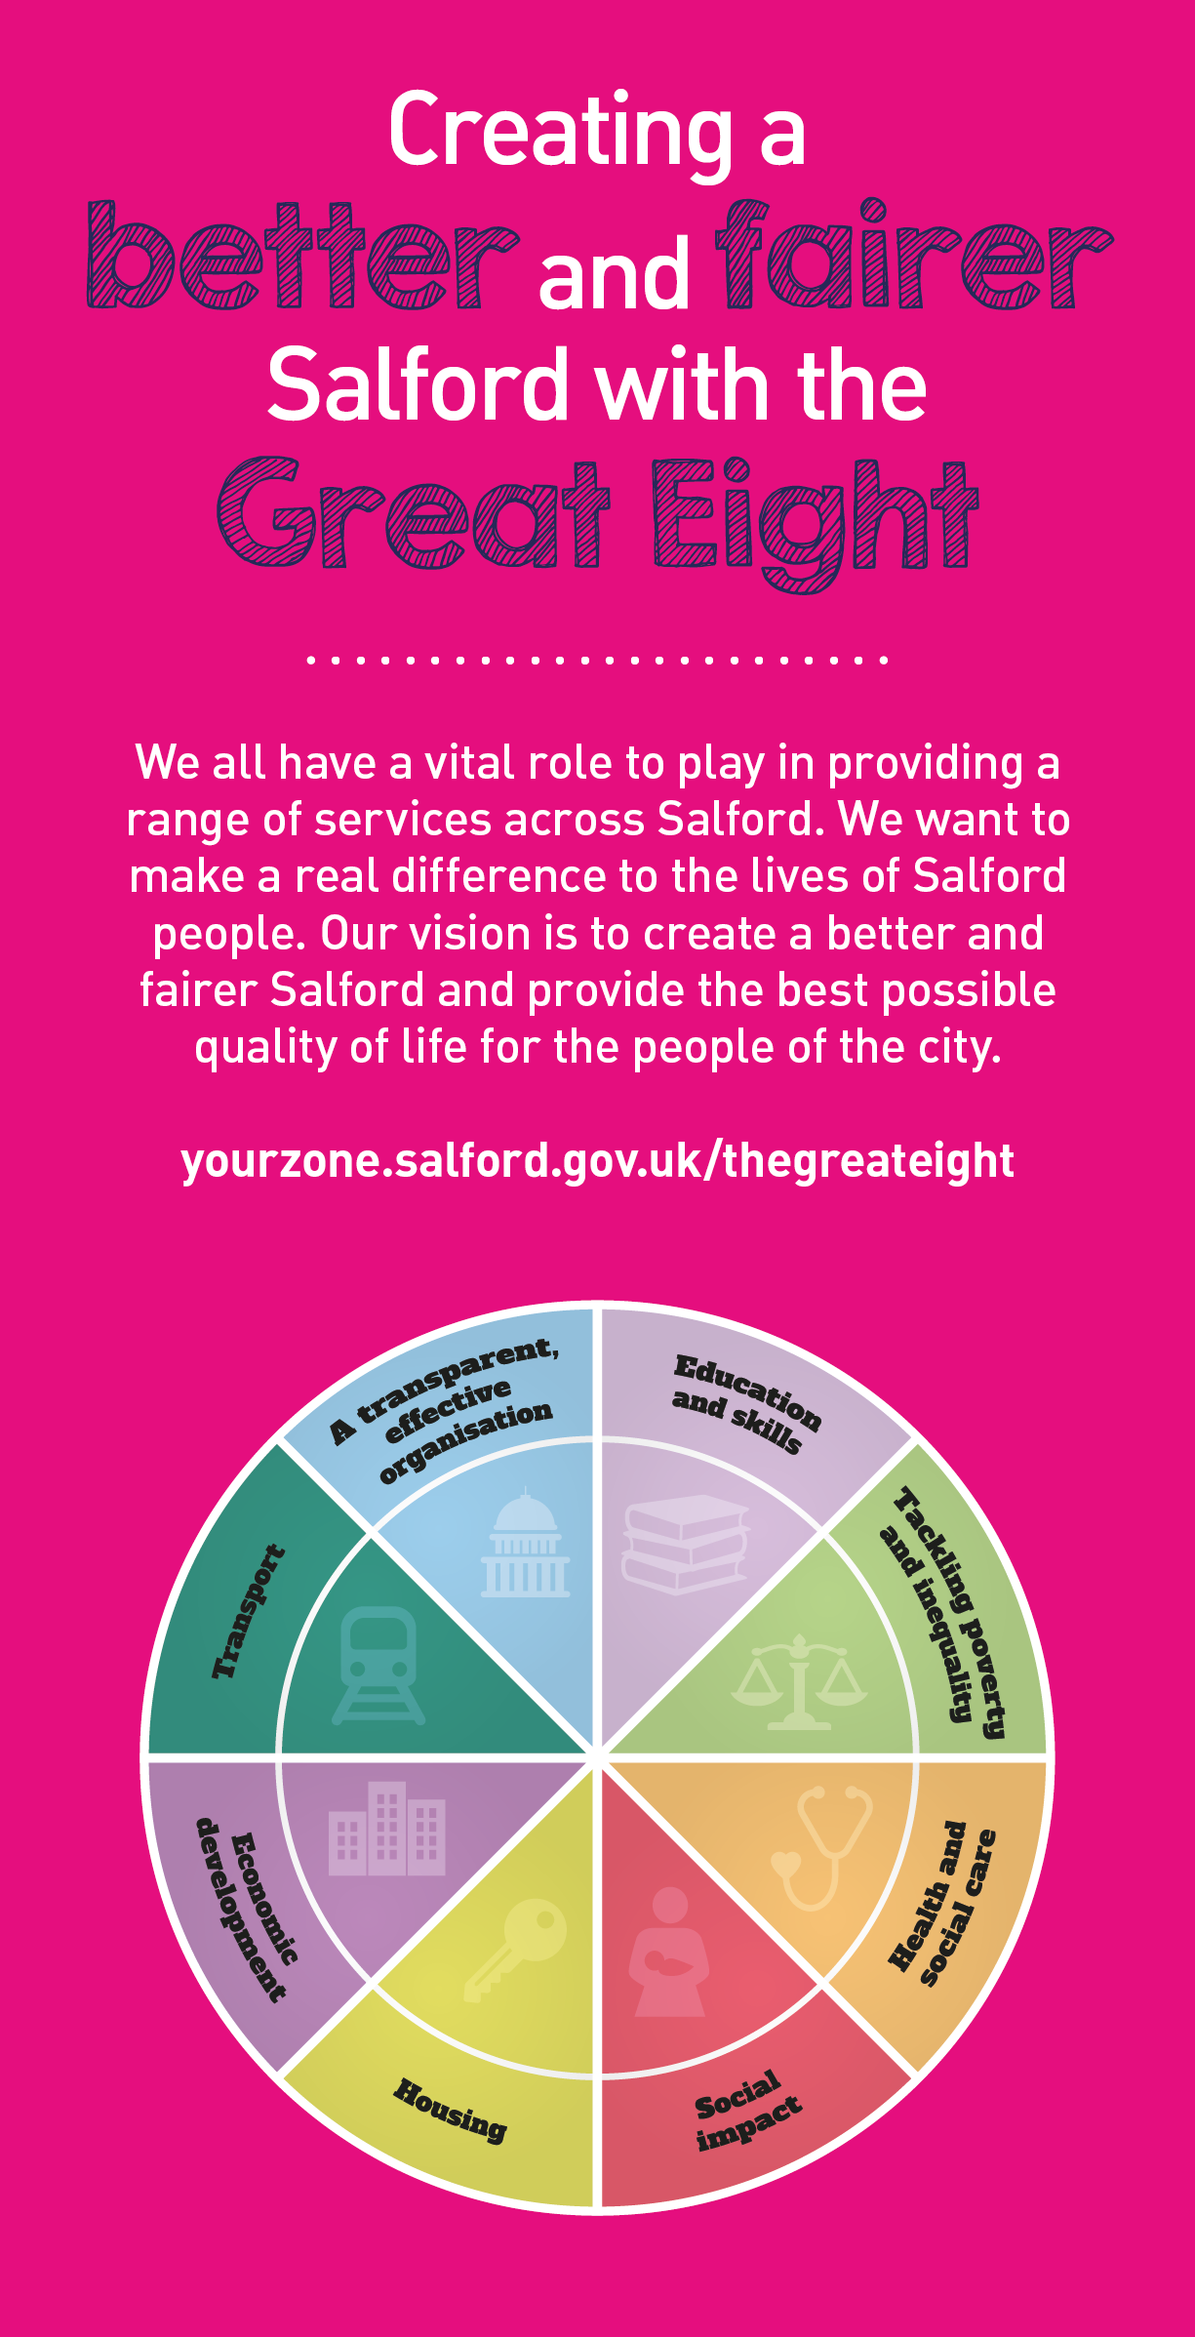
 | Key outcomes
 | - To develop and improve our communication channels with our customers through social media  - To manage a digital first response through web chat  - To deliver a high standard customer experience  - To adopt a placed based approach with customers through interactions and interventions |  |  |  |  | - To promote and encourage a digital first approach to our residents to deliver a quicker, easier and better service  To utilise technology to support the service delivery across the city  - To develop close working relationships with internal departments  - and interventions  - To engage with customers in a proactive manner
 | What we need from you
 | - Proven technical skills and ability in the role with a record of accomplishment for delivering outcomes  - Professional credibility through proven relevant experience  - To model and demonstrate our values and behaviours  - A desire to deliver an excellent customer service experience to all customers in Salford  - To have a flexible approach to deliver the best outcome for our customers  - High standards - setting challenging goals that are focused on outcomes, not activities; not accepting mediocrity  - Able to take a ‘whole system’ approach, looking for every opportunity to solve problems and improve  - Being a ‘smart worker’; carrying out your role in the most efficient and effective way  - Able to work in a team to achieve Salford Council's priorities |  |  |  |  | - Systems knowledge: Excellent Microsoft Office skills (Word, Excel and Outlook). Experience of using Public Sector systems  - Up to date knowledge of legislation and policies in relation to Universal Services  - Able to recognise and value the strengths of people, taking a strengths-based approach to make the most of opportunities  - Demonstrate respect and caring for others, treating everyone fairly; listening and acting on the things people say  - Able to build strong collaborative relationships to find creative ways to make services more sustainable and flexible  - Live by our values and use them to guide you in how you do your job; being able to hold others accountable for demonstrating our values by taking a tough stand and challenging behaviour  - Be open to learning and sharing your knowledge and skills with others; providing coaching and support to others to help them achieve their objectives and potential

Application Guidance |  | Our values
We are a values based organisation so reflecting our values or a values based approach in your evidence will support your application.

The ‘Key outcomes’, ‘What we need from you’ and ‘our leadership behaviours’ sections of the Role Profile are there to give you an understanding of what we would like to see reflected in your application. Don’t give up if you are not able to reflect all of these in your application.

Click here to enter text.

