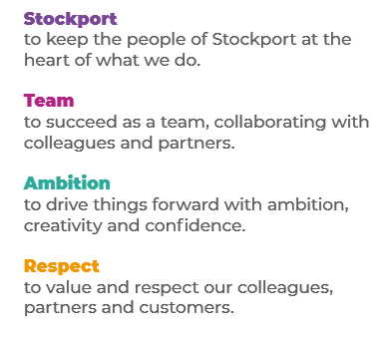
Job Profile and Working for Stockport Council
Our Council
Our employees are our greatest asset. We’re proud of the way we provide vital frontline services every day and work together, as one team.
Our 4 core values as shown above, run through everything that we do, and we aim to stay true to them regardless of the challenges that we may face.
To support our values, we have policies, guidance and procedures around health, safety and welfare, customer care, emergency planning and security that all our colleagues are adhering and working to.
We also pride ourselves on our commitment to wellbeing and inclusivity of our colleagues and residents.
You can find out more about working for Stockport Council and some of the benefits that we offer our employees at https://greater.jobs/locations/stockport/

Role: |  | Complaints Service Support Officer
Service Area: |  | Citizen Focus
Directorate: |  | Corporate and Support Services
Salary Grade: |  | Apprentice Level 2
About the Job

Main Purpose of the Job
As a Complaints Service Support Officer, you will support the Complaints Service by providing high quality administration support, working with colleagues in a fast-paced environment helping to acknowledge customer complaints and enquires, logging cases on case management systems and liaising with colleagues across the Council to ensure that timely responses are provided to our customers. The Complaints Service is set up to provide support around the following thematic complaints processes:
- Statutory Adult Social Care Complaints
- Statutory Children’s Social Care Complaints
- Corporate Complaints
- Schools Complaints
- Ombudsman Complaints
For more detailed information on each area, please visit the Council’s website: https://www.stockport.gov.uk/

Key Responsibilities
With ongoing supervision and direction, you will be expected to undertake a range of activities including the following:
- Being the first point of contact for the Complaints Service, providing a professional, effective and welcoming service to our customers and colleagues across the Council.
- Assisting colleagues in the Complaints Service in the course of their duties.
- Taking calls from members of the public and Council staff.
- Handling electronic/postal correspondence.
- Scanning, photocopying and printing.
- Accurately creating and maintaining records.
- Logging cases and uploading documents on case management systems.
- Arranging meetings.
- To work positively and inclusively with colleagues and customers so that the Council provides a workplace to deliver a service that does not discriminate against people on the grounds of their age, disability, gender reassignment, marriage, civil partnership, pregnancy, maternity, race, religion, belief, sex, or sexual orientation.
- To fulfil personal requirements, where appropriate, with regards to Council policies and procedures, standards of attendance, health, safety and welfare, customer care, emergency, evacuation, security and promotion of the Council’s priorities.

Additional Information
The responsibilities set out in this document, in the advert and any additional information are intended to provide a flavour of the work you will carry out. It is not possible to include everything you will be asked to undertake, and we expect all colleagues to work flexibly according to business needs and to enhance your own development. Your skills, abilities and training needs will be taken into account and discussed with you when any significant changes to your role are needed. In line with our flexible approach you may be required to work from home for a proportion of your time or from any of the Council's sites across the borough.
The Council is an inclusive employer and holds the Disability Confident and Armed Forces Covenant accreditations. If you have a disability, we will support you by implementing reasonable adjustments to enable you to perform your role.

About You
Please use your application to tell us how well you meet the criteria listed below as these are the key skills, experience, technical expertise and qualifications needed to be successful in the role. We will then use all the information you provide in your application to help us decide whether you are shortlisted for interview. Any interview questions or additional assessments such as tests or presentations may also be broadly based on these criteria:
- Experience of working flexibly across teams to support projects and activities

- Excellent organisational skills

- Ability to interpret information

- Effective verbal and written communication skills

- Ability to work accurately to deadlines

- Demonstrable numeracy, literacy and ICT skills at Level 2 (GCSE) or above,
or a willingness to undertake development in this area as appropriate

- Customer Service experience (Desirable)

To work to the Council’s values and behaviours by:
- Keeping the people of Stockport at the heart of what we do
- Succeeding as a team, collaborating with colleagues and partners
- Driving things forward with ambition, creativity and confidence.
- Showing value and respect to our colleagues, partners and customers.

