Holy Rosary R.C. Primary School
Fir Tree Avenue, Oldham, OL8 2SR.
Telephone: 0161 624 3035, Fax 0161 626 5238.

E-mail: info@holyrosary.oldham.sch.uk
Headteacher: Mrs. T. Cavanagh
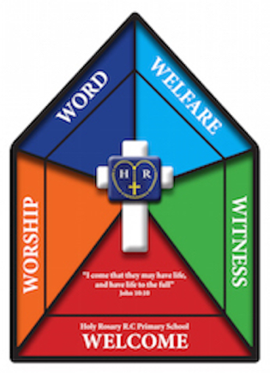
PERSON SPECIFICATION

Job Title: Class Teacher

 | Selection criteria  (Essential) | Selection criteria  (Desirable) | How Assessed
 |  |  | Essential | Desirable
Education & Qualifications | Have Qualified Teacher Status  Evidence of participation in professional development or further study | Catholic Teacher Certificate or willingness to undertake qualification.  Experience of having taught for at least 2 years | Application/ Certificates  Application/ Interview/ Certificates/Reference | Application/ Certificates  Application/ Interview/ Reference
Experience | Be able to demonstrate the ability to carry out responsibilities of a class teacher in relation to planning, delivering and assessing the National Curriculum/ Foundation Stage Curriculum.  Be able to maintain positive relationships with children, combining a sympathetic approach with effective discipline  Be able to work  co-operatively as part of a team. | Be able to demonstrate proven success raising standards beyond assigned pupils. | Application/ Interview/ Reference  Application/ Interview/ Reference  Application/ Interview/ Reference | Application/ Interview
Skills & Abilities | Be able to teach pupils of varying levels of ability and utilise teaching styles to suit their needs  Set high expectations of learning and behaviour  A thorough up to date knowledge of the range of teaching, learning strategies and how to implement them effectively.  To be able to promote and support the Catholic ethos of the school  Have the ability to communicate clearly, accurately and sensitively, both orally and in writing, with children, parents, professional colleagues, support staff, governors, external services and others as appropriate.  Have appropriate planning and organisational skills and effective ICT skills  To be willing to contribute to extra-curricular activities. | Knowledge of new technologies and their impact on learning  Evidence of leading learning outside the classroom i.e. voluntary groups | Application/ Interview/ Reference  Application/ Interview/ Reference  Application/ Interview/ Reference  Application/ Interview/ Reference  Application/ Interview/ Reference  Application/ Interview/ Reference  Application/ Interview/ | Application/ Interview/ Reference  Application/ Interview/ Reference
Knowledge | Clear knowledge of relevant policies/codes or practice and the National Standards for Teachers  Have a clear understanding of the structure of the National Curriculum/Foundation Stage Curriculum and be able to teach a wide range of subjects within all levels across the Foundation Stage and primary phase.  Be committed to participating in relevant in-service training to advance his/her ongoing development as a primary teacher.  Knowledge and awareness of some of the key teachings and values of the Catholic Faith which impact upon a Catholic School  Be able to demonstrate understanding of impact of school improvement actions on the quality of teaching and learning.  Be committed to raising the levels of achievement of children of all abilities.  Be committed to the promotion of equal opportunities  An understanding of safeguarding in relation to young children | Have had training in:  - Safeguarding  - First Aid  - Elements of SEN  Experience of leading a curriculum subject in school and evidence of impact | Application/ Interview  Application/ Interview/ Reference  Application/ Interview/ Reference  Application/ Interview/ Reference  Application/ Interview/ Reference  Application/ Interview/ Reference  Application/ Interview  Application/ Interview | Application/ Interview/ Reference
Work Circumstances | To support the ethos of our school |  | Application/ Interview
Personal Qualities | To show a commitment to the Catholic Faith and Catholic Education.  Genuine interest and love of being around children  Be enthusiastic and determined and show commitment to the role  Able to work under pressure and recognise and manage stress.  Able to work as part of a team and make valued contributions  Have flexibility, sensitivity and tact.  Can demonstrate enthusiasm and a commitment to improvement challenges  Commitment to ongoing and professional development. | Practicing Roman Catholic | Application/ Interview | Application/ Interview

NB. - Any candidate with a disability who meets the essential criteria will be guaranteed an interview.

