Job specification
Job title: | Service Manager Policy and Reform
Service: | Policy and Reform
Grade: | G14
Reporting to: | Assistant Director Homes

Your job
Wigan Council has a duty to produce a comprehensive housing strategy based on evidence.

We provide housing services to approximately 50,000 people, over 22,000 council tenancies (17,000 within the private rented sector) and we also liaise with other providers to ensure there is stock available to meet the need of the borough.

As the Service Manager for Policy and Reform you will support the delivery of services that are suitable for the management, remodelling and adaptation of existing stock for both council and private.

You will be responsible for a policy team who in conjunction with operational services will review provision to ensure services embed ‘The Deal’ principles and cross tenure housing is provided and managed within an ethical framework.

You will have responsibility for ensuring an up to date housing strategy is maintained to direct future development with colleagues Council wide and you will also oversee all investment to remodel properties for those with additional needs ensuring people have homes fit for life.

You will manage two teams comprising of approximately 20 staff who will support you with all aspects of service delivery and you will work closely with your teams to ensure a positive customer experience which streamlines the pathway for people accessing the service.

In this job you will
Within the first 12 – 18 months you will:

- Develop and implement appropriate strategies and policies to ensure the effective delivery and running of the services to meet Council aims.
- Take the lead responsibility for the creation of systems, processes and structures to deliver the strategic priorities across all housing services.
- Be responsible for the delivery of key outcomes, improvement strategies and Fresh Look reviews to fundamentally review how services are delivered to achieve Council priorities and cost reductions in line with targets set collaboratively with other services.
- Support the Assistant Director by providing technical and professional advice to elected members.
- Develop and maintain effective working relationships across the Council and with other stakeholders in particular registered providers, and private landlords that promote the Councils interests.
- Deploy resources in the most effective manner to meet service delivery projects.
- Oversee the review of supported housing services and procedures across all accommodation utilised by the Council.
- Oversee the review of temporary and dispersed accommodation in conjunction with the older persons accommodation review and allocations policy review with other Service Managers.
- Review and redesign the early intervention and prevention service and provision in relation to aids and adaptations.
- Effectively manage devolved budgets
- Represent Wigan in national and regional policy development.

In this job you will need
You must be able to demonstrate the following essential requirements:

- A level 7 qualification in Housing, Management or other relevant field or an equivalent level of skills, knowledge and experience relevant to the role.
- A current member of the Chartered Institute of Housing or other relevant body
- Significant experience of managing services.
- Significant experience of managing change and delivering tangible outcomes
- Experience of developing relationships with partners, external agencies and the voluntary sector.
- Extensive knowledge of best practice, statutory and regulatory requirement and key operational issues relevant to housing strategy and adaptations.
- Knowledge of the locality plan and integrated working methods and an ability to contribute to achieving both aims.
- The ability to reform services in a creative way.
- The ability to lead multi agency partnerships to deliver outcomes and effective working in line with Council priorities
- The ability to identify trends, future needs and assess regulatory changes and adapt the service to accommodate these.
- The ability to manage high level complex budgets.
- Experience of managing diverse service areas and managing competing priorities.
- Excellent written and verbal communication skills across a wide range of audiences
- The ability to lead teams and instil a culture of achievement and high performance throughout the service
- A current valid driving licence or the ability to travel as required using own or public transport in the most effective manner

Our culture
For us, it’s not just about all we achieve as an organisation, but how we do it. Therefore, all employees are expected to display our Be Wigan behaviours.
Be Positive… take pride in all that you do

Be Accountable… be responsible for making things better

Be Courageous… be open to doing things differently

Individuals with line management responsibilities are also expected to …
Inspire…lead by example and help others to see the big picture

Care… show genuine concern for people as individuals and value their contributions

Engage… I connect with others both within and beyond the organisation

Staff Deal
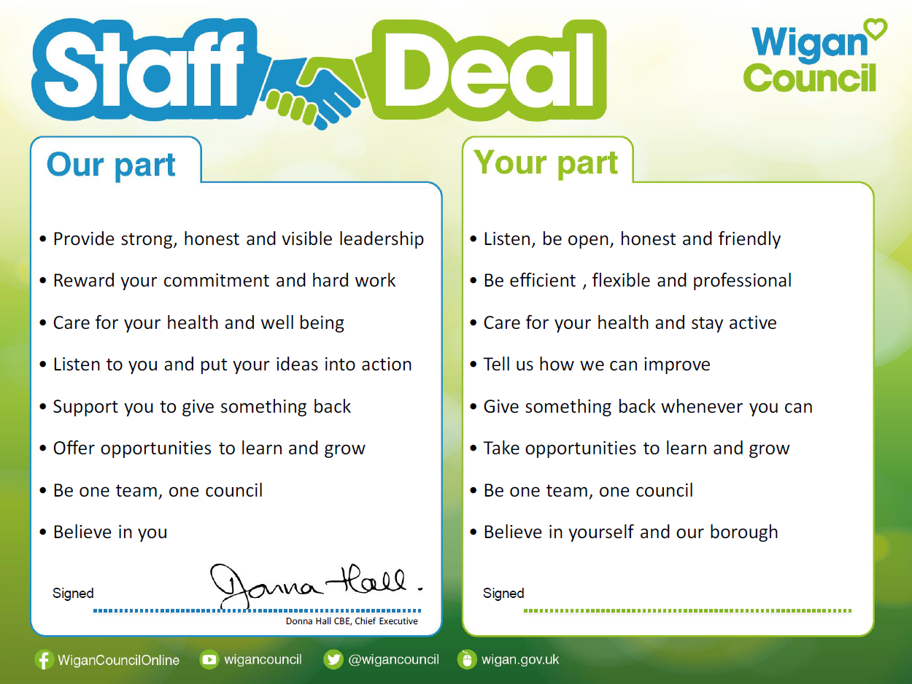
Our Staff Deal is an informal agreement with all staff. It outlines what you can expect from us, and in return what we expect from you

