SOCIAL WORKER
Service: | People | Grade: | Level 1 (3B), Level 2 (3C), Level 3 (4A) | Salary: |  |  | Dependent on level
Reporting to: | Practice Manager | Location: | Various | Hours: |  |  | 36 hours per week
About the role |  |  |  |  |  | Our priorities
- You will work directly with children and their carers using a range of knowledge, skills and interventions as required, in accordance with statutory responsibilities to secure positive outcomes for children.  - You will build effective relationships with children, young people and their families enabling full participation in assessment, planning, review and decision making.  - You will effectively manage a caseload, with varying degrees of complexity dependent upon skills and length of experience, with appropriate supervision, guidance and support.  - You will work in accordance with national and local policies and procedures, and use the law, regulatory and statutory guidance to inform practice decisions.  - You will prepare and producing a variety of high quality professional written documentation to required quality standards on behalf of the City Council.  - You will work with partner agencies and represent the Council at a range of meetings, proceedings and reviews as required. You will secure access to services, negotiating and challenging other professionals and organisations to provide the help required.  - You will provide support based on best evidence, which is tailored to meet individual child and family needs and which addresses relevant and significant risks. |  |  |  |  |  | 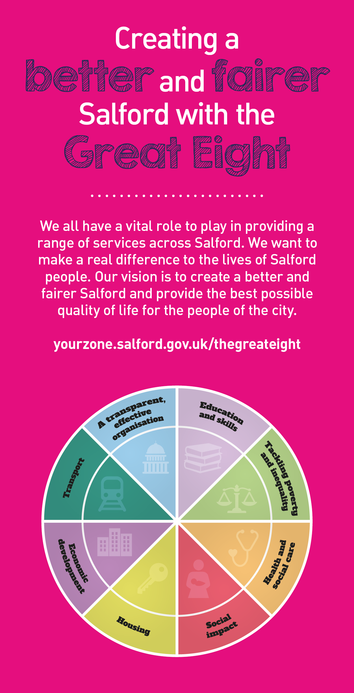

Key outcomes
- You will undertake your role demonstrating the knowledge and skills statement for child and family practitioners.  - You will work to the highest standard in line with the Council’s Employee Code of Conduct, and other relevant policies.  - You will maintain timely and accurate recording of work undertaken in client information systems, having regard to the GDPR and associated policies.  - You will be responsible for and committed to safeguarding and promoting the welfare of children and young people and for ensuring that they are protected from harm. |  | - You will be aware of, and apply Salford’s values at all times.  - You will take responsibility for your own continuing professional development and support the development of others.  - You will demonstrate a personal commitment to reflective practice, self development and team improvement.  - Through personal example, open commitment and clear action, you will ensure diversity is positively valued, resulting in equal access and treatment in employment, service delivery and communications.
What we need from you
- Possession of a recognised Social Work qualification and current registration with the professional regulatory body.
- Experience of working with children and/ or complex safeguarding. Personal and professional commitment to ensure positive outcomes for children in Salford
- Ability to communicate equally, appropriately and effectively with a wide range of individuals and groups across all sectors and levels of society. Ability to maintain accurate records and to communicate complex information clearly and concisely both verbally and in written form.
- You must clearly evidence your ability to develop effective relationships with partner agencies and effective engagement skills to work with their carer’s, families and partner agencies
- Ability to organise own time effectively, prioritising, preparing in advance and setting realistic timescales. Ability to maintain focus and objectivity under pressure and skill in managing and maintaining a complex workload
- Evidence that you have a clear understanding of the Social Worker role within a safeguarding team, and understand the concept of integrated working, supporting colleagues to achieve a shared purpose.
- Be able to demonstrate evidence of good assessment practice using analytical skills
- Ability to respond to immediate problems of a complex nature with associated risk factors and deliver immediate solutions sometimes under pressure
- Ability to think creatively and take and active role in team and service development. Personal commitment to supervision, reflective practice and self development.
- Willingness to flexibly work outside of office hours as required by the needs of the service. You will also contribute to the team duty service on a rota basis with their team members
- Ability to use IT systems to retrieve, record and update information and willingness to learn to use new systems
- Understanding of relevant legalisation which informs social work practice

Application Guidance |  | Our values
Please tell us how you feel you have the skills, knowledge and experience to be successful in the role as outlined in the ‘About the role’ section and how these will put you in the position to deliver the key outcomes ….
Some things to think about when applying:
- We are a values based organisation so reflecting our values or a values based approach will support your progression to the next stage.
- The ‘Key outcomes’ and ‘What we need from you’ sections are there to help you to understand what we would like to see reflected in your application and interview; however, we know you may not be able to reflect all of these in your application - don’t give up if this is the case.
- We don’t expect a biography, we want to get to know you through the application process so tell us ‘your story’ so we can understand how you could be successful in the role.
- We are all ‘human’ – we are looking for human beings not ‘robots’ so be yourself and let us get to know you.

Please submit a CV and a supporting statement that addresses the above.

