Commercial Project Manager (Regeneration)
Service: |  | Place | Grade: | 5A |  |  | Salary: |  |  |  | £41,846
Reporting to: |  | Group Leader Investment | Location: | Civic Centre |  |  | Hours: |  |  |  | 36 hours per week
About the role |  |  |  |  |  |  |  |  |  | Our priorities
- Drives the continued growth of the city by developing, commissioning and securing the delivery of major projects across the regeneration portfolio, working alongside multi-disciplinary teams, key delivery partners and contractors.  - Leads and embeds project management practice across the Regeneration team to ensure the successful delivery of major projects.  - Develops and promotes effective contract management and contract change management  - Reviews and agrees terms and conditions of contracts and sub-contracts ensuring that the council’s commercial position is always protected/maintained.  - Provides high quality communication and professional reports to the City Mayor, City Director and senior regeneration managers, advising them on matters of regeneration policy, project progress and deliver.  - Liaises with key developers, builds relationships, provides input to development discussions with partners and guides the delivery of high quality development activity to contribute to the city’s growth agenda.  - Assists with the development and management of the Regeneration team supporting the group leader and deputising where appropriate.  - Provides strong performance management of the Regeneration Team by owning and developing service planning, robust financial and performance management ensuring continuous improvement, value for money and best value are delivered.  - Contributes towards the development of the Regeneration team’s business plan and other agreed corporate priorities.  - Adheres to council procedures including Health and Safety, HR, Equalities and Diversity.  - Maintains effective links and joint working with public, private and voluntary agencies at City, regional and national level and to advise the Group Leader of problems and opportunities affecting strategic policy and resource procurement.  - Prepares co-ordinates and submit strategies and proposals for funding from the Greater Manchester Investment Fund, UK Government, Lottery and regional initiatives and other external agencies and to monitor these projects/programmes as appropriate. |  |  |  |  |  |  |  |  |  | 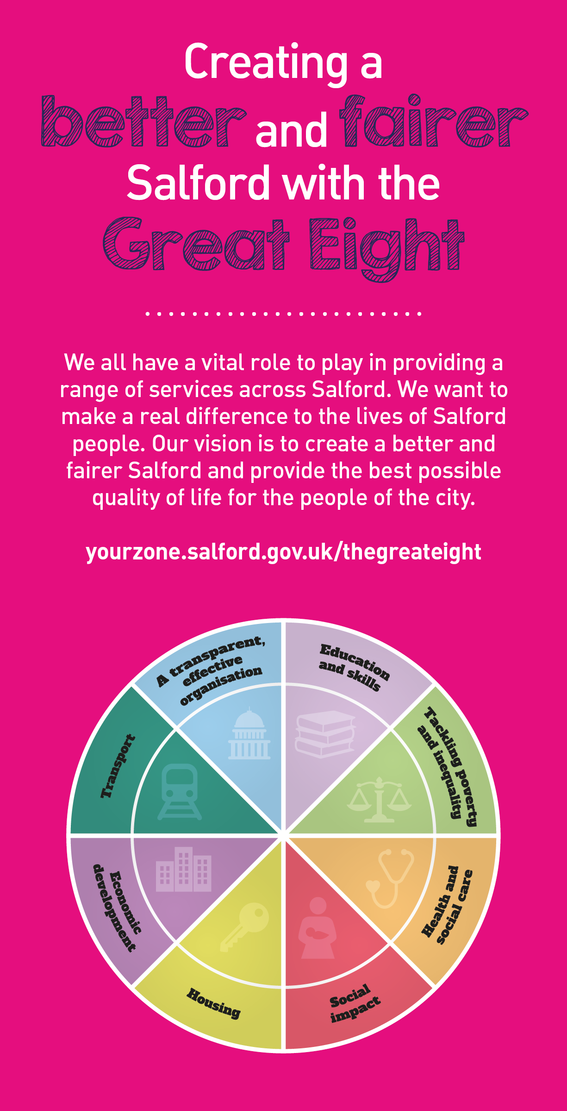
 | Key outcomes
 | - Leads delivery of key regeneration projects within a portfolio office/PMO structure  - Plans, monitors and manages projects and programmes identifying and mitigating any commercial, financial or legal risks.  - Ensures that the projects remain compliant with any legislative or governance changes at a Salford, Greater Manchester and national level.  - Manages and delivers complex, multi stakeholder projects or programmes to time and budget, ensuring highest level of communication and relationship management across all levels. |  |  |  |  | - Leads procurement exercises, ensuring best value for money and adherence to appropriate financial arrangements.  - Manages and monitors budgets and financial risks associated with programmes and projects to ensure effective management and financial propriety.  - Leads change management activities including change impact assessment, stakeholder management, managing resistance, building change capacity, designing and defining roles and responsibilities.  - Leads the drafting, evaluation, negotiation and execution of commercial contracts.
 | What we need from you
 | - Proven technical skills and ability in the role with a record of accomplishment for delivering outcomes  - Professional credibility through proven relevant experience  - Model and demonstrate our values and leadership behaviours  - 3 years experience of leading, implementing and managing a range of programmes and/or projects to deliver physical and economic regeneration.  - Experience of leading projects from inception and design phases through to successful implementation on the ground – including bid writing/case-making, procurement, contract management and risk management.  - Experience of developing and implementing effective project management systems to deliver successful major projects.  - Strong team leadership abilities with the ability to motivate and mobilised individuals outside their reporting lines.  - Experience of and working in the development industry with private sector partners, an understanding of development finance and a commercial awareness. |  |  |  |  | - A high standard of contract drafting and strong negotiation skills.  - To be an engaging, resilient, persistent, good negotiator with excellent communication skills and willing to take ownership of an exciting and significant portfolio of work.  - Highly developed organisational awareness and ability to understand any sensitivities within a complex multi-stakeholder structure, and think strategically to overcome obstacles to co-operation and progress.  - Current knowledge and understanding of planning and urban regeneration initiatives, Government funding initiatives and programmes, external funding programmes and initiatives.  - Computer literate with a good knowledge of Microsoft packages, particularly Word and Excel.  - Excellent attention to detail with an ability to work to tight deadline.  - Appropriate degree or professional qualification is desirable but not essential.
Our leadership behaviours |  |  |  |  |  |  |  |  | Our values
As a values-based leader you will:  - Model the values and embed them in the way your team delivers services  - Hold people accountable for delivering the values  - Respect and care for others, treating everyone fairly, recognising the importance of ensuring equality of opportunity for all, and listening and acting on the things people say  - Be honest, taking responsibility for your actions and decisions  - Use resources that you are trusted with wisely |  | To lead and develop people you will:  - Listen to understand, not to defend  - Give people the freedom to use their initiative  - Provide opportunities for people to discuss and solve problems and issues  - Regularly provide coaching and support to others to help them achieve their objectives and potential  - Appreciate and build on people’s strengths  - Motivate, engage, encourage and inspire others in order to be the best they can be
To create a performance and development culture you will:  - Be visible, inject pace, vigour and purpose  - Expect high standards; mediocrity is not acceptable  - Take an evidence and whole system approach in making decisions  - Maximise technology and models to deliver quicker, easier, better services  - Have a digital mindset, fully utilising digital systems and solutions to deliver services differently  - Set context and challenging goals that will motivate people to take ownership, maximise performance, and develop |  | To build and communicate a vision for the future you will:  - Be optimistic and ambitious for the city and its people, helping others to understand the need to transform public services  - Build strong collaborative relationships to find creative ways to make services more sustainable and flexible  - Recognise and values the strengths of people and places, taking a strengths-based approach to make the most of opportunities  - Support people through change, in undertaking new things, and taking risks  - Take a place and whole system approach in designing, delivering and leading services  - Ensure an inclusive approach with the aim of reflecting the increasing diversity of Salford

Application guidance

We are a values based organisation so reflecting our values or a values based approach in your evidence will support your application.

The ‘Key outcomes’, ‘What we need from you’ and ‘our leadership behaviours’ sections of the Role Profile are there to give you an understanding of what we would like to see reflected in your application. Don’t give up if you are not able to reflect all of these in your application.

