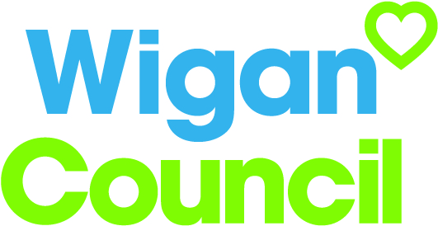
Job specification
Job title: | Service Manager Tenancy Management
Service: | Tenancy Management
Grade: | G14
Reporting to: | Assistant Director Homes

Your job
Wigan Council manages over 22,000 properties across the Wigan borough, including 1200 units designed for older people.

As the Service Manager for Tenancy Management you will be responsible for ensuring that these properties are let efficiently and that they are managed according to the tenancy agreements.

You will contribute to the creation of a vibrant community via effective stock management and the development and implementation of appropriate policies and procedures.

You will be responsible for three teams comprising of approximately 80 employees who will be responsible for managing the housing register, home matching service, property lettings, estate management including prevention and early intervention to prevent tenancy problems, and the effective management of the accommodation for older people across 41 schemes.

You will work closely with your teams to ensure a positive customer experience which maximises rental income and maintains the accommodation as tenure of choice for those who need it.

You will also work closely with colleagues across the Council to exploit efficiencies and options for people needing extra support.

In this job you will
Within the first 12 – 18 months you will:

- Develop and implement appropriate strategies and policies to ensure the effective delivery and running of the service to meet Council aims.
- Take the lead responsibility for the creation of systems, processes and structures to deliver the strategic priorities across all accommodation requirements including non-council stock allocation and management.
- Be responsible for the delivery of key outcomes, improvement strategies and Fresh Look reviews to fundamentally review how services are delivered to achieve Council priorities and cost reductions in line with targets set collaboratively with other services.
- Support the Assistant Director by providing technical and professional advice to elected members.
- Develop and maintain effective working relationships across the Council and with other stakeholders that promote the Councils interests.
- Deploy resources in the most effective manner to meet service delivery projects.
- Oversee the review of the allocations policy and procedure across all accommodation utilised by the Council.
- Oversee the review of managed accommodation in conjunction with the Service Manager Reform and Policy.
- Review and redesign the early intervention and prevention service in relation to tenancy management.
- Effectively manage devolved budgets
- Represent Wigan in national and regional policy development.

In this job you will need
You must be able to demonstrate the following essential requirements:

- A level 7 qualification in Housing, Management or other relevant field or an equivalent level of skills, knowledge and experience relevant to the role.
- A current member of the Chartered Institute of Housing or other relevant body
- Significant experience of housing management
- Significant experience of managing change and delivering tangible outcomes
- Experience of developing relationships with partners, external agencies and the voluntary sector.
- Extensive knowledge of best practice, statutory and regulatory requirement and key operational issues relevant to housing management.
- Knowledge of the locality plan and integrated working methods and an ability to contribute to achieving both aims.
- The ability to reform services in a creative way.
- The ability to lead multi agency partnerships to deliver outcomes and effective working in line with Council priorities
- The ability to identify trends, future needs and assess regulatory changes and adapt the service to accommodate these.
- The ability to manage high level complex budgets.
- Experience of managing diverse service areas and managing competing priorities.
- Excellent written and verbal communication skills across a wide range of audiences
- The ability to lead teams and instil a culture of achievement and high performance throughout the service
- A current valid driving licence or the ability to travel as required using own or public transport in the most effective manner

Our culture
For us, it’s not just about all we achieve as an organisation, but how we do it. Therefore, all employees are expected to display our Be Wigan behaviours.
Be Positive… take pride in all that you do

Be Accountable… be responsible for making things better

Be Courageous… be open to doing things differently

Individuals with line management responsibilities are also expected to …
Inspire…lead by example and help others to see the big picture

Care… show genuine concern for people as individuals and value their contributions

Engage… I connect with others both within and beyond the organisation

Staff Deal
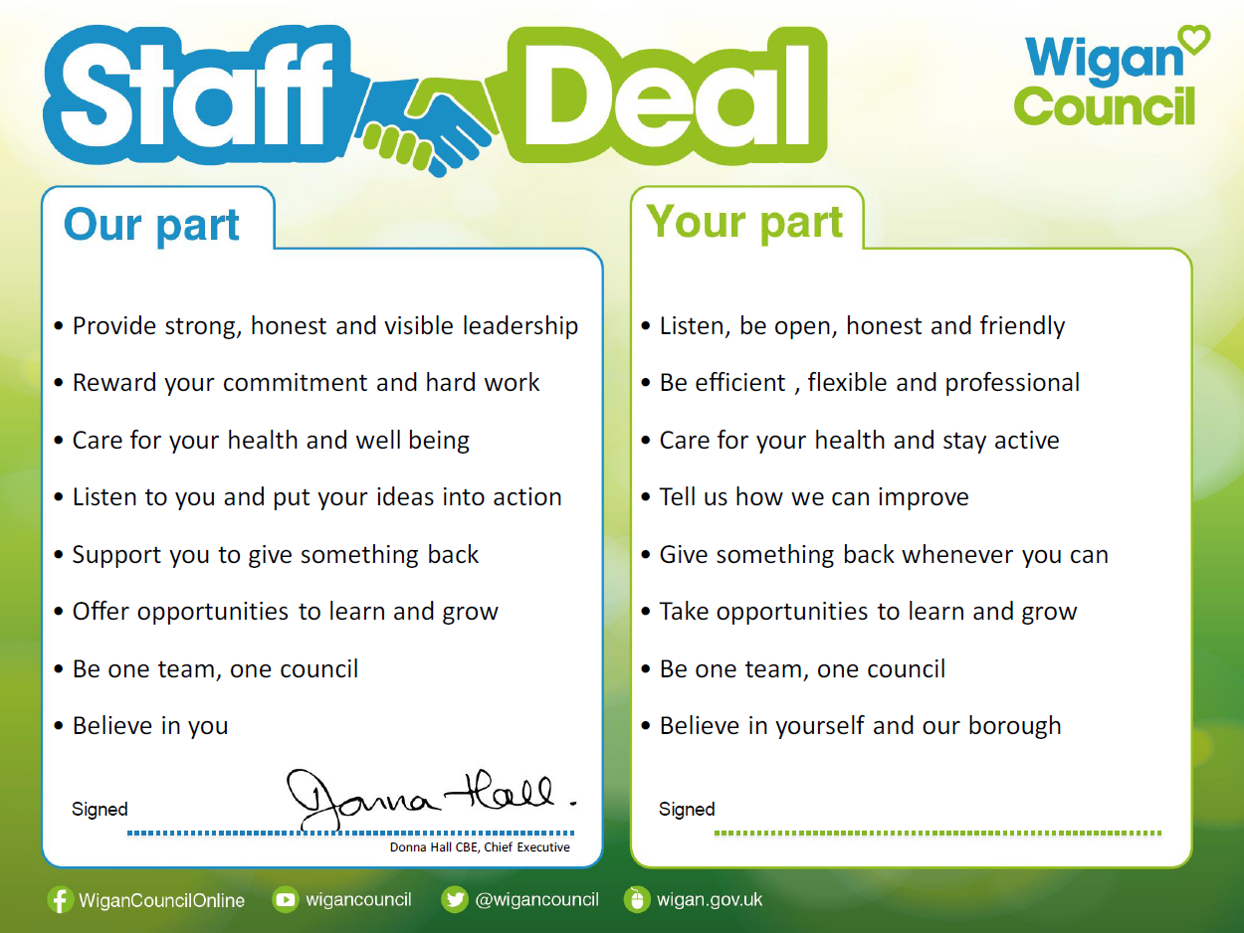
Our Staff Deal is an informal agreement with all staff. It outlines what you can expect from us, and in return what we expect from you

